Reading
- Read the text and be ready to answer the questions after the text.
ARE TODAY'S GADGETS MAKING PEOPLE SICK?
Glossary: gadget- small mechanical tool / malady - health problem / to swell up -
when part of the body becomes bigger after injury / bacteria - germs / ailment - mild illness / numbness - torpor / rash - an area of red spots on the skin / pinch - squeeze / blurred - indistinct / tingling - stinging
Lots of casual technology users are paying a very high price for the modern conveniences that their gadgets afford them: their health, and, in some cases, even their lives, are in jeopardy. Here you have the examples of some “modern-day maladies” caused by people’s lifestyle and love for gadgets.

Text neck. People often look down at their phones for long periods of time, which puts pressure on the neck and shoulders. This can lead to pain, stiffness, and long-term posture problems.

A Pain in the ... Hands. Though carpal tunnel syndrome's shining moment in the media spotlight may have come and gone, the ailment is still very much real for many a hobbled keyboard jockey.According to AOL Health, carpal tunnel occurs when the median nerve in your forearm becomes pinched due to swelling. The effect is numbness, tingling and pain in the palm side of your thumb, index and middle fingers.
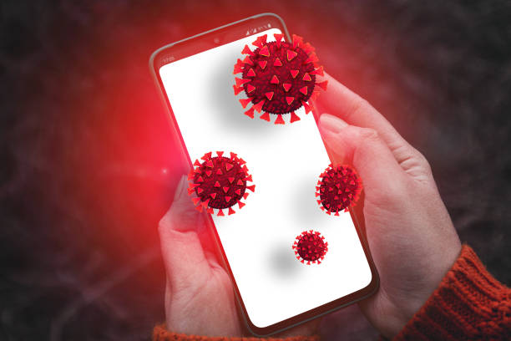
Acne and Rashes. According to microbiologists from England's Manchester Metropolitan University, your cell phone is home to more bacteria than your toilet seat – bacteria that can cause very serious illnesses such as pneumonia and meningitis. In most cases, though, a visit from the acne fairy is the worst it gets.
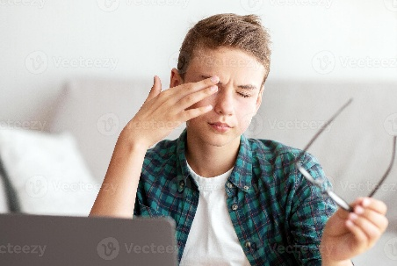
Poor Vision. Missile-locking your eyes to a monitor all day can lead to Computer Vision Syndrome (CVS), the symptoms of which include blurred vision, light sensitivity and headaches. That's because we humans weren't built for computer work.

Addiction. Like just about everything else that's fun in this world, the Internet is a magnet for compulsive types. Whether it's in the form of a poker site, role-playing video games or even eBay, online addiction is estimated to affect between 5 and 10% of the population, ruining lives and relationships along the way.
Mobile Elbow. Wrist injury experts say that the nerves in your elbow get “stressed” if they are stretched too much during phone conversations. This could result in long-term injuries to your hands and wrists.
- Read the text again. Are these sentences true (T) or false (F) or is the information not mentioned (NM) in the text?
- Lots of casual technology users are paying a very low price for the modern conveniences that their gadgets afford them.
- According to AOL Health, carpal tunnel occurs when the median nerve in your forearm becomes pinched due to swelling.
- According to microbiologists from England's Manchester Metropolitan University cell phone can’t cause very serious illnesses.
- Online addiction is estimated to affect between 5 and 100 % of the population, ruining lives and relationships along the way.
- Wrist injury experts say that the nerves in your elbow get “stressed” if they are stretched too much during phone conversations.
- Answer the questions after the text.
- What health problems can some gadgets cause?
- Which seem to be the 2 major causes of these ailments?
- Have you ever felt that a certain gadget was harming your health? In what way?

- How many gadgets do you have?
- In your opinion what can people do to reduce the health risks caused by these gadgets?

Grammar Focus

Cause & Result + Modals (should / shouldn’t)
We often talk about why problems happen and what we should do.

🔹 Cause → Result
We use:
- because / because of
- can / can lead to / can cause
Examples from the text:
- Looking at phones for a long time can cause neck pain.
- Screen use can lead to poor vision.
- Skin problems happen because of bacteria on phones.

🔹 Giving Advice (should / shouldn’t)
We use should / shouldn’t to give advice.
Examples:
- You should take regular breaks.
- You shouldn’t use your phone too much.
- People should clean their devices regularly.
- Choose the correct option.
- Looking at screens for too long (can cause / should cause) eye problems.
- Neck pain happens (because / should) people look down at phones for a long time.
- Using gadgets at night (can lead to / should lead to) sleep problems.
- Skin issues may appear (because of / should) bacteria on phones.
- Too much screen time (can cause / shouldn’t cause) headaches.
- You (should / because) take breaks while working on a computer.
- People (shouldn’t / because) ignore health problems.
- Poor posture happens (because of/ should) muscle imbalance and a lack of physical activity .
- Addiction (can lead / should lead) to serious problems.
- You (should / because) reduce screen time before sleep.
- Combine the sentences.
Use: because / because of / so
- People use smartphones a lot. They have neck pain.
- Phones are dirty. People get skin problems.
- Users stare at screens. Their eyes hurt.
- People use gadgets at night. They sleep badly.
- Students spend too much time online. They feel tired.
- People sit incorrectly. They have back pain.
- Devices are used too often. Addiction develops.
- Users don’t take breaks. They get headaches.
- People ignore health problems. The situation becomes worse.
- Gadgets are overused. People feel stressed.

- Write 120–140 words.
Topic: The role of gadgets in modern life
Include:

Writing
- how gadgets are used
- their advantages
- possible negative effects
- your opinion

Use of English

Does “phone separation anxiety” really exist?
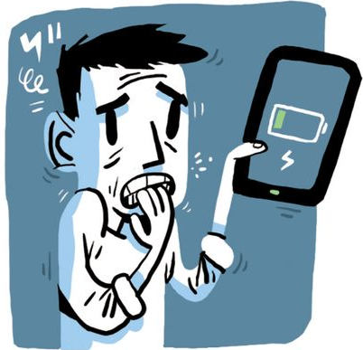
You know the feeling – you have left your phone at home and feel anxious, as if you have lost your connection to the world. “Nomophobia” (short for no-mobile phobia) affects teenagers and adults alike. You can even do an online test to see if you have it. Last week, researchers from Hong Kong warned that nomophobia is infecting everyone. Their study found that people who use their phones to store, share and access personal memories suffer most. When users were asked to describe how they felt about their phones, words such as “hurt’” (neck pain was often reported) and “alone” predicted higher levels of nomophobia.
“The findings of our study suggest that users perceive smartphones as their extended selves and get attached to the devices,” said Dr Kim Ki Joon. “People experience feelings of anxiety and unpleasantness when separated from their phones.” Meanwhile, an American study shows that smartphone separation can lead to an increase in heart rate and blood pressure.
So can being without your phone really give you separation anxiety? Professor Mark Griffiths, chartered psychologist and director of the International Gaming Research Unit at Nottingham Trent University, says it is what is on the phone that counts – the social networking that creates Fomo (fear of missing out).
“People don’t use their phones to talk to other people – we are talking about an internet-connected device that allows people to deal with lots of aspects of their lives,” says Griffiths. “You would have to surgically remove a phone from a teenager because their whole life is ingrained in this device.”
Griffiths thinks attachment theory, where we develop emotional dependency on the phone because it holds details of our lives, is a small part of nomophobia. For “screenagers”, it is Fomo that creates the most separation anxiety. If they can’t see what’s happening on TikTok or Instagram, they become panic-stricken about not knowing what’s going on socially. “But they adapt very quickly if you take them on holiday and there’s no internet,” says Griffiths.
Deliberately separating from your phone by turning it off or leaving it at home can reduce dependency and anxiety. Griffiths says the criteria for phone addiction include it being the most important thing in your life, building up the time you spend on it, withdrawal symptoms, using it to de-stress or to get excited. Your phone-use also needs to compromise relationships or work and provoke inner conflict – you know you should cut down, but can’t. Few people, Griffiths says, fulfill these criteria. But surely many of us experience some of them.
Taken from ( https://www.theguardian.com/lifeandstyle/2017/aug/28/does-phone-separation-anxiety-really-exist )
- Read the text and answer the following questions.
- What is “nomophobia”?
- Who does nomophobia affect?
- Which users are most affected?
- What feelings do users have when deprived of their mobiles?
- What is FOMO?
- What can people do to reduce phone dependency?
- TRUE or FALSE?
- Nowadays, people can test their phone dependency online. _____
- Only teenagers are affected by nomophobia. _____
- Users consider their smartphones as parts of themselves. _____
- Being apart of our smartphone causes a feeling of relief. _____
- People use their smartphones mostly to chat with their relatives and friends. _____
- Find words with the same meaning.
- alerted ___________________
- discovered _________________
- keep ______________________
- uneasiness _________________
- deep-rooted ________________
- signs _____________________

Speaking
- Complete the sentences with own ideas (cause & result).
- People get neck pain because ______.
- Eye problems occur because of ______.
- Using gadgets too much can lead to ______.
- Skin problems can be caused by ______.
- Lack of sleep happens because ______.
- Headaches can result from ______.
- Addiction may lead to ______.
- Poor posture is caused by ______.
- Stress can appear because ______.
- Health problems increase when ______.
- Give advice using should / shouldn’t.
- People use their phones all night.
→ They ______.
- Students spend too much time online.
→ They ______.
- Users do not clean their devices.
→ They ______.
- People sit in a bad position.
→ They ______.
- Someone has eye strain.
→ They ______.
- A person feels neck pain.
→ They ______.
- Users are addicted to the Internet.
→ They ______.
- People do not take breaks.
→ They ______.
- Someone uses gadgets too much.
→ They ______.
- A student has headaches from screen use.
→ They ______.

- Think about your answers to these questions.
- Are there any new gadgets that you really want to get?
- Give some examples of technology that have made the world worse.
- Do you like new gadgets or do you prefer to use technology you are comfortable with?
- What do you think robots should be used for?
- Why do people like gadgets?
- Describe an electronic gadget you like the most. You should say:
  - what it is;
  - when and from where you got it;
  - what you use it for;
and explain why it is so important to you.

- Real-life task.
Task: Write a short review of a gadget you use every day.

Home project
Include:
- description
- 2–3 advantages
- 1 disadvantage
- your recommendation
Write 80–100 words.

