What Is Sports Science?
Read the “Health Sciences Blog (American Public University)” and find the information:
- Definition of Sports Science.
- Importance of Sports Science in Athletic Performance.
- Degree Options and Career Opportunities.
- Exercise Physiology and Nutrition.
- Real-World Example of the Impact of Sports Science.

Health Sciences Blog (American Public University)
https://www.apu.apus.edu/area-of-study/nursing-and-health-sciences/resources/what-is-sports-science/

Follow the link. Describe Radika's, Victoria's and Jamie's real cases
https://www.youtube.com/watch?v=9Hqdrx1HPfA
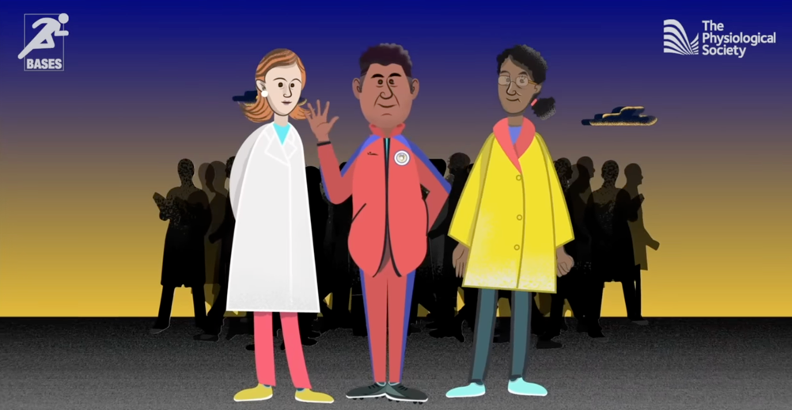
Follow the link. How does technology change sport (group work)?
https://www.hire-intelligence.co.uk/evolution-of-technology-in-sport/


