Follow the link, watch the video.
https://www.abc.net.au/btn/high/sexism-in-sport/105010814
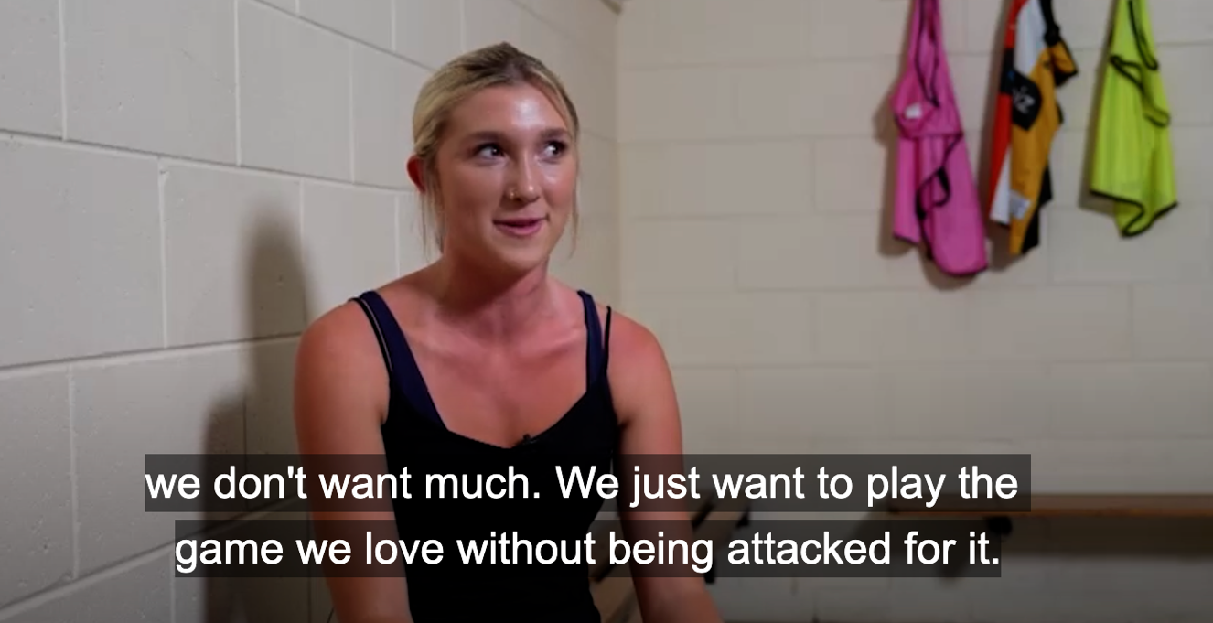
“Sexist language”. Examples:

How to resist? Is it possible?

Are there any changes now?

