https://www.youtube.com/watch?v=d_awBXYotQ0
Watch the video “Superfoods” and do the tasks bellow.
- Explain and give the context of the words:
Superfood
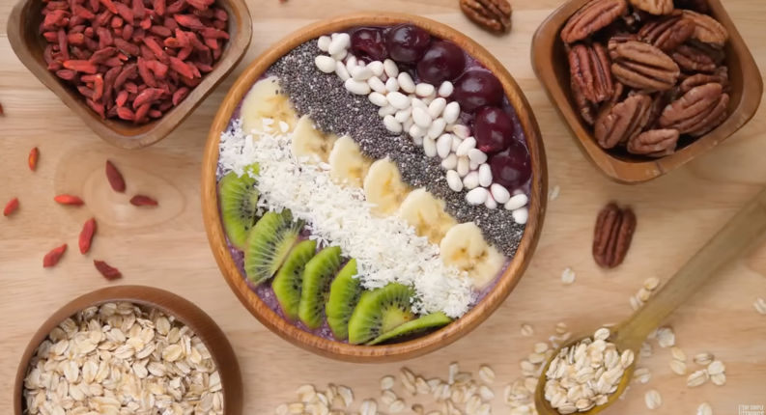
Buzzword
Fancy word
Nutrition
Marketing term
Catchy
Longevity hack
Scam
Go viral
Trend cycle
Dietary pattern

- Answer
- Is “Superfood” a scientific term?
- When did the term appear?
- Who invented it?
- What makes the food super?
- Name “superfoods”. Why is this food healthy? Is it really that healthy?
- Why do we keep chasing superfoods?

