Prepare a Vegetarian Dinner
You are going to host a dinner for a vegetarian guest. Your task is to plan and describe a complete vegetarian dinner menu. Pick up one of the guests on the next page.
Instructions:
- Create a three-course dinner menu (starter, main course, dessert).
- Make sure all dishes are vegetarian (no meat or fish).
- Write a short description (3–5 sentences) of each dish, including:
  - Main ingredients
  - Cooking method
  - Why it is suitable for a vegetarian
- Ask the GPT chat to visualize your menu

Useful link: https://klopotenko.com/en/vegetarian-menu/
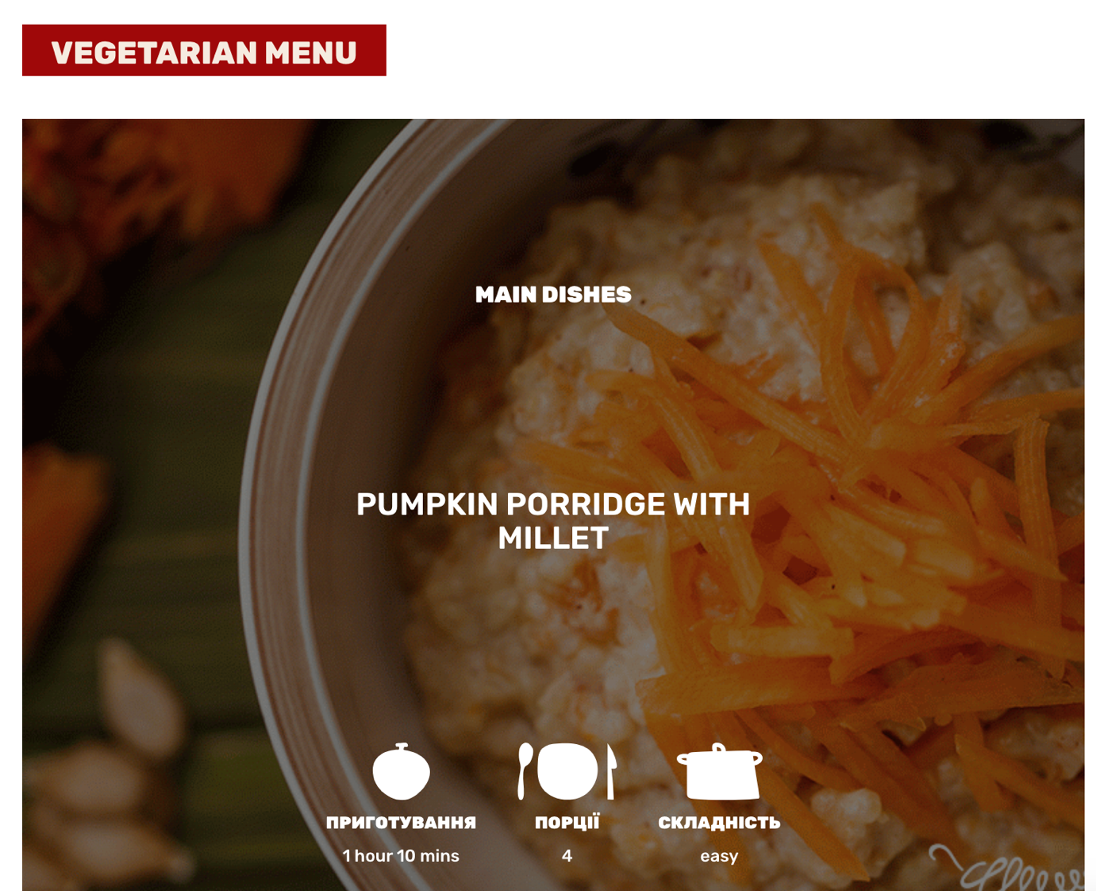
Guest 1
- No meat or fish
- Prefers organic vegetables
- Loves spicy food
- Avoids mushrooms
- Enjoys herbal tea

Guest 2
- Lacto-vegetarian (eats dairy, no eggs)
- Prefers mild flavors
- Likes Italian cuisine
- Avoids very oily dishes
- Loves fresh salads

Guest 3
- Vegan (no animal products)
- Gluten-free
- Prefers simple home-style cooking
- Likes legumes and beans
- Drinks only water or fresh juice

Guest 4
- Vegetarian, eats eggs and dairy
- Loves Asian food
- Enjoys tofu and rice dishes
- Doesn’t like very spicy meals
- Prefers light desserts

Guest 5
- Vegetarian
- Prefers high-protein meals
- Avoids fried food
- Likes seasonal vegetables
- Enjoys dark chocolate for dessert

