Job satisfaction.
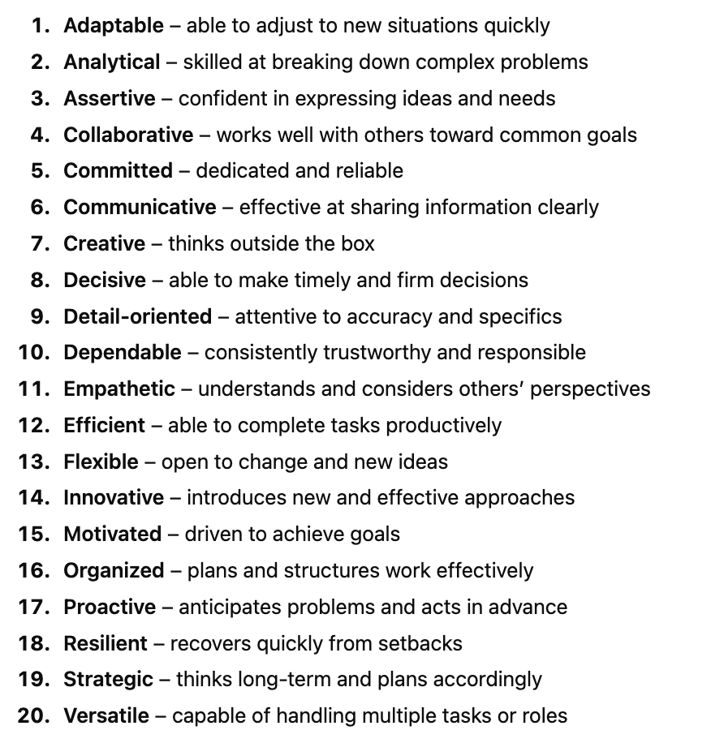
Match the 20 adjectives to the categories:
Outgoing and Sociable
Factual and Realistic
Objective and Analytical
Flexible and Spontaneous
Reserved and Introspective
Idealistic and Theoretical
Empathetic and Sentimental
Structured and Decisive

Look at the diagram “Job satisfaction”. What is the most relevant for you. Vote with the sticker. In group or alone explain your choice.
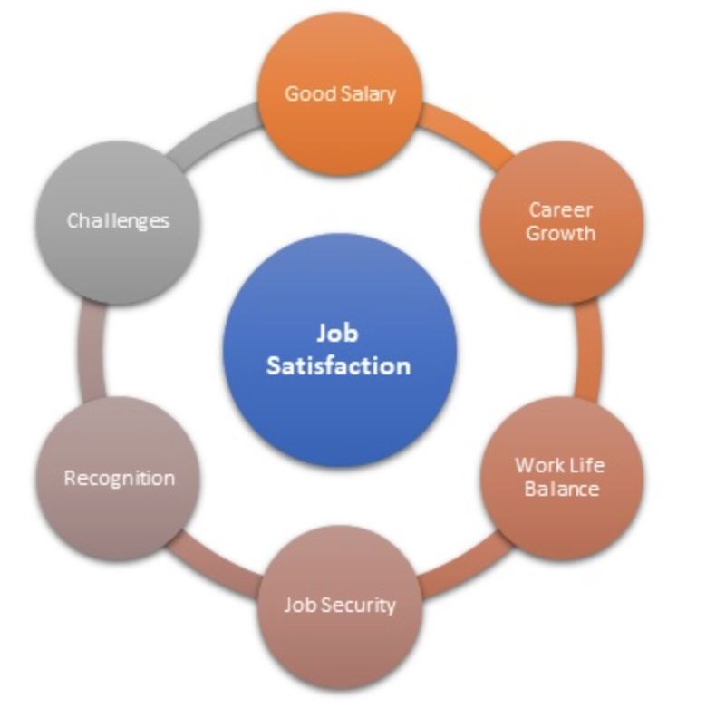
Creative task
You are the owner of the start up company. Design a short presentation how your company provides job satisfaction to its employees. Use Chat GPT to create visuality (a picture) summarizing job satisfaction priorities of your company (use keywords).
