Змістовий модуль 9. ENGINEERING
Завдання
- What do engineers do? Do you know any? Look in the pictures what different types are there?
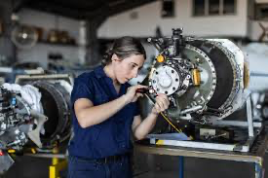

- Підручник ст 86: Cotton, D., Falvey, D., & Kent, S. (2014). Language Leader: Intermediate. Pearson Education. Look at the text. Where do you think it comes from? Who is it aimed at?

- Підручник ст 86: Cotton, D., Falvey, D., & Kent, S. (2014). Language Leader: Intermediate. Pearson Education. Read the text again. Match these inventions with the types of engineering mentioned in the text.

- roads
- aircraft
- a washing machine microchip
- a heart pacemaker

- Підручник ст 87: Cotton, D., Falvey, D., & Kent, S. (2014). Language Leader: Intermediate. Pearson Education. Lindsey Barone is one of the few women engineers in a high position. Listen to the interview. What type of engineering has she worked in?

- Follow the link and watch the video about greatest engineering achievements. What impressed you the most?
https://www.youtube.com/watch?v=YcYMVB3jPh8

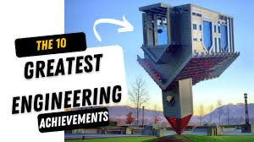

- Look at the Top greatest engineering achievements and Write a short paragraph about what you think is the greatest engineering achievement. Think about these questions: Why do you think it is the greatest achievement? How has it improved people's lives? What would people's lives be like without it?

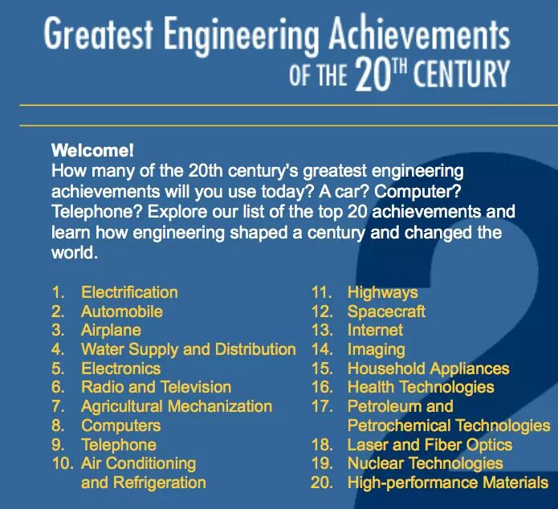

- Підручник ст 87: Cotton, D., Falvey, D., & Kent, S. (2014). Language Leader: Intermediate. Pearson Education. Work in small groups. Look at the list of some great engineering achievements and do the following.

- Підручник ст 90-91: Cotton, D., Falvey, D., & Kent, S. (2014). Language Leader: Intermediate. Pearson Education. Read the text quickly. Tell a partner what you found most interesting.

- Work with a partner to discuss the following. What is the largest man-made structure you have over been in or on? How did you feel?
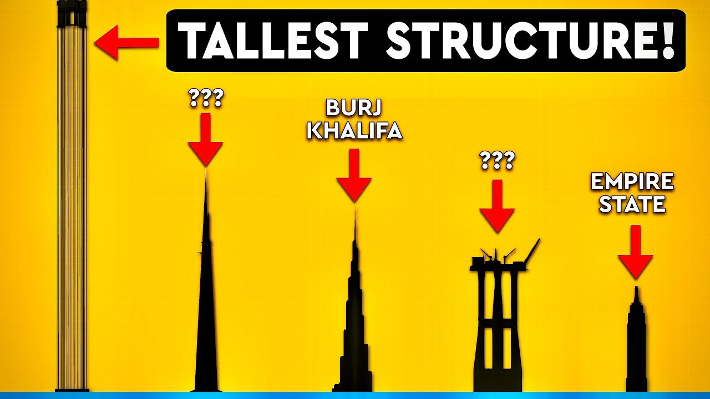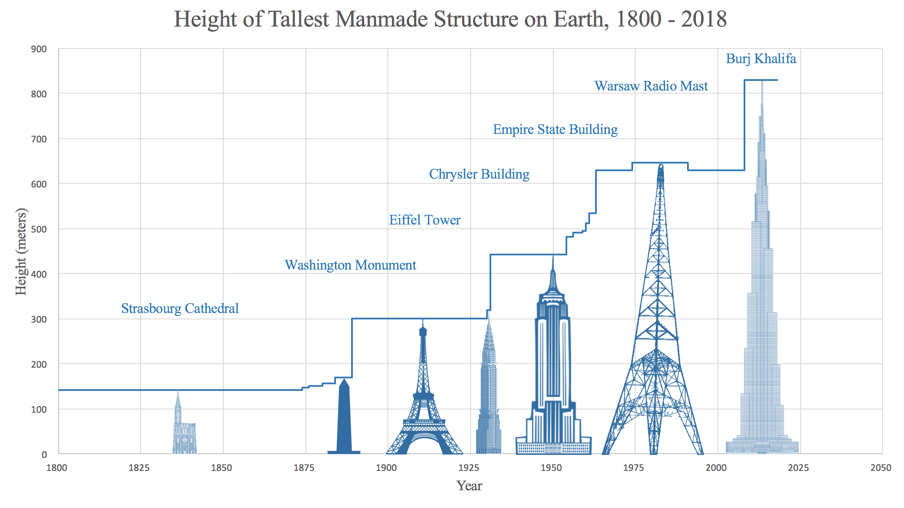

- Підручник ст 92 Listening 4.2: Cotton, D., Falvey, D., & Kent, S. (2014). Language Leader: Intermediate. Pearson Education. Listen to an extract from a television news programme. Discuss these questions.

- Підручник ст 92 Listening 4.4: Cotton, D., Falvey, D., & Kent, S. (2014). Language Leader: Intermediate. Pearson Education. Listen to two city planners talking about the benefits of the project. Note down the benefits they mention. Compare them with the ones you discussed in Exercise 3b.


- Підручник ст 92 Listening 4.5: Cotton, D., Falvey, D., & Kent, S. (2014). Language Leader: Intermediate. Pearson Education. Listen to a conversation between three city planners about a name for the vertical city and complete it.

