Змістовий модуль 8. BUSINESS
- Work with a partner to discuss these guestions.
- Can vou name a successful business from your country?
- Can you name a business from another country which is successful in your country?
- Why do you think these businesses are so successful?

- Who is this man in the picture? What is he famous for?


- Підручник ст 76: Cotton, D., Falvey, D., & Kent, S. (2014). Language Leader: Intermediate. Pearson Education. Complete the statements with the words in the box.

- Підручник ст 76: Cotton, D., Falvey, D., & Kent, S. (2014). Language Leader: Intermediate. Pearson Education. Read a page from a website on starting a new business. Whose advice do you think is the best for your situation: which ot the business areas would vou prefer to work in?

- Підручник ст. 77: Cotton, D., Falvey, D., & Kent, S. (2014). Language Leader: Intermediate. Pearson Education. You are going to watch an interview with Teresa Le, chef and owner of Ládudu, a Vietnamese restaurant in London. Before you watch, read these extracts from the interview and discuss questions a-f with a partner.

- Підручник ст. 78: Cotton, D., Falvey, D., & Kent, S. (2014). Language Leader: Intermediate. Pearson Education. Read the three texts quickly and match them with the following ethical problems.

- Grammar. How is Past Con. is formed? Where is it used?
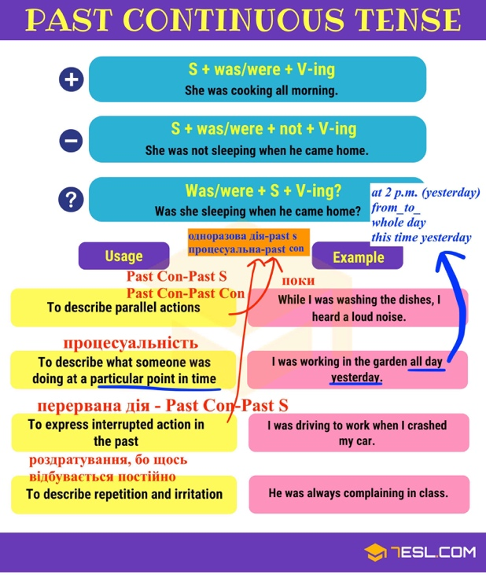
- Put in the verbs in brackets into the gaps to form positive sentences in Past Continuous. 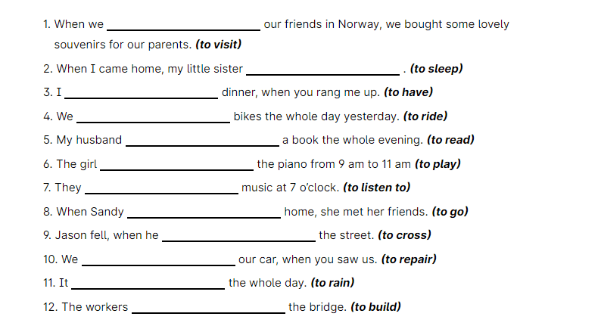
- Підручник ст. 81: Cotton, D., Falvey, D., & Kent, S. (2014). Language Leader: Intermediate. Pearson Education. Complete the text with the past simple or past perfect of the verbs in brackets.

- Discuss these questions.
- Who are the business icons in your country?
- Why are they successful?
- Who is the most successful person you know?
- Why are they successful?

- Put in the verbs in brackets into the gaps to form negative sentences in Past Continuous.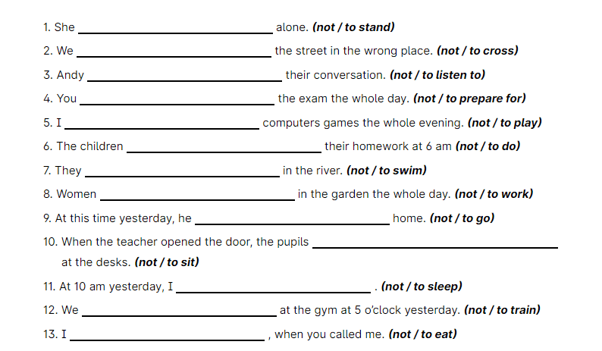
- You and your team are launching a new business. Your goal is to create a unique product or service and present it to potential investors. Prepare a small presentation Work in pairs or small groups and decide:
- What is your company name?
- What product or service do you offer?
- Who is your target audience?
- What problem does your business solve?
- What makes your idea different from competitors?
