Змістовий модуль 7. DESIGN.
Завдання

- Підручник ст 68: Cotton, D., Falvey, D., & Kent, S. (2014). Language Leader: Intermediate. Pearson Education. Designers need to think about the following when designing new products: material, shape, texture. Look at the words in the box and put them into the correct category.

- Follow the link and choose the best design of the items. Explain your chouce
https://wordwall.net/uk/resource/96993562

- Підручник ст 68: Cotton, D., Falvey, D., & Kent, S. (2014). Language Leader: Intermediate. Pearson Education. Work in groups of three. Read your text quickly, then share your information with your group. Compare the information with your ideas from Exercise 2.

- What is special about the design of these signs.


- Робочий зошит (Workbook) ст. 46: Cotton, D., Falvey, D., & Kent, S. (2014). Language Leader: Intermediate workbook. Pearson Education. Match an adjective from the box to the pictures.

- Робочий зошит (Workbook) ст. 47: Cotton, D., Falvey, D., & Kent, S. (2014). Language Leader: Intermediate workbook. Pearson Education. Write the correct ending to complete these abstract nouns. Listen to the audio 2.9 and complete the notes from their meeting.
- Підручник ст 68: Cotton, D., Falvey, D., & Kent, S. (2014). Language Leader: Intermediate. Pearson Education. Read the text and find the noun forms of the verbs below in the texts.

- Підручник ст 70: Cotton, D., Falvey, D., & Kent, S. (2014). Language Leader: Intermediate. Pearson Education. Read the article and match the headings to the paragraphs.

- Look at the photo. What is this? Would you like to own any of these Alessi designer products? Why?/Why not?


- The Museo Alessi is one of the founders of Museimpresa, the Italian association of museums and business archives. What is dspecial about Alessi’s design? Following the link and descower: https://alessi.com/

- Робочий зошит (Workbook) ст. 48: Cotton, D., Falvey, D., & Kent, S. (2014). Language Leader: Intermediate workbook. Pearson Education. Look at these pairs of sentences. Choose from the phrases below to complete sentence b with the same meaning as sentence a.

- Робочий зошит (Workbook) ст. 49: Cotton, D., Falvey, D., & Kent, S. (2014). Language Leader: Intermediate workbook. Pearson Education. Match a phrase 1-6 to each picture a-f.

- Підручник ст 72-73: Cotton, D., Falvey, D., & Kent, S. (2014). Language Leader: Intermediate. Pearson Education. Read the article and match the headings to the paragraphs. Work in groups of four. You are judges for this year's competition and will choose the winning design. Choose one product each from the text on page 73. Read the description and take notes on the key points.

- Describe your product to the other judges in your group. You may add extra information you wish to cover all the catagories. Complete the evaluation form for the other three products as you listen to the other judges. Marks are out of ten. Do not evaluate your own product.

- Підручник ст 75: Cotton, D., Falvey, D., & Kent, S. (2014). Language Leader: Intermediate. Pearson Education. The head of a large airline has asked you to write a report on two top-of-the-range headphones, recommending one of them for use in the airline's First Class cabins. Write the report, using the notes on the right.

- Follow the link and choose the best headphones design and explain your choice: https://www.sennheiser.com/en-be/catalog/products/headphones?srsltid=AfmBOoqdVL6HysAw2hKpJjvn7wmJGN-QSEmX8dnYEZ1yitd22pGqwwR9
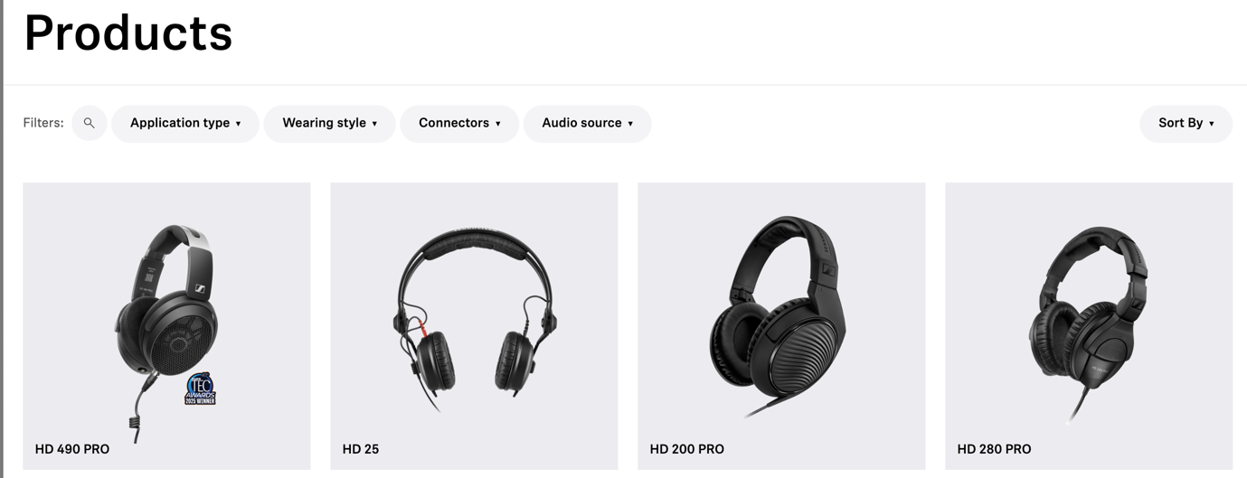

- Look at the linking words. Where do you use them? Underline the correct linkers in these sentences. Робочий зошит (Workbook) ст. 52: Cotton, D., Falvey, D., & Kent, S. (2014). Language Leader: Intermediate workbook. Pearson Education.

