Змістовий модуль 7. IT Support

Тема 1. Fault Diagnosis. Understanding Faults. Fault Diagnosis: Questions and Answers.

- Match problems with the definitions

Connection Error | a performance issue where a program, device, or system operates at a reduced speed, taking longer than expected to complete tasks, often due to resource limitations or inefficiencies.
Fault | a sudden and complete failure of a program, process, or system, causing it to stop functioning and often close unexpectedly.
Hanging | when a program or system becomes unresponsive, appearing to freeze and stop accepting user input, without necessarily closing or crashing.
Crashes | broader term meaning that a system, component, or process cannot perform its intended function. This can be temporary (recoverable) or permanent (irrecoverable).
Running Slowly | an issue where a device, application, or system cannot establish or maintain communication with another system, network, or service (e.g., a website not loading because the internet connection fails).
Failure | a defect, bug, or malfunction in hardware, software, or configuration that prevents it from operating correctly. It may or may not immediately cause visible problems.

- Match problems and examples. Read the definitions. Give your examples.
Problems
- Connection Error – an issue where a device, application, or system cannot establish or maintain communication with another system, network, or service (e.g., a website not loading because the internet connection fails).
- Fault – a defect, bug, or malfunction in hardware, software, or configuration that prevents it from operating correctly. It may or may not immediately cause visible problems.
- Hanging - when a program or system becomes unresponsive, appearing to freeze and stop accepting user input, without necessarily closing or crashing.
- Crashes – a sudden and complete failure of a program, process, or system, causing it to stop functioning and often close unexpectedly.
- Running Slowly - a performance issue where a program, device, or system operates at a reduced speed, taking longer than expected to complete tasks, often due to resource limitations or inefficiencies.
- Failure - broader term meaning that a system, component, or process cannot perform its intended function. This can be temporary (recoverable) or permanent (irrecoverable).

Examples
- A misconfigured DNS setting in Windows causes websites not to resolve properly.
- A video game closes instantly to the desktop when loading a new level.
- Microsoft Word stops responding and shows “Not Responding” in the title bar, requiring a force quit.
- A laptop takes 10 minutes to boot because it has too many startup applications running.
- A user tries to open Gmail but gets “Unable to connect to server” because their Wi-Fi is down.
- A hard drive fails mechanically, making it impossible to boot the operating system.

- Підручник ст 61 D.Hill. English for Information Technology. Vocational English 2. Course Book A2-B1. Pearson. 2019

Тема 2. Software Repair. Filling in Service Reports. Fault Diagnosis questions. Possible Solutions.

- Підручник ст 60 D.Hill. English for Information Technology. Vocational English 2. Course Book A2-B1. Pearson. 2019

- Read the text about IT Suport. What levels of support are there?
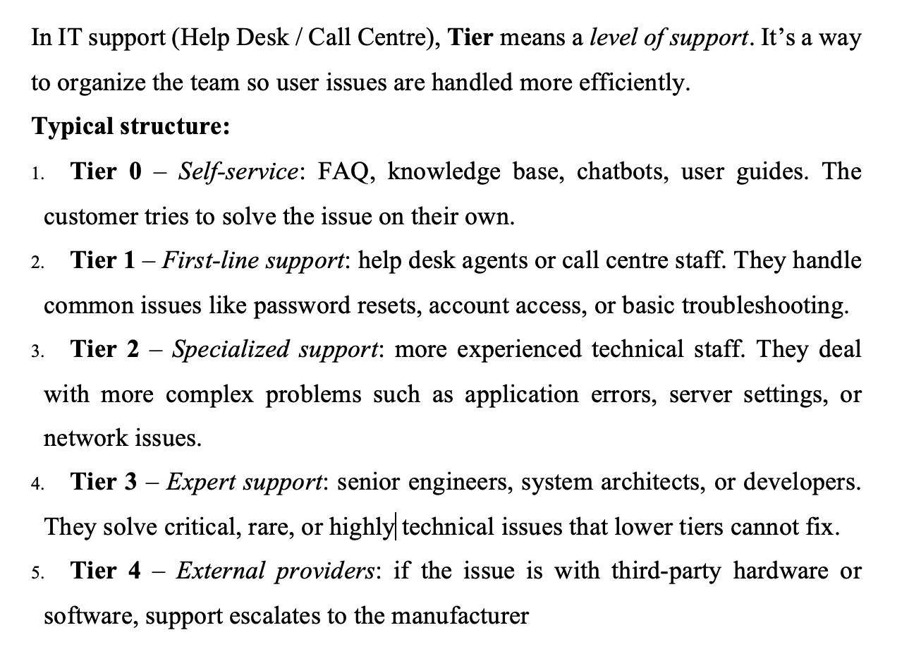
- Listen to the dialogue audio 45. D.Hill. English for Information Technology. Vocational English 2. Course Book A2-B1. Pearson. 2019. Explain the meaning: “accounting software”, “download”, “install”, “double click on the icon”, “follow the instructions,”” click through the steps”.

- Підручник ст 62 D.Hill. English for Information Technology. Vocational English 2. Course Book A2-B1. Pearson. 2019. Complete this company troubleshooting guide. Use the words in brackets and language from the Language box.

- Підручник ст 63 D.Hill. English for Information Technology. Vocational English 2. Course Book A2-B1. Pearson. 2019. Work in pairs. Roleplay dealing with a monitor problem using the troubleshooting guide in 6. Take turns being a caller with a blank monitor screen and the help desk technician.

Тема 3. Hardware Repair.Using Toolkits and Making Repair.
- Read the text and answer the questions:
- What tools are included in a basic hardware toolkit?
- Why is it important to unplug a device before repair?
- What is the purpose of a multimeter?
- What skills are important for hardware repair?
Hardware repair is an important skill in many technical jobs. It involves fixing physical parts of computers, machines, or electronic devices. To perform hardware repair, technicians use different tools from a toolkit.
A basic hardware toolkit usually includes screwdrivers, pliers, a wrench, a hammer, a multimeter, and sometimes a soldering iron. Each tool has a specific purpose. For example, screwdrivers are used to remove or tighten screws, while pliers help hold small parts. A multimeter is used to check voltage and test electrical connections. Before starting a repair, it is important to follow safety rules. First, turn off the device and unplug it from the power source. Then, wear protective equipment such as gloves or safety glasses. Always work in a clean and organized space.
When making a repair, the technician must first identify the problem. For example, if a computer does not turn on, the issue may be a faulty power supply or a damaged cable. After diagnosing the problem, the technician replaces or fixes the damaged part. Finally, the device is tested to make sure it works properly. Good hardware repair requires patience, attention to detail, and technical knowledge. With practice and the right tools, many common problems can be solved quickly and safely.

Speaking Task:
- Have you ever repaired a device? What was the problem?
- What tools do you know how to use?
- Why is safety important in hardware repair?
Тема 4. Customer Service.
- Підручник ст 64 D.Hill. English for Information Technology. Vocational English 2. Course Book A2-B1. Pearson. 2019. Listen to two repair technicians in a computer shop talking about a computer a customer has brought in for repair. Have they solved the problem yet?

- Підручник ст 64 D.Hill. English for Information Technology. Vocational English 2. Course Book A2-B1. Pearson. 2019. Complete these conversations. Use the words in brackets and language from the Language box. Add any other words necessary.

Тема 5. Solving Customer Service Problems. Phonecalls.
- Read the dialogue, explain the meaning of the highlighted words
- Make up your own dialogues, changing the problem. Use your active vocabulary.

