Змістовий модуль 3. JOBS.
- Підручник ст 20: Cotton, D., Falvey, D., & Kent, S. (2014). Language Leader: Intermediate. Pearson Education.
- Робочий зошит (Workbook) ст. 11: Cotton, D., Falvey, D., & Kent, S. (2014). Language Leader: Intermediate workbook. Pearson Education.

- Follow the link and say what are the best jobs for 2025
https://www.indeed.com/career-advice/news/best-jobs-2025

- Підручник ст 27: Cotton, D., Falvey, D., & Kent, S. (2014). Language Leader: Intermediate. Pearson Education.
- Підручник ст 28: Cotton, D., Falvey, D., & Kent, S. (2014). Language Leader: Intermediate. Pearson Education.

- Look in the picture and choose the most relevant job skill.
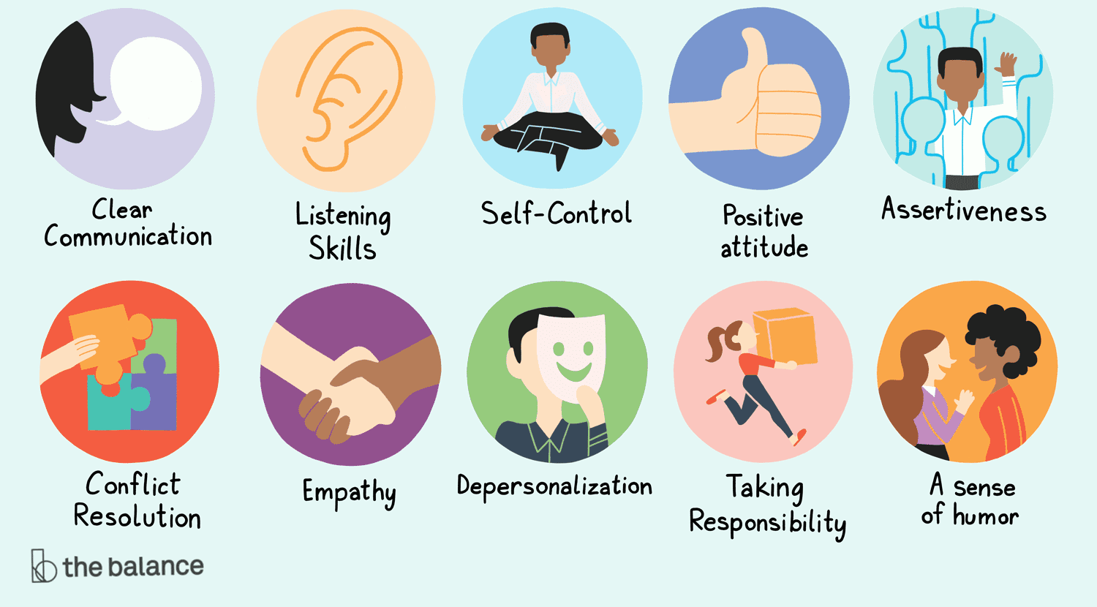
- Create a poster showing:
- Job title
- Skills needed
- Typical tasks
- Why they like it


- Interview Role-Play
- Work in pairs: one is the interviewer, the other is the applicant. Use the given phrases
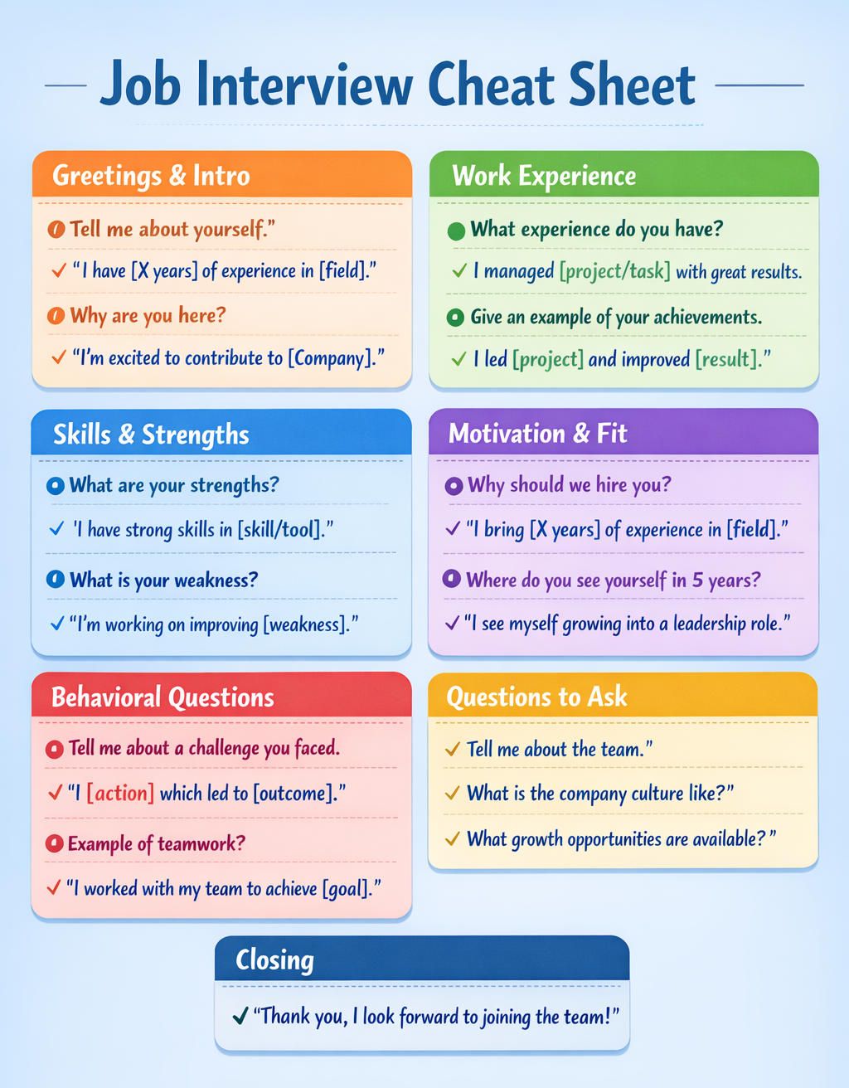

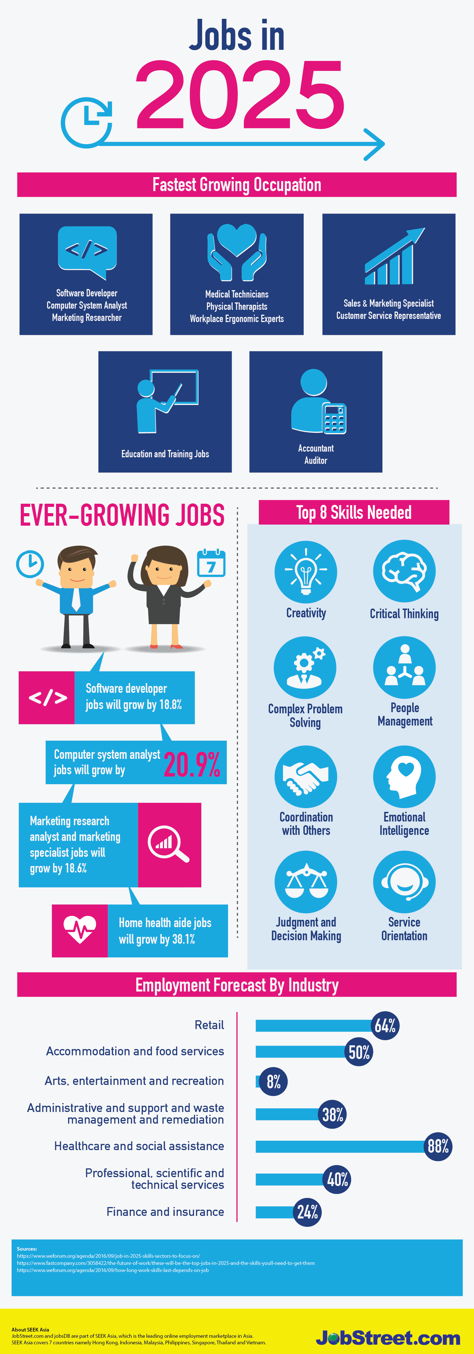
- Look at the infographic and describe the job market in 2025

- Grammar material. Look at the grammar bank, what is the usage of Present Perfect Continuous
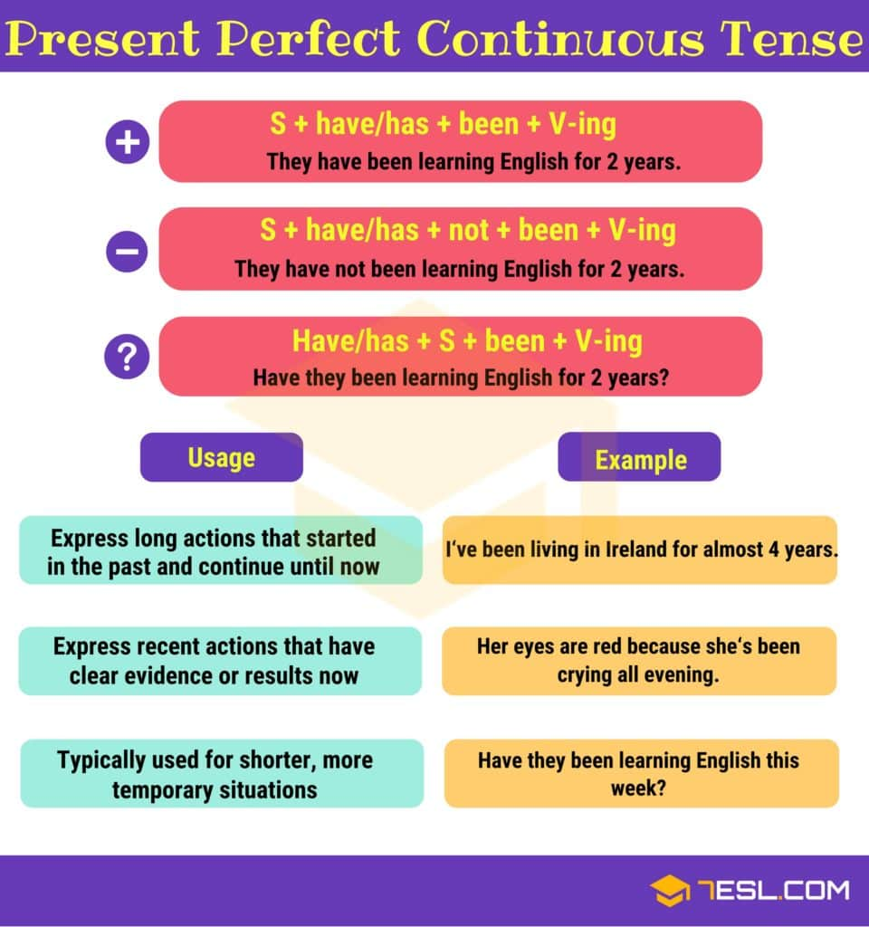
- Complete the sentences using Present Perfect Continuous Positive Form
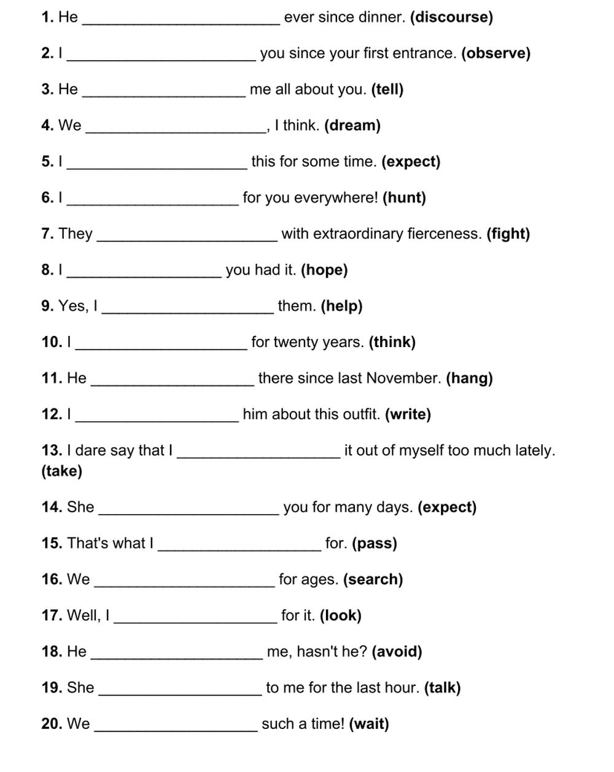
- Grammar material. Look at the grammar bank, what signal words do you use for Present Perfect Continuous.

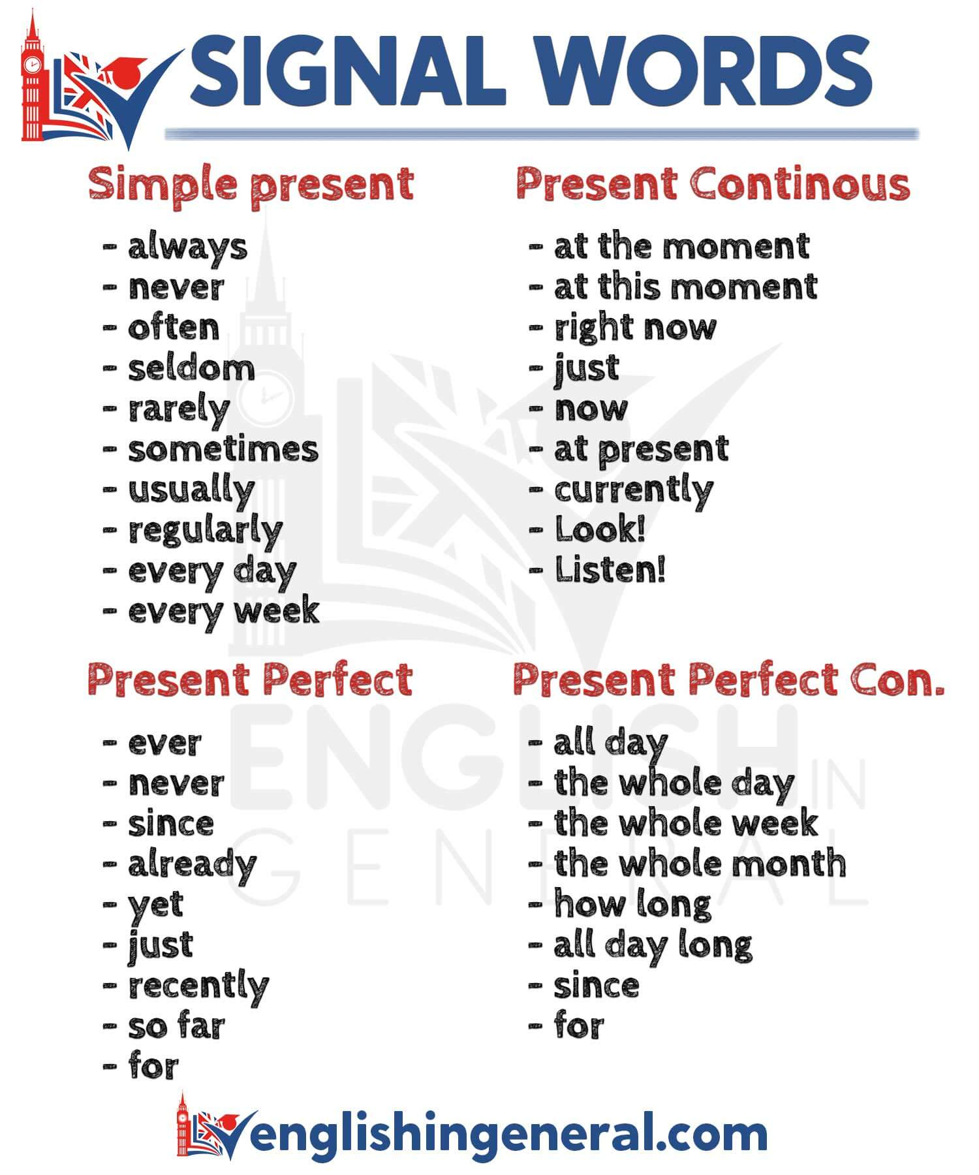
- Make up 5 sentences using Present Perfect Continuous and the listed signal words.

