Змістовий модуль 2. TRAVEL
Завдання
- Підручник ст 16: Cotton, D., Falvey, D., & Kent, S. (2014). Language Leader: Intermediate. Pearson Education.
- Робочий зошит (Workbook) ст. 11: Cotton, D., Falvey, D., & Kent, S. (2014). Language Leader: Intermediate workbook. Pearson Education.
- Design Your Dream Trip
- Imagine you can travel anywhere in the world.
- Write a short itinerary for 3–5 days: where you go, what you see, what you eat.
- Use phrases like I would like to…, I want to see…, I will visit….

- Робочий зошит (Workbook) ст. 13: Cotton, D., Falvey, D., & Kent, S. (2014). Language Leader: Intermediate workbook. Pearson Education.
- Travel Poster or Brochure . Look at the Brochure and tell about this trip.

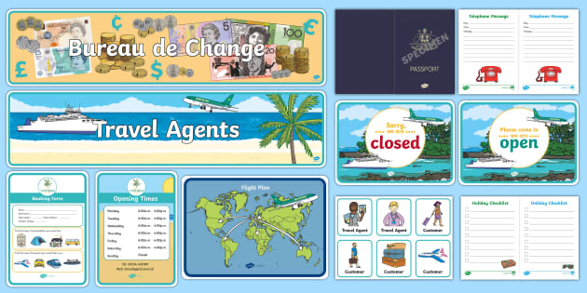

- Create a poster or mini-brochure for a country or city. Include: sights, local food, interesting facts, and a slogan. Present it to the class using descriptive language.
- Робочий зошит (Workbook) ст. 14: Cotton, D., Falvey, D., & Kent, S. (2014). Language Leader: Intermediate workbook. Pearson Education.

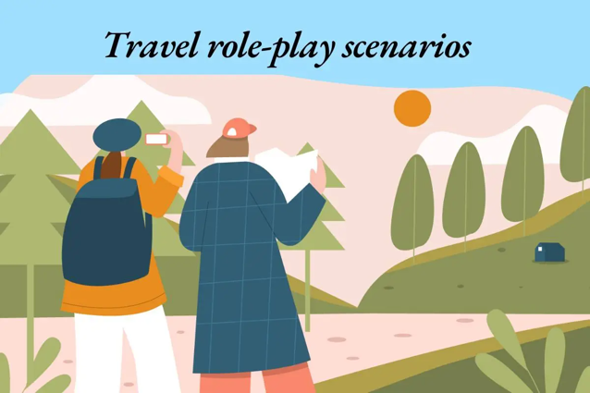
- Travel Role-Play
- Work in pairs: one student is a tourist, the other is a travel agent.
- The tourist asks about destinations, tickets, and hotels.
- Use questions and Present Simple/Continuous: Where can I go? What are people doing there?
Use General Travel Vocabulary below

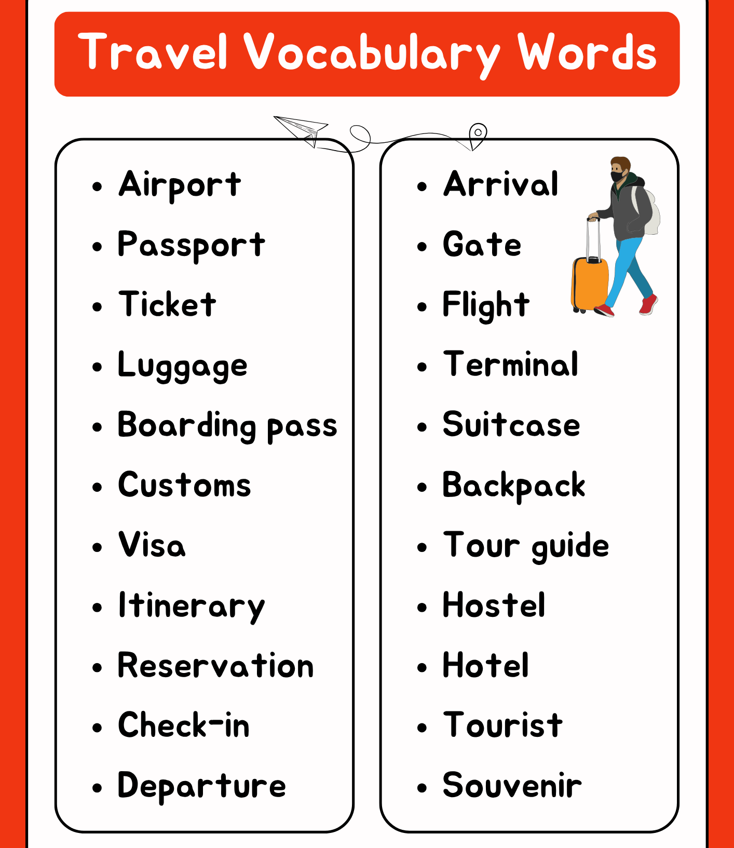

- Grammar material.
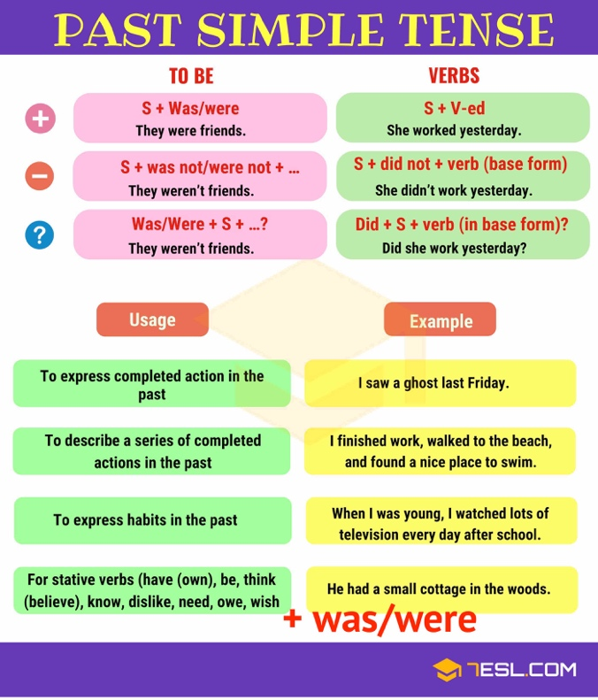
- Fill in the gaps with the right form of the verbs in brackets.
- Make negative for sentences - 3, 7, 16, 20
- Make questions for sentences - 1, 6, 8. 13, 22
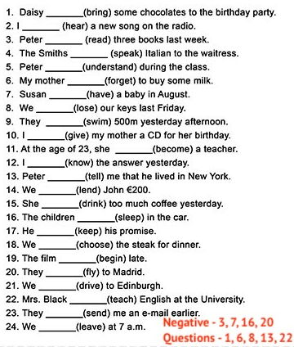
- Підручник ст 20: Cotton, D., Falvey, D., & Kent, S. (2014). Language Leader: Intermediate. Pearson Education.

- Follow the given link and find the ansqers to the questions:
- Who was Wilfred Thesiger and when did he live?
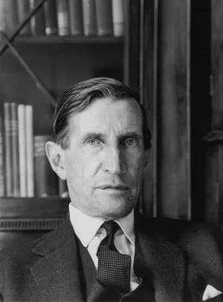
- What places did he explore, and why were they significant?
- What challenges did he face during his travels?
- How did he document his journeys (books, photographs, films)?
- What is his legacy in the field of exploration and travel writing?
- Which of his adventures do you find most interesting, and why?

https://www.britannica.com/biography/Wilfred- Thesiger

