Змістовий модуль 1. PERSONALITY.

Завдання
- Підручник ст 6: Cotton, D., Falvey, D., & Kent, S. (2014). Language Leader: Intermediate. Pearson Education.
- Робочий зошит (Workbook) ст. 6: Cotton, D., Falvey, D., & Kent, S. (2014). Language Leader: Intermediate workbook. Pearson Education.
- Choose a superhero and write a short description of their personality. Use active vocabulary to explain:
- Their strengths and abilities
- Their character traits (e.g., brave, clever, kind)
- How they help others or fight villains

Завдання
- Підручник ст 6-7: Cotton, D., Falvey, D., & Kent, S. (2014). Language Leader: Intermediate. Pearson Education.
- Complete the sentences using the word bank: adventurous, ambitious, assertive, bossy, cautious, creative, energetic, likeable, moody, organised, quiet, reliable, sensible, sensitive, serious, sociable, talkative, thoughtful
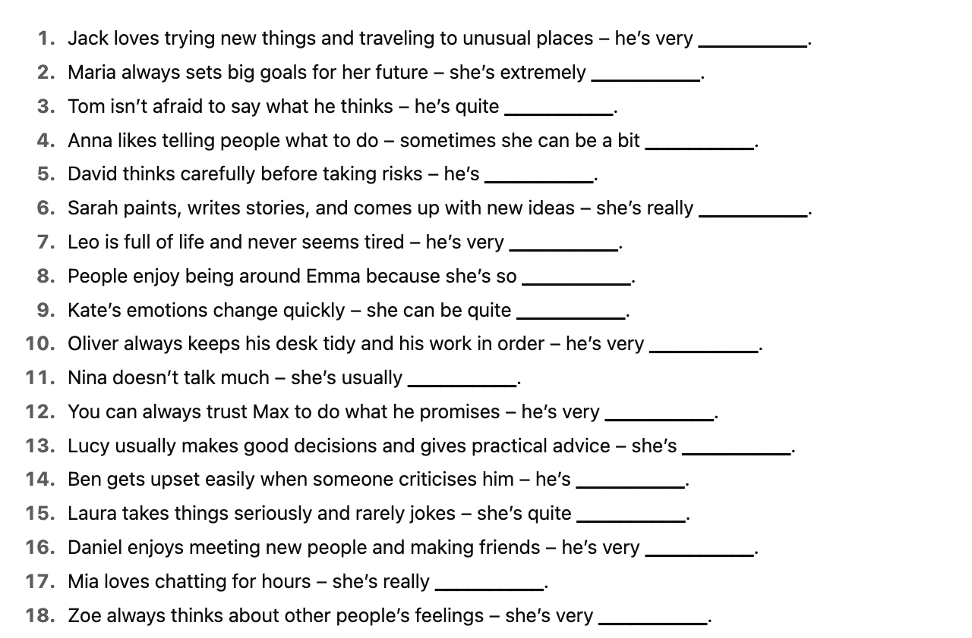

- Listen to the three people talking about themselves and about each other and complete the table.

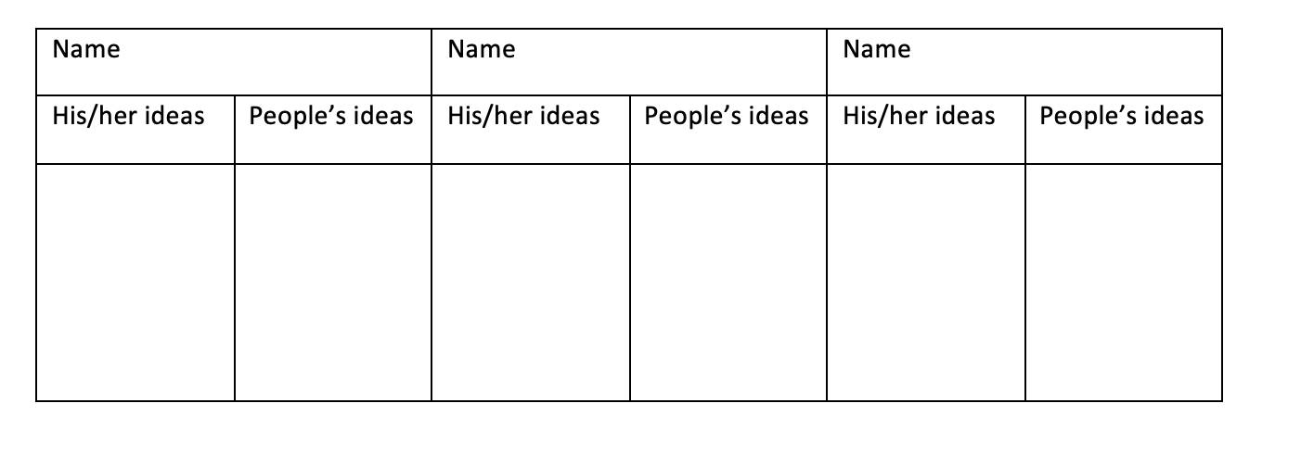

- Підручник ст 8-9: Cotton, D., Falvey, D., & Kent, S. (2014). Language Leader: Intermediate. Pearson Education.
- Grammar material. Look at the grammar bank. Describe your daily routine.

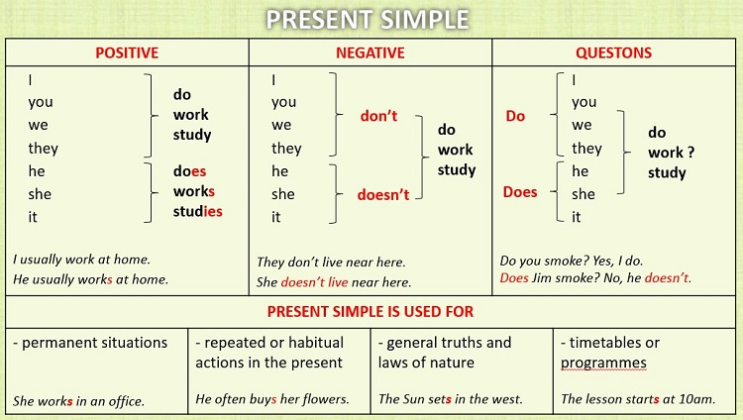

- Grammar material. Look at the grammar bank. Make up 6 sentences for every “usage”.

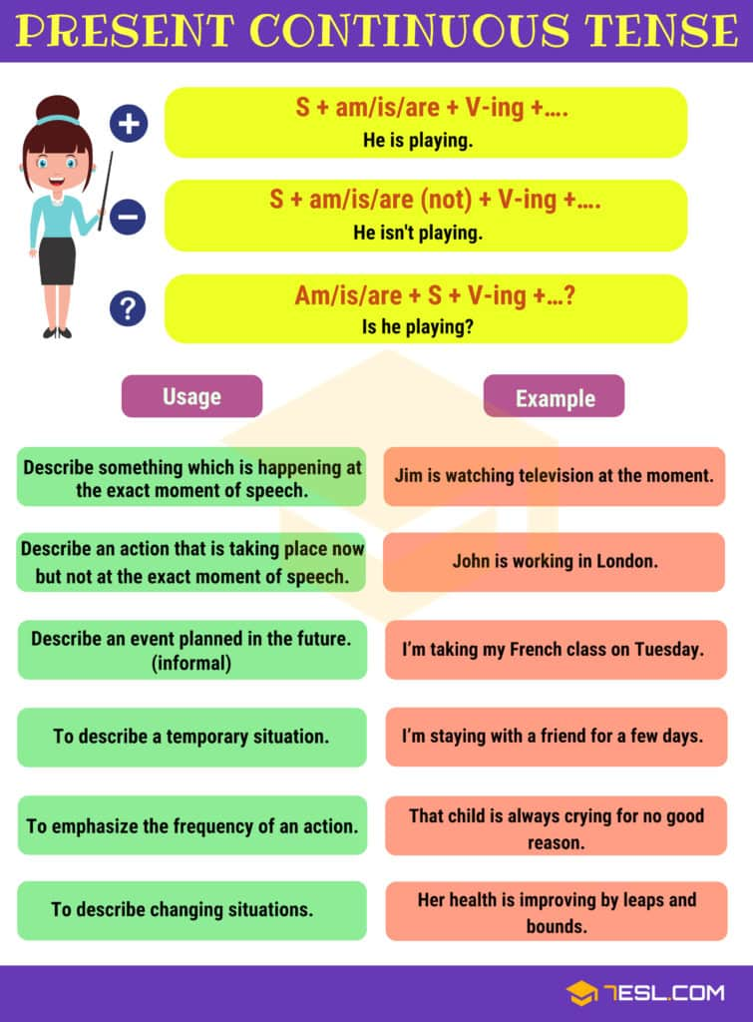
- Choose the correct verb form
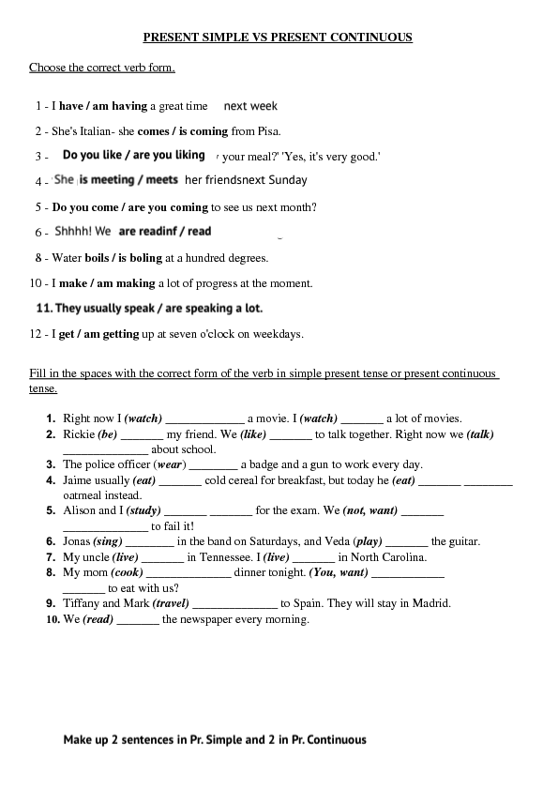
- Fill in the spaces with the correct form of the verb in simple present tense or present continuous tense.
- Підручник ст 11: Cotton, D., Falvey, D., & Kent, S. (2014). Language Leader: Intermediate. Pearson Education.
- Підручник ст 13: Cotton, D., Falvey, D., & Kent, S. (2014). Language Leader: Intermediate. Pearson Education.

