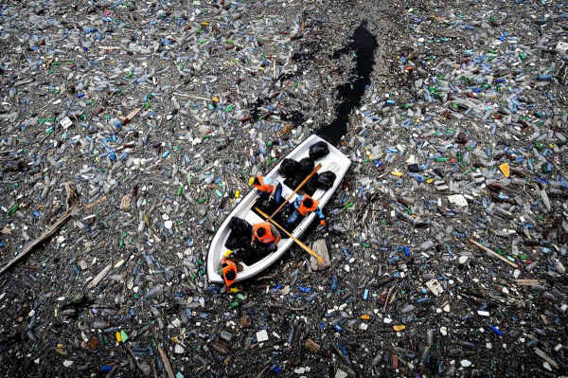
Strange Holiday Resorts
Match the given images with the corresponding descriptions and be prepared to discuss with your partners which of these resorts you would like to visit and why. Look up the bold printed words in a dictionary if you don’t know them.

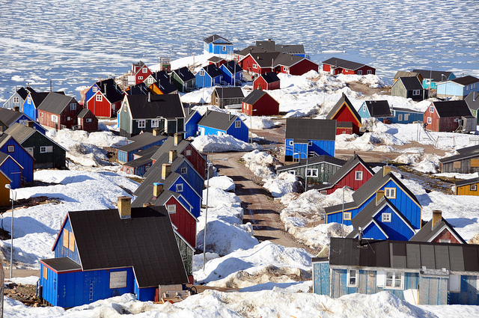
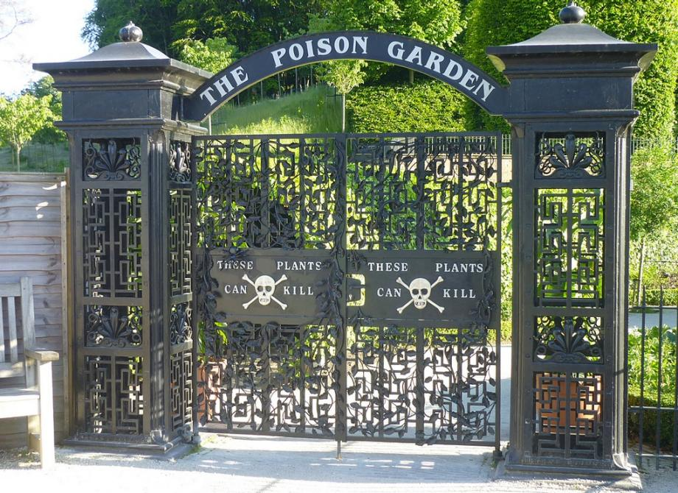

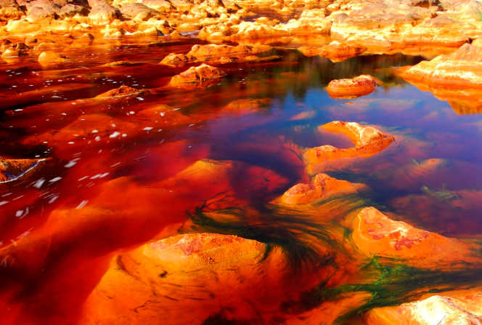

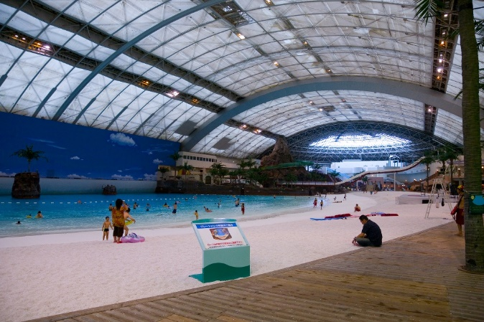
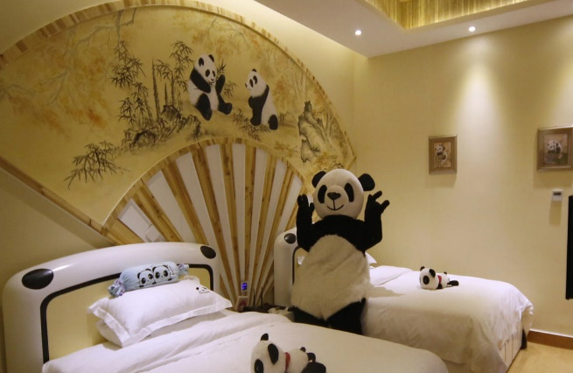

Panda lovers of the world now have another place to call home (for a few nights, at least). In 2013, the Panda Inn, a panda-themed hotel in China's Sichuan province, opened its doors to guests. The 32-room hotel is decorated with panda art, panda furniture and panda-shaped stuffed animals. Even staff members dress in panda suits.
[Panda Inn, Sichuan, China]

Welcome to Ittoqqortoormiit, Greenland. Here you can live with the Inuit and incredible wildlife that surrounds Igloo Village. Dog sledding, traveling to frozen fjords, visiting deserted villages, and sleeping in an icy cave are just a few of the things you can do at this cold weather destination. Hopefully the local bears won’t realize you’re a tourist and eat you out of spite. [Igloo Village]

Rio Tinto, or Red River as it translates, is a river in Andalucía famed for its coloured water. The unusual river is one of the places on Earth that most closely resembles the surface of Mars. The site along the river is full of copper, silver, gold, iron and has been heavily mined since ancient times. The river's water is dense due to the metals it carries and it has low oxygen content. [Rio Tinto, Spain]

Some people are skipping their cruise to the Caribbean and opting to sail to a Texas-sized patch of floating trash in the Pacific Ocean instead. For about $10,000 per person, you can head to the Great Pacific Garbage Patch — famous for it’s high concentrations of plastic waste, chemical sludge, and debris trapped by the currents of the North Pacific Gyre (a swirling pattern of oceanic currents). Vacationers help operate a trawl that collects microscopic plastic particles that threaten local wildlife and haul bigger heaps of junk offshore. [Great Pacific Garbage Patch]
The world’s only indoor beach was located in Miyazaki, Japan. It shut down in 2007, but during its 14-year run the Ocean Dome saw up to 1.25 million visitors per year. The Dome featured a fake volcano, fake sand, fake fish and fauna, a steady 86 degrees Fahrenheit, and water park rides. The vast man-made beach measured around 984 feet long and had a retractable roof that sported a permanent blue sky. [Seagaia Ocean Dome]

Alnwick is home to about 100 killer plants like Atropa belladonna (deadly nightshade), Strychnos nux-vomica (strychnine), and Conium maculatum (hemlock). The garden has a license to grow things like cannabis, which is kept behind bars in a giant cage. Another attraction Alnwick is popular for is the castle on the same grounds that was a stand-in for Hogwarts in several of the Harry Potter films. [Alnwick Poison Garden]
Texts taken from the following websites in shortened/abridged/changed form:
http://flavorwire.com/293413/10-of-the-most-bizarre-vacation-destinations/9
http://www.latimes.com/travel/deals/la-tr-oddspots-pg-photogallery.html
http://travel.aol.co.uk/photos/weird-travel-destinations/98764/?ref=20556222

