Collocations: do, play or go with sports and other activities
In British English, you can "do sport". In American English you can "play sports".
A typical mistake Spanish speakers make is using the verb practise for sports:
*I love practising sport. This should be: I love sport.
*I usually practise sport every evening. This should be: I usually do sport every evening.
However, in American English you can use the verb practise or practice (as it is spelt there) to mean "to train": The team is practicing for tomorrow's competition.

When other words related to sports are used, we may use other verbs:
"What sports do you do?"
"I play tennis".
Observe these pictures:
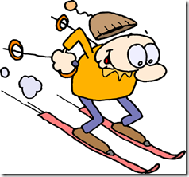 | 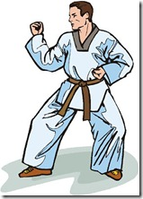 | 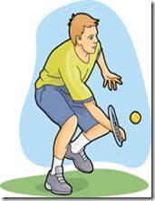
Go skiing | Do karate | Play tennis
There are three verbs that collocate with sports and other free time activities: go, do and play, but they are not interchangeable:
- Go is used with activities and sports that end in -ing. The verb go here implies that we go somewhere to practice this sport: go swimming.
- Do is used with recreational activities and with individual, non-team sports or sports in which a ball is not used, like martial arts, for example: do a crossword puzzle, do athletics, do karate.
- Play is generally used with team sports and those sports that need a ball or similar object (puck, disc, shuttlecock...). Also, those activities in which two people or teams compete against each other: play football, play poker, play chess.
In this table there is a list of sports and activities that collocate with these verbs:
Go | Do | Play
riding | aerobics | badminton
jogging | gymnastics | table-tennis
hitch-hiking | taekwondo | football
fishing | judo | basketball
sailing | karate | chess
windsurfing | kung-fu | cricket
skiing | ballet | board games
snowboarding | exercise | snooker
swimming | yoga | hockey
dancing | athletics | baseball
skating | archery | rugby
cycling | a crossword puzzle | volleyball
running | tai chi | squash

Some exceptions to the rules:
- You use do with three activities that end in -ing: do boxing, do body-building and do weight-lifting because they don't imply moving along as the other activities ending in -ing.
- Golf: if there is an idea of competition, you use the verb play. However, you can say go golfing if you do it for pleasure: Tiger Woods plays golf. We'll go golfing at the weekend.

