S
urveys show that kids are addicted to their smart phones and other mobile devices. So if it seems as if teenagers are spending a lot of time connected to their screens, that’s because they are. About a quarter of their day to be exact.
The average teen between 13 and 18 spends about nine hours a day consuming media – and that is outside of their school and homework. Kids aged 8 to 12, or tweens, are spending about six hours in front of the screens. They are watching shows, playing games, connecting on social media and listening to music – sometimes all at the same time.
Multitasking is the new normal when it comes to homework time. Most teens listen to music while doing their homework, but many also watch TV (51%) and text (60%). Being asked teenagers say they don’t think it is a problem and don’t believe it has any impact on the quality of their work. However, there is evidence that suggests multitasking

makes it harder to retain information and that you might perform more poorly on the tasks you are doing.
Another fact surveys find is that it seems kids spend more time consuming media than connecting with their parents and even their teachers.
Task:
Go to kortlink.dk/mk4g or scan this qr-code:

Watch the video you find in this article and answer the questions below:
1. What role do mobile devices play in families? And in family conflicts?
2. What have the kids decided not to spend time on anymore in their lives?
3. What is the Teen Technology Trap?
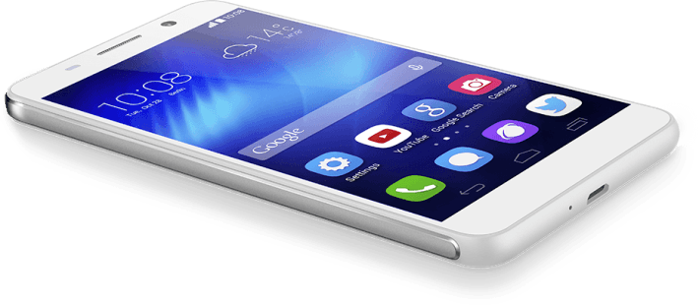
4. What can parents do in order to deal with the Tech Trap?

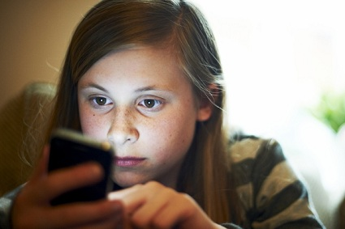

Social media & You
Now you have to do a little thinking about your personal use of social media:
1. What platforms do you use?
2. How much time do you spend on the platforms?
3. When do you first go online on a typical day?
4. When is the last time you go online on a typical day?
5. Do you have a lot of friends online?
6. Friends online, are they as good as real friends are? Why/why not?
7. Imagine this picture was posted on Instagram. Write a message for this picture:
________________________________________________________________________________________________

