STAY INTERESTED, STAY MOTIVATED
- Discuss which of the topics you find interesting. With a partner, find three which you feel similar about.

art and culture | politics | celebrity lives | environment
healthy living | professional development | science and technology | travelling

2. Complete the gaps with the words provided.
a) stimulating/enthusiastic/rewarding
1) a technological innovation I’m …………………. about
2) a topic of conversation I find ………………….
3) a …………………. experience I’ve had
b) captures/inspires/sparks
1) something that …………………. my interest when I’m travelling
2) something that …………………. me to do my best work
3) a type of news story which always …………………. my attention
c) accomplishment/eager/inspiration
1) an …………………. I’m particularly proud of
2) a piece of art that is a great source of ………………….
3) something I’m …………………. to do when I retire

3. Discuss what you might learn in each of the English lessons below and say how enthusiastic you would be to have them. Which topic captured your attention most?
• Do you feel FOMO? Phrasal verbs with ‘out’
• Decision time (business case study)
• Curious questions about curiosity
• The city of the future is here
• The story of Frida Kahlo (advanced tense review)
• It’s so hot right now!

4. Finish the sentences so that they are true for you. Compare with a partner.
a) What inspires me to get up in the morning is…
b) The most rewarding things about my job are…
c) When I’m not very enthusiastic about a task I need to do, I…
d) In an English lesson, I’m always eager to…
e) My biggest accomplishment in terms of studying English is…

5. Watch a video https://youtu.be/eNqJYIns4Rk about motivation and discuss the questions.
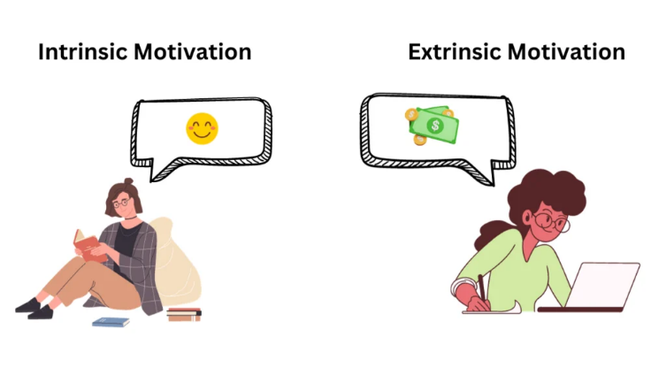
• What is the difference between extrinsic and intrinsic motivation?
• Is your motivation for learning English intrinsic or extrinsic? Why? Was it the same in the past?
• Is your motivation in other areas of life, e.g. work, intrinsic or extrinsic? Why do you think so?
• Which motivation helps you accomplish more, intrinsic or extrinsic? Why?
• Which motivates you more, success or failure? Give examples.

6. Use the words to create questions.
EXAMPLE: how long / you / learn / English /?
How long have you been learning English?
a) you / use / be / more enthusiastic about / learn / than you are now /?
…………………………………………………………………………………………..
b) how often / you / ask / meet deadlines /?
…………………………………………………………………………………………..
c) why / you / decide / take up / this course /?
…………………………………………
d) you / consider / take / a two-year English course / get a better job /?
…………………………………………
e) when / you / find yourself stuck / do repetitive work, / how / you / motivate
yourself / continue /?
…………………………………………
f) if / you / have more free time / in the past, / you / spend it / study English /?
…………………………………………
g) what / inspire / you / choose / the profession you have /?
…………………………………………………………………………………………..
h) what language other than English / you / recommend / study /?
…………………………………………………………………………………………..
i) if / you / have to / quit a bad habit, / how / you / start /?
…………………………………………………………………………………………..
j) what / the things / you / wish / you / be good at /?
…………………………………………………………………………………………..
k) what / discourage / you / pursue / your goals /?
…………………………………………………………………………………………..
l) you / ever / try / motivate / someone else / do something /?
………………………………………………………………………………………..

Синдром втрачених можливостей або FOMO (Fear of missing out) — це нав'язливе відчуття, що інші люди успішніші за вас, більше встигають і живуть краще життя. Під впливом таких думок ви можете почати хапатися одночасно за багато справ, боячись щось пропустити в житті. Як результат — швидке виснаження та апатія.

