DEMO

materials taken from Roadmap B2 p. 116-117

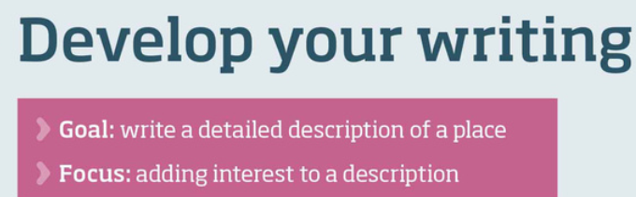

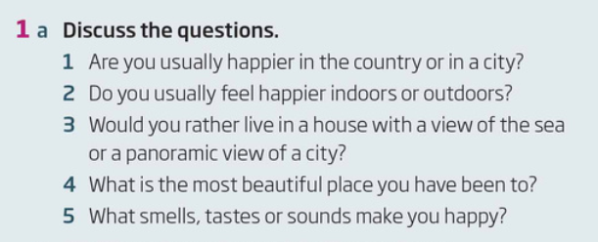

|  |
| --- |

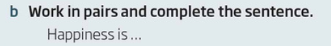

|  |
| --- |

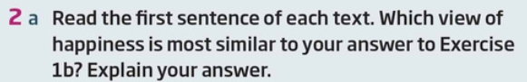

|  |
| --- |

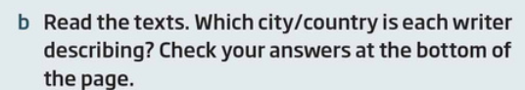

|  |
| --- |



|  |
| --- |

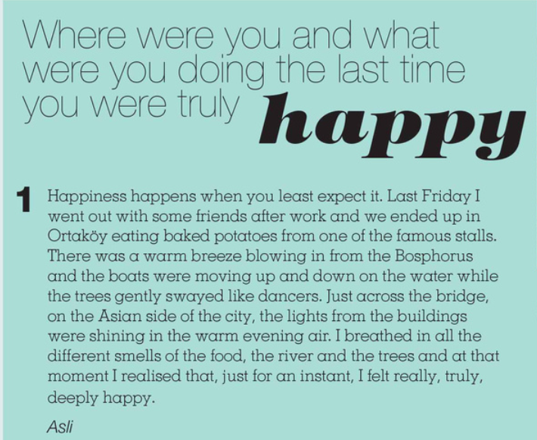

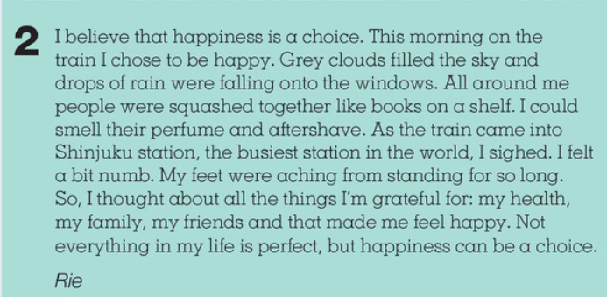

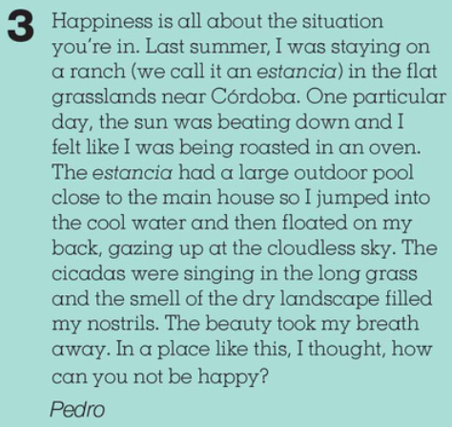

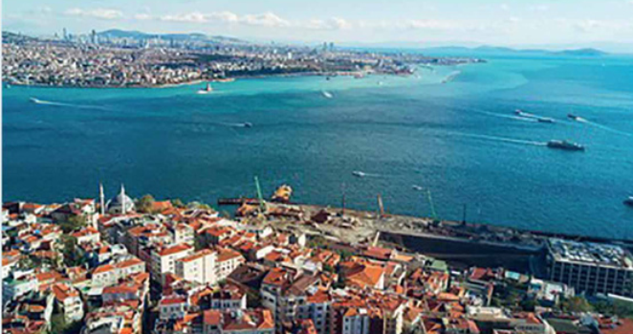

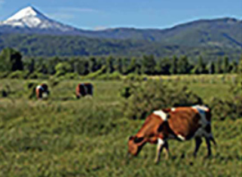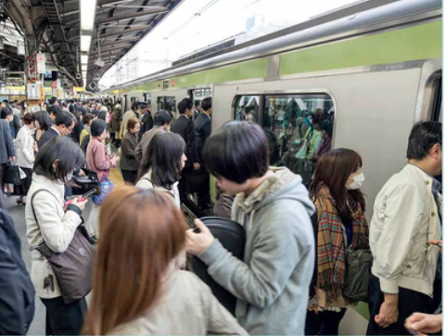



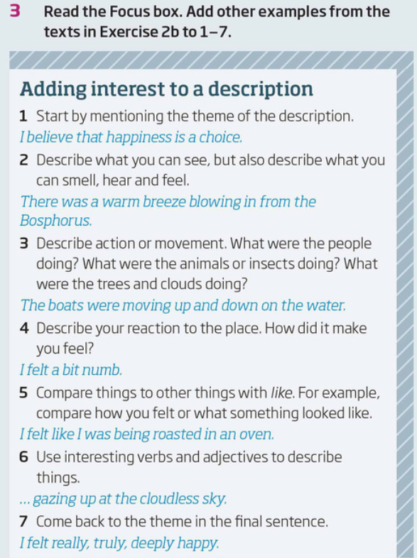

|  |
| --- |

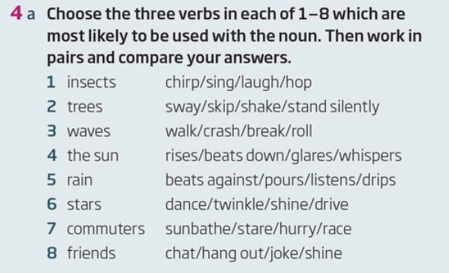

|  |  |  |
| --- | --- | --- |

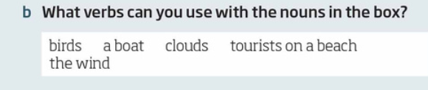

|  |
| --- |

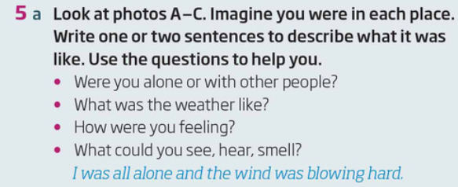

|  |
| --- |
|  |

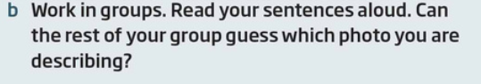

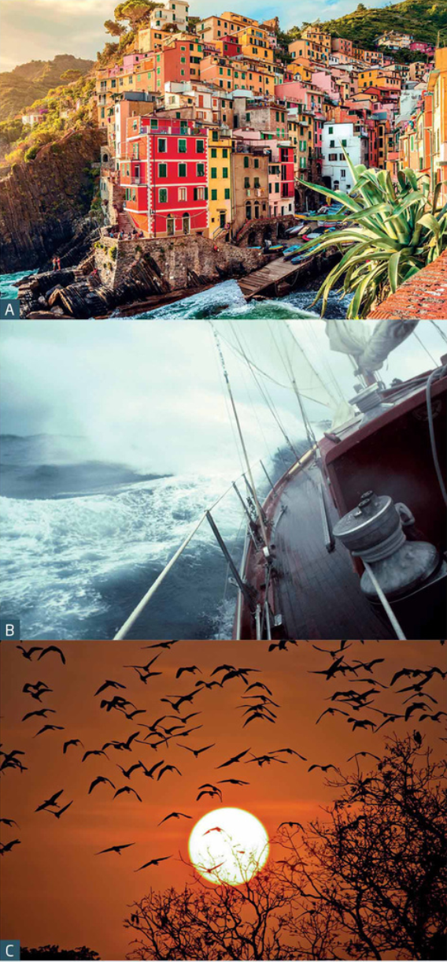

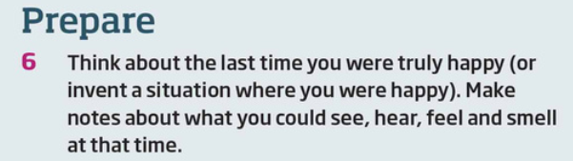

|  |
| --- |

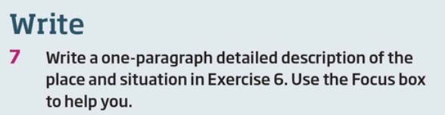

|  |
| --- |

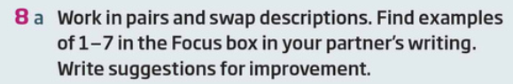

|  |
| --- |



|  |
| --- |

Extra writing tasks:

Plan a detailed two-week dream vacation.