**JOB ADVERTS**

**PREPARATION: Match the words with the definitions.**

|  |  |
| --- | --- |
| ***cash***  ***a trainee***  ***chatty***  ***valuable***  ***a career***  ***skilled*** | talkative  an informal word for money  having a special ability or training  a person’s chosen job and life’s work  very useful or important  a person who is being trained to do a job |

**Do you need some cash? Are you looking for work? Well, look at these job adverts and do the exercises to improve your reading skills.**

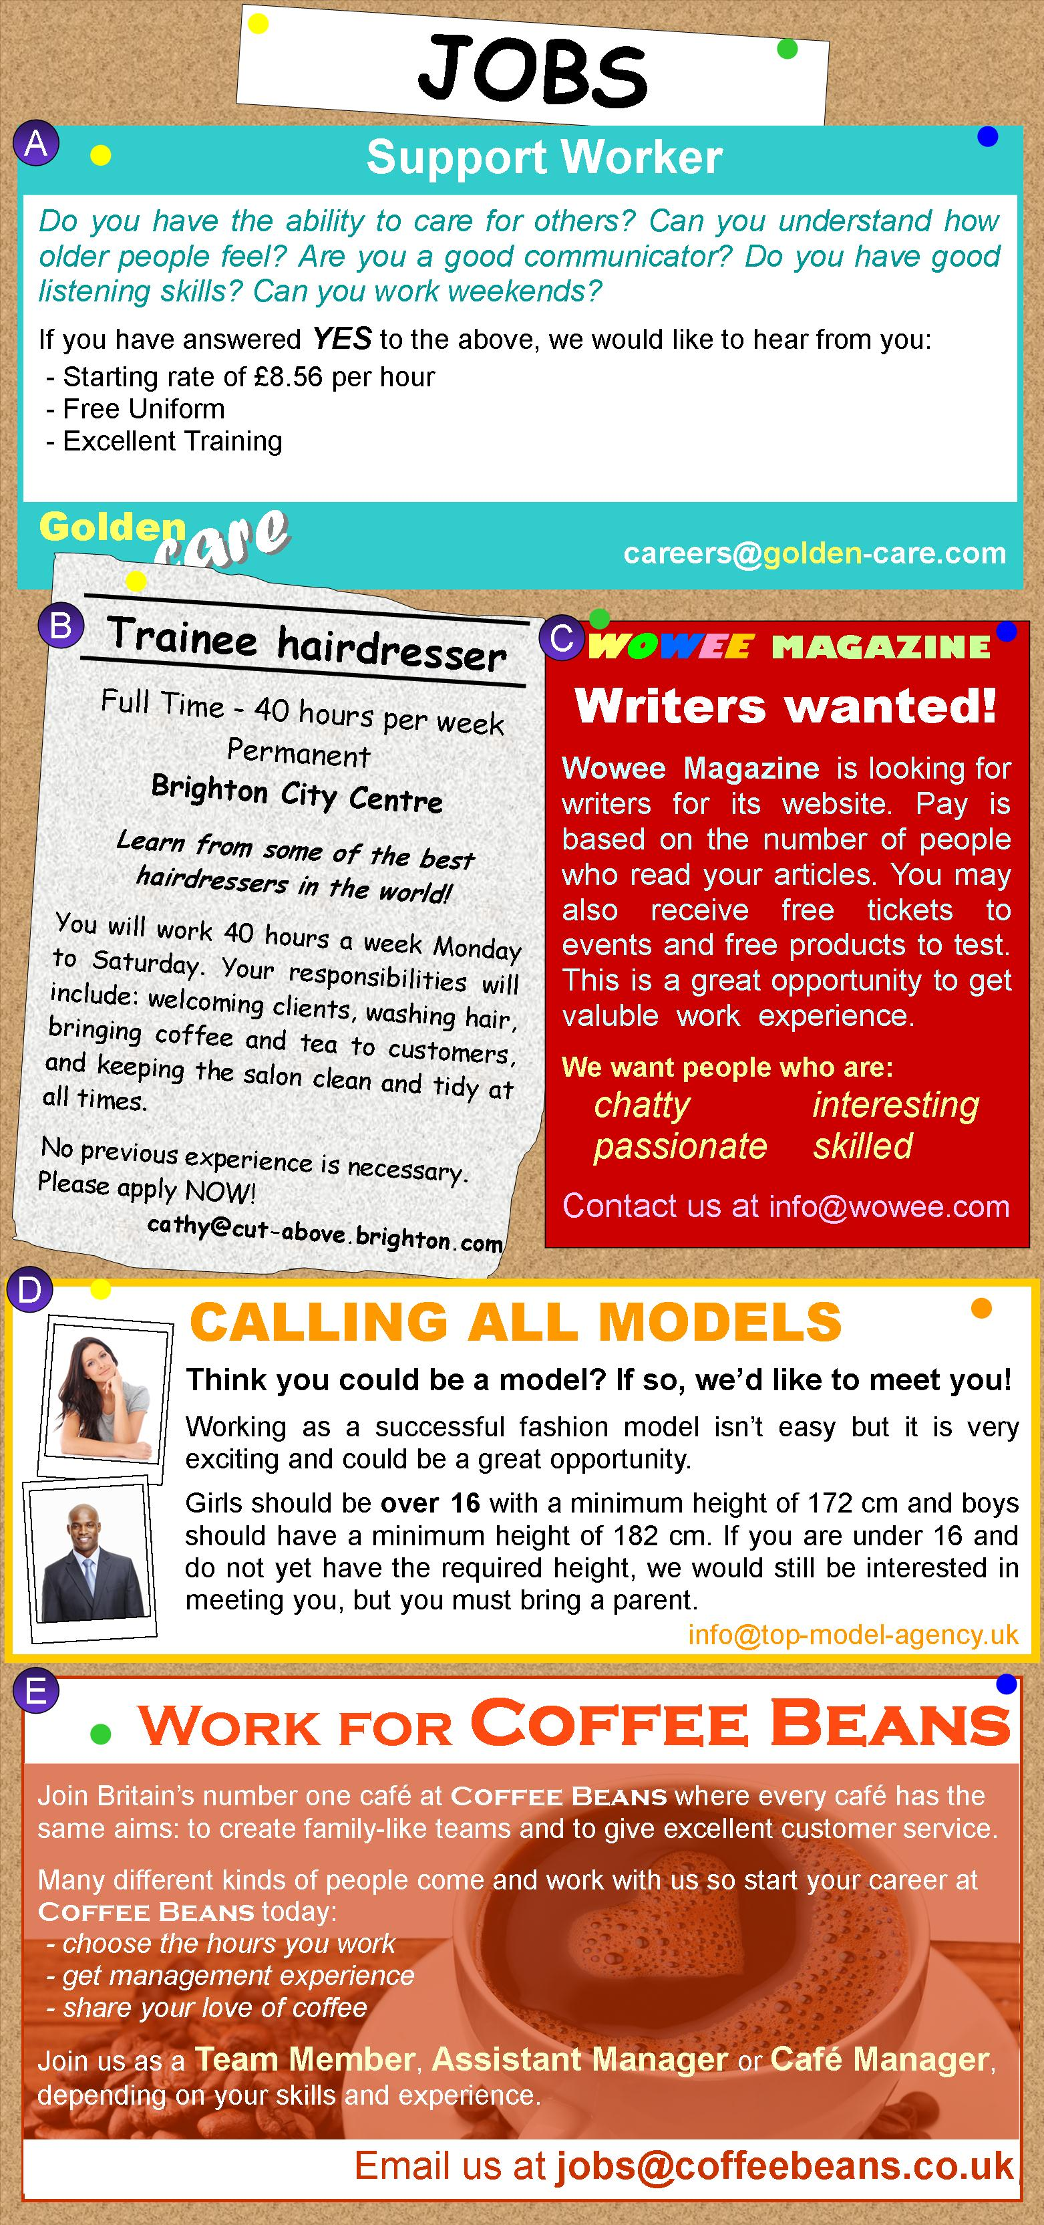

**Check your understanding: Which job would be best for each person?**

|  |  |
| --- | --- |
|  | **RECOMMENDED JOB** |
| Nina is studying English and has her own blog. She is a very sociable person, and is interested in music and fashion. | **A: SUPPORT WORKER** |
| Dave has just finished school and is looking for a full-time job. He is sociable, likes working with his hands and cares about his appearance. | **B: TRAINEE HAIRDRESSER** |
| Dewei enjoys helping people. He wants to make a difference to other people's lives. He is looking for opportunities to learn new things that will help him in his career. | **C: WOWEE MAGAZINE WRITER** |
| Sarah is a student and she is looking for flexible, part-time work. She doesn't want to work in a restaurant or shop. She is tall, beautiful and has her own unique look. | **D: MODEL** |
| Sam is friendly and sociable. He has experience working in a restaurant and wants a job with more responsibility. He is studying part-time so he needs flexible working hours. | **E: *COFFEE BEANS* CAFÉ WORKER** |

**Check your understanding: gap fill**

**Fill the gaps with the correct letter: E, A, E, C, B, C, D, A.**

1. You never have to wear your own clothes for job __.

2. Job ___ offers possibilities for children under 16 years old.

3. Your pay for job ___ depends on how successful you are at the job.

4. Job ___ requires physical contact with customers.

5. Job ___ offers management opportunities.

6. You might get some 'freebies' if you do job ___.

7. You need to work closely with your team for job ___.

8. Job ___ is for someone who likes working with older people.

**Discussion Do you have a part-time job? Which of these jobs would you most like to do? Explain your choice.**

**Create your own job advertisement.**