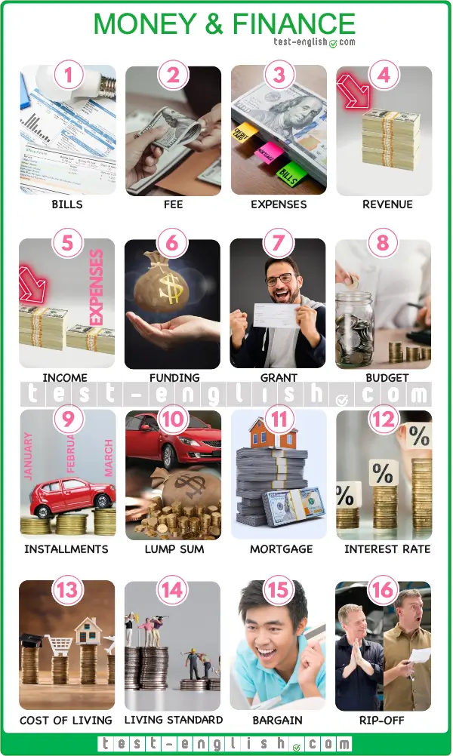

A 1 **bill** is a printed statement showing the money you owe for services, goods, or utilities, and a 2 **fee** is a fixed price you pay a person or organization for their services.

* *Our electricity* ***bill*** *was higher than usual last month.*
* *The lawyer’s* ***fee*** *was much higher than I’d expected it to be.*

3 **Expenses** are the money that a person or company has to pay for goods or services, such as food and bills.

* *I generally use cash to pay for my day-to-day* ***expenses****.*

4 **Revenue** is the total amount of money made by an organization’s operations over a given period, and 5 **income** is the money that remains from the revenue after all the taxes and expenses have been deducted.

* *The company’s* ***revenue*** *came to over $20,000,000 last year.*
* *Their* ***income*** *more than doubled in less than a year.*

6 **Funding** is money given to finance a specific project or purpose, which can come from various sources like governments, organizations, or investors. A 7 **grant** is a type of funding that is typically given by a government or organization for a specific purpose, such as education and does not need to be repaid.

* *I received a* ***grant*** *from the government to study for my postgraduate degree.*
* *We received* ***funding*** *from the government to carry out our research.*

Your 8 **budget** is the amount of money that you have available to spend.

* *The project went over* ***budget*** *and required additional funding.*
* *Our monthly household* ***budget*** *includes expenses for groceries, utilities, and rent.*

An 9 **installment** is one of a number of payments of a fixed amount paid for goods or services over a specific period of time, whereas a 10 **lump sum** is a single payment that is made at a given time instead of paying in installments.

* *I decided to pay for it in* ***installments*** *over a twelve-month period.*
* *You save a bit more money by paying the* ***lump sum****.*

A 11 **mortgage** is a particular kind of loan specifically for purchasing property, such as a house or apartment. The 12 **interest rate** is the percentage charged by the lender for the loan, which influences the total amount that will be repaid over time.

* *We recently took out a* ***mortgage*** *to buy a flat in the center of town.*
* *The* ***interest rate*** *on our loan has risen by 2%.*

The 13 **cost of living** refers to the amount of money needed for basic necessities like housing, food, taxes, and healthcare. The 14 **standard of living**, on the other hand, is the general level of wealth and comfort of people in a specific society.

* *The* ***cost of living*** *has risen in the past year.*
* *We have a relatively high* ***standard of living*** *around here.*

A 15 **bargain** is an item offered for sale at a lower price than expected. A 16 **rip-off** is something that you buy that was too expensive for the quality you got.

* *I bought these heels for $10. What a* ***bargain****!*
* *$30 for a pizza is an absolute* ***rip-off****!*

**ADJECTIVES AND MODIFIERS**

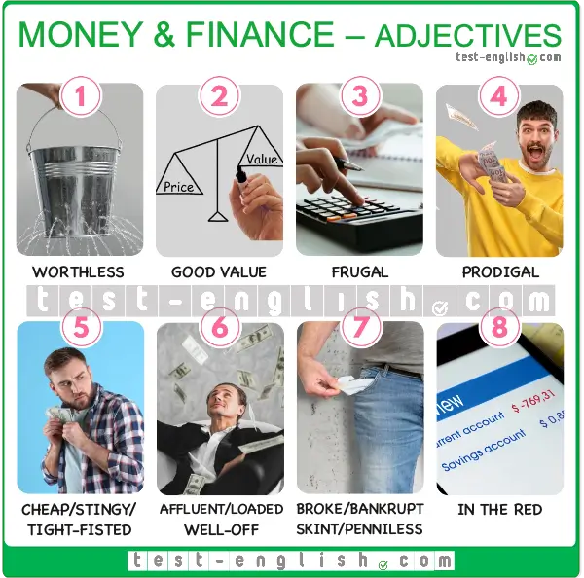

1 **Worthless** means without value, so something that is worthless is worth nothing. 2 **Good value**, on the other hand, means something is of good quality or abundant and therefore well worth the money you spend on it.

* *This is completely* ***worthless****; it’s rusty and doesn’t work.*
* *This vacuum was* ***good value****; it didn’t cost much and it’s an excellent brand.*

People who are 3 **frugal** are careful or economical with money and don’t overspend, and people who are 4 **prodigal** spend money carelessly on unnecessary things.

* *I’m trying to be more* ***frugal*** *and not buy anything I don’t need.*
* *Joe needs to be less* ***prodigal*** *and stop buying clothes he’s not going to wear.*

Someone who is 5 **cheap**, **stingy**, or **tight-fisted** is mean with their money and tries to spend as little as possible.

* *Tony was too* ***cheap*** *to buy his girlfriend a birthday present.*

6 **Affluent** and **well-off** are both adjectives that mean financially comfortable or wealthy. **Loaded** has a similar meaning, but is much stronger and means extremely rich.

* *You’d have to be quite* ***well-off*** *to afford a house in this neighbourhood.*
* *Peter has homes in four countries; he’s absolutely* ***loaded****!*

7 **Broke**, **skint**, **penniless**, and **bankrupt** are all ways of saying someone has no money. Being **bankrupt** is slightly more serious, however, as it means one is legally recognised as being unable to pay off their debts. If a person is 8 **in the red**, on the other hand, they have spent more money than was in their account and therefore owe money to the bank.

* *By the end of each month, I’m usually* ***broke****.*
* *After a year of poor sales, the company was declared* ***bankrupt****.*
* *After purchasing the sofa, my account was* ***in the red****.*

**VERBS, PHRASAL VERBS AND VERB PHRASES**

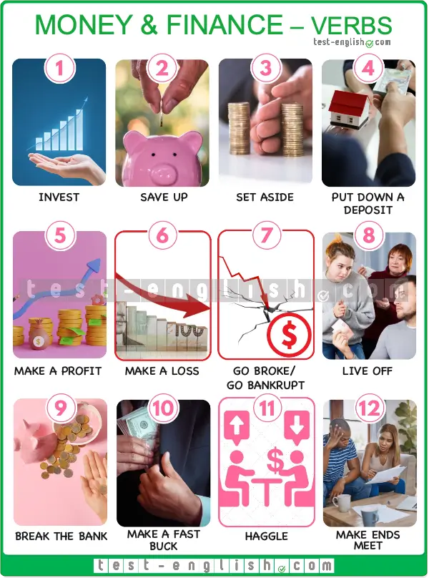

When you 1 **invest** money in something (e.g., shares, a financial scheme, or a business venture), you put money into it in the hope of making more money from it.

* *I* ***invested*** *several hundred euros in shares last month.*

When you 2 **save up** money, you accumulate it for a specific future purpose. 3 **Set aside** is similar to save up, and when you **set money aside**, you put money aside for a particular thing.

* *James is* ***saving up*** *for a new bicycle.*
* *I* ***set aside*** *money every month to pay for petrol.*

If you 4 **put down a deposit**, you make an initial basic payment for something, such as a house or a course, with the intention of paying the rest later or in installments.

* *We recently* ***put down a deposit*** *on a cottage in Wales.*

If you 5 **make a profit**, you get more money than you invested in something. If you 6 **make a loss**, however, you make less money from it than you invested.

* *We* ***made quite a good profit*** *from our investment in those shares.*
* *Richard was annoyed when he realised that he’d* ***made a loss*** *from his investment.*

If you 7 **go broke**, you spend all your money and end up without any, and if you **go bankrupt**, you declare yourself broke in the eyes of the law.

* *At the rate I’m spending money, I’ll* ***go broke*** *by the end of the week!*
* *We were all shocked when we heard that the company had* ***gone bankrupt****.*

When you 8 **live off** another person, you depend on them financially.

* *He is 35 and still* ***lives off*** *his parents.*

If something 9 **breaks the bank**, you use all or most of your money to get it, so you don’t have any left.

* *Buying that engagement ring nearly* ***broke the bank****.*

A **buck** is a slang word for a dollar, and if you 10 **make a fast buck**, you make money quickly, and often unscrupulously, from something.

* *Sam tried to* ***make a fast buck*** *by investing in a financial scheme.*

If you 11 **haggle** with someone, you negotiate a lower price for something with a seller.

* *I* ***haggled*** *with the carpet vendor and managed to negotiate a lower price.*

When you 12 **make ends meet**, you earn just enough money to live and pay for your basic needs.

* *Now that I’ve gone part-time at work, I’m barely* ***making ends meet****.*