Part A • Grammar, Vocabulary and How to …
GRAMMAR
1 Choose the correct words to complete the sentences.
1 Cycling / Having cycled across town, I noticed how much traffic there was.
2 Speaking / Having spoken to your teacher, we’ve agreed that you need to work a bit harder this term.
3 Driven / Driving to work this morning, I saw a huge advertisement for that new film.
4 Finished / Having finished the first series, I decided not to watch the second one.
5 Working / Having worked from home, I don’t see many people during the day.
6 Completing / Having completed the report, I gave it to my manager so she should check it.
7 Looking / Looked through the magazine, I came across an interesting article about birds.
8 Knowing / Having known Yvonne for many years, I doubt she would have taken the money.
9 She opened / Opening the door and the children jumped out of the car.
10 Arriving / He arrived at the airport, he remembered that he’d left his passport at home.
/10

2 Complete the second version of the sentences using the words in brackets.
1 You don’t feel good about yourself because you don’t do enough exercise.
_______________ more exercise, you would feel better about yourself. (if)
2 I only found the place because you drew me a map.
_______________ me a map, I wouldn’t have found the place.(if)
3 If I finish work on time, I’ll be home for dinner.
I’ll be home for dinner _______________ work on time. (provided)
4 She’ll only lend you her phone if you look after it.
She’ll lend you her phone _______________ it. (as)
5 If we don’t pay them half of the money now, they won’t finish painting the house.
They won’t finish painting the house _______________ them half of the money now. (unless)
6 You can finish work early today if you agree to stay late tomorrow.
You can finish work early today _______________ to stay late tomorrow. (condition)
7 I would only go climbing if we had an instructor with us.
I’d go climbing _______________ an instructor with us. (so)
8 If you borrow my car, you must drive it carefully.
You can borrow my car _______________ it carefully. (on)
9 He’d have called by now if his phone hadn’t run out of charge.
He’d have called by now _______________ of charge. (unless)
10 If he had the right experience, Martin would give him the job.
Martin would give him the job _______________ the right experience. (so)
/10

VOCABULARY
3 Complete the sentences with the correct form of go, have and make.
1 I was doing really well so I don’t understand what __________ wrong.
2 Denis and Tom don’t seem to __________ much in common, do they?
3 I never __________ the opportunity to learn a language when I was younger.
4 Do you think this email __________ sense? I don’t want to confuse anyone.
5 I hope the meeting __________ according to plan tomorrow.
/5

4 Complete the sentences with words related to homes and living conditions.
1 Their new house is in excellent c _ _ _ _ _ _ _ n so they won’t need to do any work to it.
2 Hackney is a f _ _ _ _ _ _ _ _ _ e neighbourhood in East London where lots of young people want to live.
3 We stayed in an e _ _ _ _ _ t hotel in Paris with attractive furniture and architecture.
4 It’s a s _ _ _ _ _ _ s apartment so there’s plenty of room for a family.
5 Our house is so boring to look at. I’d prefer one with more c _ _ _ _ _ _ _ r.
/5

5 Choose the correct words to complete the sentences.
1 If people are living in justice / poverty, they may not have enough money for food.
2 Problems caused by civil rights / global warming will increase as the Earth gets hotter.
3 There are thousands of homelessness /
endangered languages which may disappear in the future.
4 The council plans to increase access to unemployment / housing by building hundreds of new homes.
5 Overcrowding / Literacy is a problem because there isn’t room for so many people.
/5
6 Match the sentence beginnings (1–5) with the endings (a–e).
1 I’m amazed how she got her life back
2 He didn’t get to where
3 He managed to get to
4 She never got her confidence
5 Angela helped me get

a the other side after his problems.
b out of a difficult situation.
c together so quickly.
d back after she lost her job.
e he is now by being mean.
/5

HOW TO …
7 Complete the sentences with the words and phrases in the box.
at the same time be sure of by saying
first point for instance good example
I can see in order to obvious impact
out of control
1 One thing we can __________ is that the amount of traffic in the city has decreased.
2 We have done several things to improve the park. __________, we have created an insect garden and a play area.
3 The council have fitted video cameras __________ catch people who drive too fast.
4 I’d like to start off __________ that I disagree completely with your plans.
5 As far as __________, you have done an excellent job.
6 Some people were disappointed with the result. __________, everyone seemed to enjoy the match.
7 The factory is due to close next year. The __________ of this will be on the people who work there.
8 The __________ I’d like to make is that the council needs to rethink its planning strategy.
9 Pollution levels seem to be __________ at the moment. They’re getting higher every day.
10 Access to education has improved over the years. A __________ of this is that more people go to university now.
/10

Total: /50

Part B • Listening, Reading and Writing
LISTENING
1 [Audio UT8.01] Listen to a talk about food banks. Number the topics (A–G) in the order they are mentioned.
1 ___
2 ___
3 ___
4 ___
5 ___
6 ___
7 ___
A How food banks spread across Britain
B The different ways food needs to be stored
C The main reasons people need to use food banks
D The different ways of getting food to clients
E Some difficulties faced in going to a food bank
F The main reasons for setting up a food bank
G A project to help people in another country
/7
2 [Audio UT8.01] Listen again. Complete the sentences with a word or short phrase.
1 According to evidence, __________ has not increased in recent years.
2 Many poor parents try to prevent their children being __________.
3 The Hendersons set up a food bank after working with young __________ people in Bulgaria.
4 The Hendersons organised a __________ of food banks across Britain.
5 Steven noticed that some people couldn’t pay for __________ to go to food banks.
6 Steven was allowed to keep food in space owned by a __________.
7 There are __________ people in Steven’s group who provide food to local families.
8 If you haven’t got a refrigerator, you can’t keep __________ for your food bank.
/8

READING
3 Read the article about housing problems in Barcelona. Tick the topics which are mentioned.
1 Holiday accommodation in Barcelona can be found online. ___
2 Housing problems in Barcelona have made people homeless. ___
3 Banks have agreed to lend money to people for affordable housing. ___
4 A new type of housing has been successfully introduced in Barcelona. ___
5 Some of Barcelona’s property will appear in a new horror film. ___
/5
Dealing with Barcelona’s housing problem
Like other major European cities, Barcelona has seen a large increase in the number of holiday apartments. Property is relatively expensive in Barcelona, but thanks to new apps and websites, anyone can turn their home into a holiday rental, allowing homeowners to make a bit of extra money. The problem is that some local residents are not so pleased about this situation. Some of them are fed up with crowds of tourists taking over the once quiet streets of their neighbourhoods. Others say that holiday rentals are taking valuable housing away from local people. People who have lived in Barcelona’s neighbourhoods for decades are now being forced out because they can’t afford to live there.

On top of that, Barcelona has a lack of affordable housing for people on low incomes. Only around half the population can afford to buy an apartment, or, if you’re one of the wealthier residents, a house. At the same time, the cost of renting is so high that many people end up sharing tiny apartments. It’s not uncommon to see entire families squeezed into a two-room apartment. To make matters worse, while social housing is available for people on low incomes, there’s much less than in other European cities like Vienna. As a result, the most unfortunate people may find themselves sleeping on the streets.

Around fifteen years ago, an organisation called Hàbitat3 set up a project to find a practical solution to Barcelona’s housing problem. At first, they tried to persuade some banks to allow people to use their disused properties. Although there were many empty properties in the city, the banks weren’t keen to make them available. As a result, Hàbitat3 decided to ask the owners of empty apartments to rent them to people on low incomes. As many of them were in poor condition, Hàbitat3 came up with an interesting proposal. They would improve the flats in exchange for cheaper rent. Many of the owners agreed and since then the project has helped thousands of people find apartments.

More recently, the local government has come up with another interesting solution to the problem. One of the issues with providing affordable housing is it can take a long time to build. For that reason, they decided to turn shipping containers into temporary housing. Apart from being much quicker to build, the big metal containers are recycled so they contribute to a more sustainable solution. Although they aren’t very spacious, the containers homes are stylish and modern. Despite some complaints about them being too hot in summer, the project has been a success and the government is due to build more container homes in the near future.

While the government has been responsible for a lot of affordable housing, another group of people has also been active. They are squatters, who are people who take over and use empty flats and houses, known as squats. There have been horror stories in the press about people returning from holidays to find their house has been occupied by squatters. However, there are also more positive stories of squatters taking over buildings that had been empty for decades. Apart from being used for housing, they are sometimes turned into social spaces. They’re popular with local residents because their vegetable gardens and workshops help build a sense of community.
4 Read the article again. Choose the correct answer (A, B, C or D).
1 What does the writer say about holiday apartments in the first paragraph?
A They are more expensive than in the past.
B They have upset some people from the city.
C They can be used for housing poor people.
D They are only found in the quiet neighbourhoods.

2 What problem does the writer mention in the second paragraph?
A Most people on low incomes are now homeless.
B The majority of people can’t afford to buy property.
C Social housing is not available to those on low incomes.
D Some people have to put up with a lack of living space.

3 According to the writer, how has Hàbitat3 helped people in Barcelona?
A By making an arrangement with homeowners.
B By persuading banks to share their properties.
C By showing them how to improve their apartments.
D By giving them money to pay for accommodation.

4 What does the writer say about shipping containers in the fourth paragraph?
A It can take a long time to turn them into apartments.
B It is unlikely that the government will use them again.
C They can be uncomfortable at certain times of year.
D They have more room than other accommodation.

5 What do we learn about people called squatters in the fifth paragraph?
A They are not always unpopular with local people.
B They take over buildings in order to rent them out.
C They have been active in the city for decades.
D They are supported by the local government.
/10

WRITING
5 Put the words in the correct order to make sentences.
1 interview / your / can / I / available / at / be / convenience / for
___________________________________________.
2 pleasure / would / you / meet / It / a / be / to
___________________________________________.
3 happy / require / I / be / information / any / would / provide / to / you / further
___________________________________________.
4 you / forward / look / from / to / hearing / I
___________________________________________.
5 positions / have / I / important / several / held
___________________________________________.
/5

6 Read the advert and write an application email.
Volunteer positions

Moving Forward

Moving Forward is a national organisation which connects volunteers with local community projects. We have helped thousands of people find the perfect voluntary job in their local community. Whatever your ability or experience, we would like to hear from you.
Please tell us about your:
- background
- abilities
- experience
- availability for interview

Send your application email to Federico Sampson.
Write your email in 140–190 words.
/15

Total: /50

Part C • Speaking
SPEAKING
1 Make questions and ask your partner.
1 What activity / would / have a go at / if / had the chance?
2 What / best way / make a difference / in the world?
3 What / most fashionable / part / of your town?
4 Would / prefer / live alone / or / other people?
5 If / could / solve / one problem in the world, / what / be?
/5

2 Answer your partner’s questions.
/5

3 Describe the picture to your partner. Why do you think community might be important to these people?
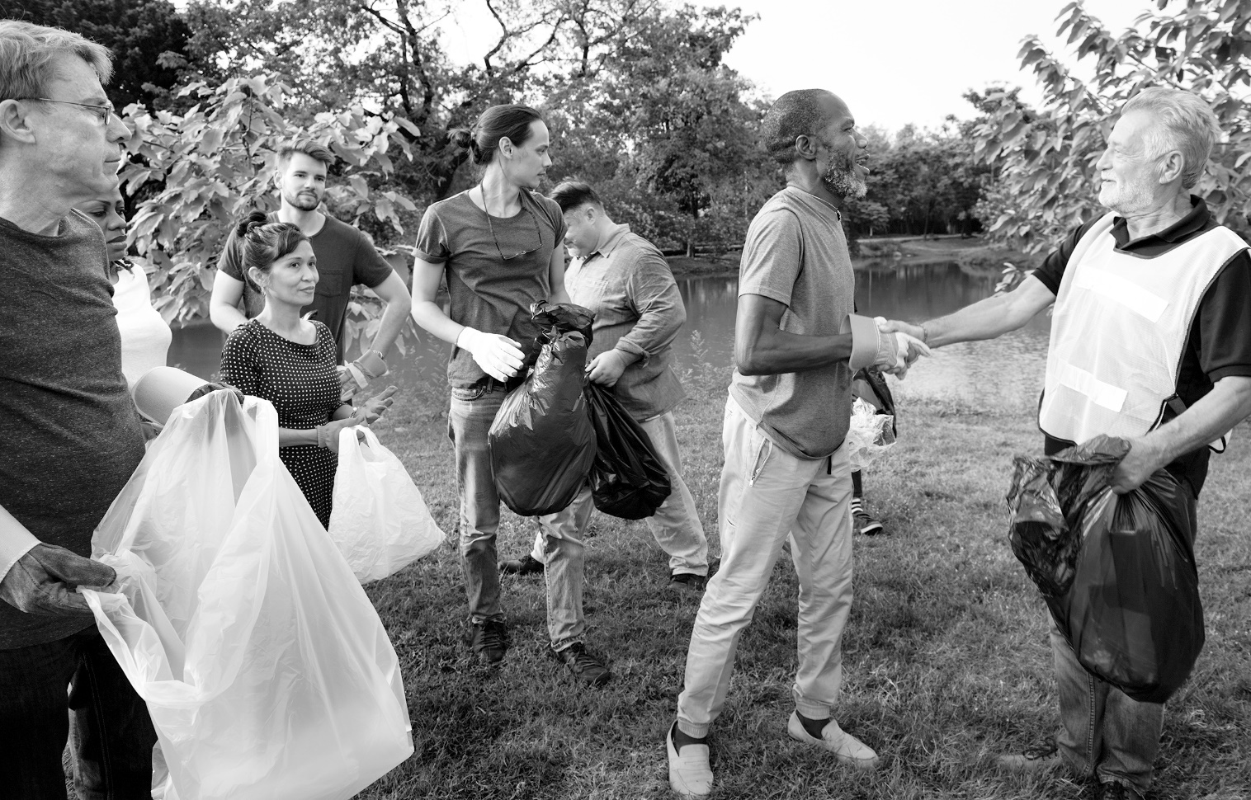
/10

Total: /20

