Part A • Grammar, Vocabulary and How to …
GRAMMAR
1 Complete the second version of the sentences using the modal verb in brackets.
1 I’m sure you didn’t see Iris at the beach because she was shopping with me.
You __________ Iris at the beach because she was shopping with me. (can’t)
2 It’s possible that I’ve met him before, but I don’t remember it.
I __________ him before, but I don’t remember it. (might)
3 I’m certain that they’ve gone to bed because the lights are off.
They __________ to bed because the lights are off. (must)
4 I’m sure she hasn’t been sleeping well lately because she always looks tired.
She __________ well lately because she always looks tired. (can’t)
5 I’m sure they were watching the TV. They never answer the phone when they’re watching a programme.
They __________ the TV. They never answer the phone when they’re watching a programme. (must)
6 I think the police have stopped those people for driving too fast.
Those people __________ for driving too fast. (must)
7 Maybe they took your wallet when you were getting on the underground.
They __________ your wallet when you were getting on the underground. (could)
/7

2 Choose the correct option (a, b or c).
1 I can’t understand this film. If only I ___ French!
a did speak b would speak c could speak
2 I wish I ___ from you more often. You hardly ever call.
a heard b would hear c hear
3 If only I ___ more people here. I’d be much happier.
a know b knew c known
4 I wish I ___ anything to Renata. I didn’t mean to upset her.
a didn’t say b hadn’t said c wouldn’t say
5 We should ___ earlier. It’s getting dark now.
a have left b had left c left
6 I wish you ___ make so much noise in the mornings!
a won’t b couldn’t c wouldn’t
7 I ___ used your computer without asking. I’m sorry.
a shouldn’t b shouldn’t have c should have
8 If only the children ___ what I say! They just ignore me.
a did b will do c would do
/8

3 Choose the correct words to complete the sentences.
1 However / On the one hand, I’d like to work less, but, on the other hand, I need the money.
2 I like my new boss, although / however she can be quite strict sometimes.
3 On the one hand / Though she wanted to go out, I wouldn’t let her until she finished her homework.
4 Tristan has never been any good at football. Although / On the other hand, he’s brilliant at tennis.
5 I can’t see you this afternoon. Although / However,
I am available tomorrow morning.
/5

VOCABULARY
4 Complete the sentences with words related to chance.
1 I saw him throw the milk on the floor. It wasn’t
a _ _ _ _ _ _ _ _ l.
2 I bumped into your brother b _ c _ _ _ _ e in the shopping mall.
3 It was u _ _ _ _ _ _ _ _ _ e that the restaurant was full.
4 The high temperatures were caused by a f _ _ _ k weather event.
5 His promotion was u _ _ _ _ _ _ _ _ d because he hadn’t been working very well.
6 We were f _ _ _ _ _ _ _ e enough to meet the president on one occasion.
7 I’d like you to take three cards at r _ _ _ _ m from the pack.
/7

5 Choose the correct words to complete the sentences.
1 His decision to sell all of his possessions was a
life-changing / thirty-year-old event for him.
2 We’ve got all-consuming / long-lasting light bulbs so we won’t need to change them for years.
3 Maria Callas was a second-hand / world-famous opera singer, who was much loved in the 20th century.
4 I love having children, but being a parent is
all-consuming / long-lasting. I don’t have any free time.
5 Are there any good second-hand / time-consuming shops around here? I’m looking for some old furniture.
6 I want to complete this game, but it’s twenty-year-old / time-consuming. I’ve spent days playing it.
7 He’s a long-lasting / widely respected historian so I tend to believe what he says.
/7

6 Complete the sentences with the phrases in the box.
back to the drawing board blessing in disguise cup of tea missed the boat piece of cake
the grass is always greener on the other side
1 You might think the job looks good now, but just remember that __________.
2 I thought it would be a __________, but it was harder than I expected.
3 I took so long thinking about their job offer that I __________. They offered it to someone else.
4 Some people like science fiction, but it’s not my __________. I prefer historical drama.
5 I don’t think this is working out as we planned. Let’s go __________.
6 When I got sick it was a __________ because I didn’t have to do that presentation at work.
/6

HOW TO …
7 Complete the sentences with the words and phrases in the box.
avoid break it down common go into
if you want involves leave out once
slow down step
1 You need to __________ because you’re talking too fast.
2 Don’t __________ the conclusion. It’s the most important part of a report.
3 The next __________ is to add the flour to the mixture.
4 __________ spending too much time in front of a screen. It can give you a headache.
5 This situation is complicated. Let’s __________ so we can examine the facts.
6 __________, you can drive a bit faster here.
7 One __________ mistake is to be too ambitious. You should only do what you are capable of doing.
8 __________ you’ve learnt the basics, you can move on to more advanced skills.
9 I don’t want to __________ the details right now. We can come back to them later.
10 The final stage __________ leaving the dish to rest for half an hour.
/10

Total: /50

Part B • Listening, Reading and Writing
LISTENING
1 [Audio UT7.01] Listen to five people talking about things that annoy them. Match the speakers (1–5) with the statements (A–E).
1 Miriam ___
2 Ruben ___
3 June ___
4 Andrew ___
5 Chelsea ___

A I get annoyed when people don’t stick to an arrangement they have made.
B I get angry when customers receive poor service.
C It annoys me when people spend too much time on electronic devices.
D I don’t like it when people share false information about other people.
E It bothers me when people don’t care about other passengers on public transport.
/5
2 [Audio UT7.01] Listen again. For each speaker, choose the correct answer (A, B or C).
1 Miriam regrets the fact that she
A had told her colleagues about her wedding plans.
B helped her colleagues spread rumours in the office.
C didn’t discuss her feelings with her manager.

2 Ruben wishes that he
A hadn’t taken his phone out in the restaurant.
B had dealt with the situation more calmly.
C hadn’t talked about work with his partner.

3 June is unhappy about
A the way she spoke to another passenger.
B the lack of available seats on the bus.
C the behaviour of an elderly man.

4 Andrew thinks he should have
A arranged to meet his friend earlier.
B warned his friend not to take the bus.
C entered the stadium on his own.

5 Chelsea wishes that she had
A checked the reviews on the internet before choosing the restaurant.
B told the person in charge of the restaurant that she was not happy.
C chosen a different night to take her friend out to a restaurant.
/10

READING
3 Read the article about the effect someone had on the writer’s life. Complete the text by matching the missing sentences (A–H) with the gaps (1–8).
A However, my optimism disappeared once I started at my new school.
B I talked it through with her and she convinced me not to give up.
C That’s when we’d rush out into the playground and run around like crazy.
D It turned out she had been following my career all those years.
E It must have been one of those wet days when we couldn’t play outside.
F At first, she would teach me simple tunes, but, after a while, she taught me musical theory and how to read music.
G It must have been a difficult choice for him because he loved country life.
H I knew I shouldn’t have been there so I apologised and got up to leave.
/8
An important influence
Pianist Julie Abrahams remembers someone special.

I went to a little village primary school with a lovely, warm atmosphere. It was out in the countryside, surrounded by green fields and rolling hills. Inside, the classrooms were brightly painted and staffed by kind-hearted teachers. Like most of the other kids, though, I couldn’t wait for the bell to ring at lunchtime. 1 ___ We had to burn off the energy we’d built up during the morning somehow!

After a couple of years, my dad was offered a job in the city. He’d worked as a vet for years and now he had the chance to teach veterinary science at a university. 2 ___ I suppose the chance to teach in a world-famous university was too good to miss, though. However, leaving the village was a sad day for all of us and I was particularly upset about leaving my little school.

At first, it seemed like our move to the city had been a blessing in disguise. The university had provided us with a beautiful, big house and the city seemed so exciting.
3 ___ There was none of the warmth or kindness I’d experienced in the previous place. This school was huge and no one seemed to take any notice of me. Now I spent playtime on my own, wondering what my old friends were doing.

I still clearly remember the first time I sat down at a piano.
4 ___ I’d decided to have a look around the school, which was still new to me, and I came across the music room by chance. It was full of all sorts of instruments, but my attention was drawn to the piano in one corner of the room. Checking that there were no teachers around, I went over to it and lifted up the lid.
It can’t have been long when I heard a voice behind me. The teacher asked me what I was doing, but she didn’t sound annoyed. 5 ___ However, to my surprise, she said I didn’t need to go and encouraged me to sit back down at the piano. A little confused, I did what she said, and that random meeting turned out to be my first piano lesson.

Her name was Miss Connolly and over the next few years, she spent many lunch breaks showing me how to play the piano.
6 ___ I don’t know why she gave up her lunch breaks to help me and I never thought about asking her. I was just grateful for the fact that someone was paying me some attention.

I’d been having my informal lessons for a few years when my father announced that we were moving back to the countryside. All of a sudden, my world had been turned upside down again. How could I carry on learning the piano without Miss Connolly? 7 ___ In fact, I’ve since learnt that she even spoke to my father to convince him to buy a piano. That way I could keep practising when we moved back to the country.

Unfortunately, I didn’t speak to Miss Connolly again for many years. After we left the city, I lost touch with her, but I didn’t stop playing the piano. Then, some years later, I was giving a concert in Edinburgh and, after the performance, I bumped into her unexpectedly. 8 ___ She hadn’t contacted me because she thought I might have forgotten her. That’s when I realised that I should have made more of an effort to stay in touch with her.
4 Read the article again. Are the statements True (T) or False (F)?
1 Julie didn’t enjoy lunchtimes at her first primary school. T / F
2 Julie’s father had recently started working as a vet when they moved to the city. T / F
3 In the beginning, Julie was pleased to move to the city. T / F
4 Julie had been looking for the music room when she found it. T / F
5 Julie had been in the music room a short amount of time when she heard someone behind her. T / F
6 Miss Connolly persuaded Julie’s father to get a piano.
T / F
7 Julie had known that Miss Connolly would be at the performance in Edinburgh. T / F
/7

WRITING
5 Complete the sentences with the words in the box.
conclude conclusion essentially sum take
1 __________ it from me, resources are limited so you need to use them well.
2 To __________ up, the world has become a safer place in the last fifty years.
3 In __________, there are far more advantages than disadvantages.
4 __________, the government needs to spend more money to deal with this problem.
5 To __________, I would like to see more action and fewer words.
/5

6 Write social media posts in response to the posts below. Write one response for each of the posts. Make sure you end with a clear conclusion and give your opinion.
A
Most of us spend too much time worrying about tomorrow and not living for the moment.
B
School should do more to help young people develop their talents.
Write your responses in 140–190 word in total.
/15

Total: /50

Part C • Speaking
SPEAKING
1 Make questions and ask your partner.
1 Have / ever experienced / freak / weather event?
2 What / most time-consuming / activity / in your day?
3 Have / ever / missed the boat / on / important opportunity?
4 What / bought / that / later / regretted / buying?
5 Have / got / bad habits / would like / change?
/5

2 Answer your partner’s questions.
/5

3 Describe the picture to your partner. How is this person using their talent?
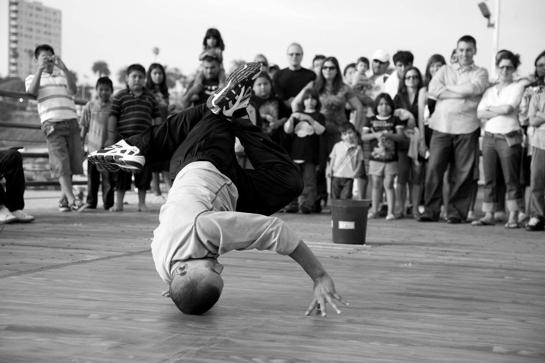
/10

Total: /20

