Part A • Grammar, Vocabulary and How to …
GRAMMAR
1 Complete the second version of the sentences using the modal verb in brackets.
1 I’m certain they moved house because they clearly don’t live there anymore.
They __________ house because they clearly don’t live there anymore. (must)
2 It’s possible that she stayed at home yesterday as she wasn’t feeling well.
She __________ at home yesterday as she wasn’t feeling well. (might)
3 They failed the exam so I’m sure they didn’t study very hard.
They failed the exam so they __________ very hard. (can’t)
4 I’m sure you were watching TV half the night if you managed to finish that series.
You __________ TV half the night if you managed to finish that series. (must)
5 I’m pretty sure it hasn’t been raining because the ground isn’t wet.
It __________ because the ground isn’t wet. (can’t)
6 I think someone broke the window when they were playing football.
The window __________ when someone was playing football. (must)
7 It’s possible Jack was offered a better job, which is why he left.
Jack __________ a better job, which is why he left. (might)
/7

2 Choose the correct option (a, b or c).
1 I wish I ___ the drums, but it’s too late to learn now.
a could play b would play c had played
2 If only you ___ the present to Gareth, it would still be a surprise.
a didn’t mention b hadn’t mentioned c had mentioned
3 I wish you ___ your clothes on the floor. It’s not my job to pick them up.
a left b wouldn’t leave c aren’t leaving
4 We should ___ something to drink. I’m thirsty now.
a bring b brought c have brought
5 If only I ___. Then I wouldn’t have to go to work by bus.
a can drive b could drive c am able to drive
6 I wish I ___ mean to Agata. She’s not talking to me now.
a had been b haven’t been c hadn’t been
7 I shouldn’t ___ for that job. I didn’t have the right skills.
a have applied b applied c apply
8 I wish my parents ___ nearer. They live too far away.
a live b didn’t live c lived
/8
3 Choose the correct words to complete the sentences.
1 The training course was difficult. Although / However, it was very useful.
2 On the one hand / Though we’d planned to paint the bedroom blue, we painted it white in the end.
3 I’d like to invite Chris to the party. Although /
On the other hand, I don’t want to invite too many people.
4 The restaurant was lovely, although / however the food was a bit expensive.
5 However / On the one hand, I want to live abroad, but, on the other hand, I think I’d miss my family.
/5

VOCABULARY
4 Complete the sentences with words related to chance.
1 You were very f _ _ _ _ _ _ _ e to get a ticket for the show because they’ve sold out now.
2 Scientists are saying that last week’s snowstorm was a
f _ _ _ k event.
3 We chose people at r _ _ _ _ m for our survey into lifestyle habits.
4 I came across the book I was looking for b _
c _ _ _ _ e.
5 It was u _ _ _ _ _ _ _ _ _ e that you couldn’t meet Sandy.
6 She didn’t mean to break your tablet. It was
a _ _ _ _ _ _ _ _ l.
7 Kirsty’s email was quite u _ _ _ _ _ _ _ _ d because I hadn’t heard from her for years.
/7

5 Choose the correct words to complete the sentences.
1 The Royal Albert Hall is a second-hand /
world-famous concert hall in the centre of London.
2 She is a long-lasting / widely respected psychologist who has published many papers.
3 The birth of a child is a life-changing / twenty-year-old event for many couples.
4 I bought all-consuming / long-lasting batteries so they don’t need replacing too soon.
5 The book is no longer in print, but you should be able to find a second-hand / time-consuming copy.
6 She left her all-consuming / thirty-year-old job because she never had any time for herself.
7 I’ve got a twenty-year-old / time-consuming car, which is in perfect condition.
/7
6 Complete the sentences with the phrases in the box.
back to the drawing board blessing in disguise cup of tea missed the boat piece of cake
the grass is always greener on the other side
1 I’m not a big fan of detective novels. They’re not really my __________.
2 I tried to make a table, but it fell apart. However, I went __________ and my new design worked!
3 Although I didn’t get tickets for the show, I was sick anyway, so it was a __________, really.
4 Think carefully before you make any big changes because __________.
5 I spent too long deciding whether to rent the flat and in the end I __________.
6 My driving test was easier than I expected. It was a __________!
/6

HOW TO …
7 Complete the sentences with the words and phrases in the box.
begin careful essential figure out
final stage go over once optional
talk it through watch out
1 Let’s __________ some of the basics so we know you understand them.
2 To __________ with, you’ll need to open an account.
3 If you and Connie don’t agree, it’s important that you __________ together.
4 The __________ involves uploading your video to the internet.
5 It’s __________ that you don’t tell anyone your password. You must keep it secret.
6 __________ you’ve completed your report, you need to hand it in.
7 Be __________ not to speak too fast in your presentation.
8 I can’t __________ what they want. Do you have any idea?
9 You don’t have to buy travel insurance. It’s __________.
10 __________ for the traffic. The cars go very fast here.
/10

Total: /50

Part B • Listening, Reading and Writing
LISTENING
1 [Audio UT7.01] Listen to five people talking about things that annoy them. Match the speakers (1–5) with the statements (A–E).
1 Miriam ___
2 Ruben ___
3 June ___
4 Andrew ___
5 Chelsea ___

A It bothers me when people don’t care about other passengers on public transport.
B I get annoyed when people don’t stick to an arrangement they have made.
C I don’t like it when people share false information about other people.
D I get angry when customers receive poor service.
E It annoys me when people spend too much time on electronic devices.
/5
2 [Audio UT7.01] Listen again. For each speaker, choose the correct answer (A, B or C).
1 Miriam regrets
A telling her colleagues she was going to get married.
B not mentioning her colleagues’ behaviour to her manager.
C not complaining to her colleagues about their behaviour.

2 Ruben wishes he
A hadn’t gone out for dinner with his partner.
B had realised his partner had a problem at work.
C hadn’t reacted so angrily to the problem.

3 June feels that she
A should have dealt with the situation more calmly.
B should have given her own seat to the elderly man.
C shouldn’t have got involved in the problem.

4 Andrew wishes he
A hadn’t bought his friend a ticket for the match.
B hadn’t waited for his friend to arrive at the match.
C had arrived at the match at the same time as his friend.

5 Chelsea regrets the fact that she
A didn’t make a complaint in the restaurant.
B chose a restaurant with disappointing food.
C wrote a negative review on the internet.
/10

READING
3 Read the article about the effect someone had on the writer’s life. Complete the text by matching the missing sentences (A–H) with the gaps (1–8).
A The best thing, though, was that I had free time after I’d finished work for the day.
B It was replaced with one of discipline and seriousness instead.
C She’d been walking her dog and she stopped to sit down on a nearby bench.
D She’d wanted to meet up before she left, but I was busy setting up an exhibition in New York.
E My classmates must have thought I was a bit strange, but they were never mean to me.
F It was also Anita who suggested going to art college, which I had never considered until then.
G However, I don’t remember being concerned and I may have felt a sense of relief.
H Sometimes it would be a solitary bird sitting on the riverbank, at other times it would be a couple taking an early evening walk.
/8
A great influence
Artist Jan Simmons remembers someone special.

I never felt that I had much in common with the other kids at school. At playtime, I was always the one kid on his own in a corner of the playground. While they were running around or excitedly chatting in their little groups, I would be busy sketching little pictures in my notebook. 1 ___ In fact, when I think back to my junior school days, I have fond memories.

Unfortunately, when I started at the local secondary school, the atmosphere of warmth and kindness I had felt at junior school disappeared. 2 ___ The secondary school was widely respected and it had a reputation for high levels of achievement. However, students were expected to work incredibly hard and we had little time to develop our own passions. Once I’d finished my homework, I was too exhausted to even pick up a pencil.

Although I’d done my best to keep up at school, I completely messed up my leaving exams. My parents were disappointed of course because they’d been expecting me to go to university. 3 ___ After all, studying had never been my cup of tea. My parents’ dream of me going off to pursue some degree at university had been completely unrealistic.

Fortunately, there were plenty of options for school leavers in those days. I found a job painting and decorating, and it was good to have some money and independence. 4 ___ School work had been so time-consuming that I’d practically stopped drawing for the last couple of years. Now, with my evenings free, I could do it as much as I wanted.

Straight after work, I would grab my pencils and head down to the river to sketch out whatever took my fancy. 5 ___ For the first time in years, I finally felt I could breathe. Failing my leaving exams seemed like a blessing in disguise.
I was down by the river one afternoon when, by chance, I met Anita. 6 ___ After a few minutes, I noticed her looking intently at what I was drawing. That’s when we started talking and she told me she was an art teacher. She recommended changing the perspective of my sketch and I remember being a little surprised by her honesty!

After that random meeting, Anita and I stayed in touch and we began to develop a close friendship. She invited me to work in her little studio and she encouraged me to explore new ways of working. 7 ___ It was the best piece of advice anyone had ever given me. I ended up going to study art in London, which was really the beginning of my career as an artist.

Unfortunately, I haven’t spoken to Anita for years, and the last time I heard from her, she was going to live in Australia.
8 ___ I wish I’d gone back to say goodbye because meeting Anita had been life-changing for me. After all, if it hadn’t been for her, I might still be decorating people’s houses in my hometown.
4 Read the article again. Are the statements True (T) or False (F)?
1 Jan didn’t have enough time to draw after he started secondary school. T / F
2 Jan had always expected to study a degree at university. T / F
3 Jan found it difficult to get work when he left school.
T / F
4 Jan thinks that failing his exams turned out to be positive for him. T / F
5 Anita gave Jan some unexpected advice by the river.
T / F
6 Jan had little contact with Anita after their first meeting. T / F
7 Jan thinks he should have gone to see Anita before she left for Australia. T / F
/7

WRITING
5 Complete the sentences with the words in the box.
conclude conclusion overall sum take
1 To __________, we need to take this problem more seriously.
2 __________ it from me, you won’t be successful if you don’t work hard.
3 __________, there are more pros than cons.
4 In __________, businesses need to take more responsibility for their actions.
5 To __________ up, people should spend more time considering their impact on the environment.
/5

6 Write social media comments in response to the posts below. Write one response for each of the posts. Make sure you end with a clear conclusion and give your opinion.
A
Most of us spend too much time worrying about tomorrow and not living for the moment.
B
School should do more to help young people develop their talents.
Write your responses in 140–190 words in total.
/15

Total: /50

Part C • Speaking
SPEAKING
1 Make questions and ask your partner.
1 Do / mind / having / unexpected visitors / to / home?
2 Where / best place / buy / second-hand things / your town?
3 Who / most widely respected / person / know?
4 What / wish / done / when / younger?
5 What behaviour / find / most annoying?
/5

2 Answer your partner’s questions.
/5

3 Describe the picture to your partner. How are these people using their talent?
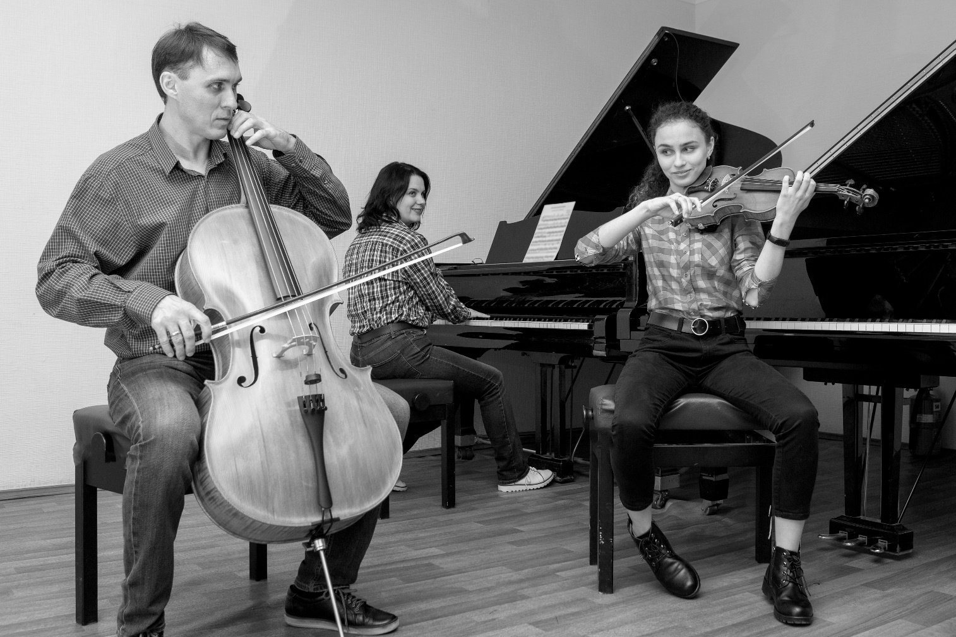
/10

Total: /20

