Part A • Grammar, Vocabulary and How to …
GRAMMAR

1 Circle the correct words.
0 They must stop / must have stopped for a coffee on the way because they haven’t arrived yet.

1 She couldn’t / must have been happy when she realised her phone had been stolen.
2 Our apartment must have / must have been built in the 1960s.
3 Her latest film is bound to be a hit. However / Though, it might upset some of her fans.
4 You might have to work long hours. Although / On the other hand, you’d receive a good salary.
5 Although / On the one hand they’ve had their problems, they still seem happy together.
___ / 5

1 Complete the second version of the sentences. Use the words in brackets.
0 I should have worked harder at school!
- If ___only I’d worked___ (ONLY) harder at school!
1 Can you stop complaining about everything?
- I ____________________ (WISH) complaining about everything.
2 It was a bad idea to take this road. We’ll be late now.
- We ____________________ (HAVE) this road. We’ll be late now.
3 I don’t know how to play. That’s why I need to ask you.
- If I knew how to play, I ____________________ (NEED) to ask you.
4 He wasn’t warm because he didn’t wear a coat.
- If he’d worn a coat, he ____________________ (HAVE) warmer.
5 You can’t stay up late if you make too much noise.
- You can stay up late ____________________ (PROVIDED) too much noise.
- If we don’t act together, we can’t tackle climate change.
- We can’t tackle climate change ____________________ (UNLESS) together.
___ / 6

3 Complete the second sentences. Use participle clauses.
0 I began to feel sick when I was sitting in the back of the car.
- ____Sitting____ in the back of the car, I began to feel sick.
1 I bought some sunglasses because I’d lost my old ones.
- _______________ my old sunglasses, I bought some new ones.
2 I realised I had no money, so I went to the bank.
- _______________ I had no money, I went to the bank.
3 We had driven for miles, but we were still lost.
- _______________ for miles, we were still lost.
4 I thought I saw my house when we flew over the city.
- _______________ over the city, I thought I saw my house.
___ / 4

VOCABULARY

4 Circle the correct words.
0 The participants in our research project were chosen at random / by chance.

1 Although it’s old, the house is in excellent / stylish condition.
2 You were time-consuming / fortunate to get an appointment. I’ve been waiting for months.
3 Although levels of endangered languages / literacy are low, the situation is improving.
4 I don’t have much money so I try to buy second-hand / life-changing furniture.
5 We need to make sure enough homelessness / housing is available as the city’s population grows.
6 We need a(n) unfortunate / long-lasting solution – not just a short-term one.
7 It’s a lovely building with a lot of character / secure.
___ / 7

5 Match (1–4) with (A–E) to make sentences.
0 Don’t worry. The exam will be _B_
A back to the drawing board.
B a piece of cake.
C the boat, I’m afraid.
D not my cup of tea.
E greener on the other side.

1 People say the grass is always ___
2 I don’t like science fiction. It’s ___
3 This isn’t working. Let’s go ___
4 You’re too late! You’ve missed ___

___ / 4

6 Circle the answer (A, B or C) that best completes each sentence.
0 Unfortunately, Bob and I don’t ___ anything in common.
^{A} have | ^{B} make | ^{C} get

1 The fact that he never helps us ___ hand in hand with his selfishness.
^{A} gets | ^{B} goes | ^{C} makes

2 Everything ___ to plan and the work was finished last Monday.
^{A} got | ^{B} went | ^{C} was

3 He only ___ to where he is now because his parents helped him.
^{A} got | ^{B} went | ^{C} made

4 I’d been working late for weeks so I ___ a point of going home early yesterday.
^{A} got | ^{B} had | ^{C} made
___ / 4

HOW TO …

7 Complete the sentences with the words and phrases (A–F). There are TWO words and phrases you do not need.
A be careful
B figure out
C final stage
D optional
E slow down
F watch out

0 This stage is _D_. You can leave it out if you want to.
1 I couldn’t ___ how to upload the file so I sent it as an attachment.
2 Your presentation will be clearer if you ___ a bit.
3 The ___ involves presenting the results of the survey.
___ / 6

8 Circle the correct words.

0 As far as / The first point I can see, you need to phone this number.
1 Hotter weather would like to make / lead to a lack of water in some parts of the world.
2 His latest film is another good example of / by far the best one he’s made.
3 After the match, the crowd got out of / off by control and the police were called.
4 Her arguments are true for two main reasons / obvious impacts.
___ / 4

TOTAL: ___ / 40
x 1.25 = ___ / 50

Part B • Listening and Reading
LISTENING

1 [Audio PT4.01] Listen to five people talking about their regrets. Match the people (1–4) with the statements (A–E).
A I wish I’d taken part in this activity when I was younger.
B I should have bought something when I had the chance.
C I shouldn’t have spent so much on my hobby.
D It's a shame I didn’t know about this in the past.
E I regret throwing away something I’d created.
0 Larry _D_
1 Nadia ___
2 Patrick ___
3 Cara ___
4 Ian ___
___ / 4

2 [Audio PT4.01] Listen again. Circle the correct answer (A or B).
0 What advice did Larry receive from his doctor?
^{A} He should try spending less time working. | ^{B} He should try disconnecting from the world.

1 What does Nadia say about cricket?
^{A} Her family was very passionate about it. | ^{B} Her father made her go to cricket practice.

2 What talent did Patrick have as a child?
^{A} He could remember all the bus journeys he had taken. | ^{B} He could memorise the journeys taken by buses.

3 Why was Cara unable to get a Penny Black?
^{A} She took too long deciding whether to buy it. | ^{B} She couldn’t pay for such an expensive stamp.

4 How does Ian feel now about the second-hand radio?
^{A} Pleased that he didn’t buy it. | ^{B} Annoyed that he spent so much on it.
___ / 4

3 [Audio PT4.02] Listen to two people, Helena and Marcus, talking about world issues. Are the statements True (T) or False (F)?
0 Helena mentions how the media focus on negative news stories. _T_
1 Marcus believes there is less crime than in the past. ___
2 Marcus thinks some reporting in the media is unreliable. ___
3 Helena thinks the actions of some social media users may lead to bad results. ___
4 Helena believes that social media is a good place to discuss difficult topics. ___
___ / 8

READING

4 Read the text about the main issues facing communities. Match the people (1–4) with the issues (A–G). There are TWO issues you do not need.
A civil rights
B endangered languages
C global warming
D literacy
E overcrowding
F poverty
G unemployment

0 Ursula: _B_
1 Damian: ___
2 Suzy: ___
3 Paolo: ___
4 Selina: ___

___ / 4

The big issues
We asked young people about the big issues in their communities and how they can be solved.
URSULA
Like many communities, we’ve got unemployment and poverty, but the issue
that upsets me most is that Scottish Gaelic is at risk of dying out.
Although it’s been spoken around here for hundreds of years, the problem is
that it’s used by fewer people from each generation, which is why it’s
at risk. Fortunately, the majority of children now learn it at school so
hopefully they’ll grow up using it. However, unless the government
does more to promote its use, its future seems uncertain.

DAMIAN
Until last year, we used to have a big factory on the outskirts of the town,
which made car parts. However, when the company was bought out,
the factory was closed down and thousands of jobs were lost overnight. It
was terrible because nearly everyone in the town was affected and
we’ve never recovered. The worst thing is that there are plenty of skilled
workers in the town with nothing to do. In my opinion, the government
should invest in retraining so they could find work in other industries.
SUZY
My town’s a popular tourist destination and, in the last few years, more and
more flats have been turned into tourist accommodation. This has
been great for the local economy, and made some people very rich, but a lot
of families have been pushed out as there isn’t enough space for them.
What’s annoyed me most is that the council have never asked how we feel
about it and just keep building new tourist accommodation. If they
asked us, they’d find out that we don’t want any more tourists here.

PAOLO
This is an international problem really, but it affects my community more
than most. I live on a very flat island so rising sea levels are a big
threat. At certain times of the year, parts of the island are covered in water.
There’s no doubt that rising temperatures are responsible for the
problem, but it’s difficult for my community to solve the problem on its own.
We can build bigger walls to protect us from the sea, but, unless the
whole world comes together to deal with the problem, I’m afraid my island
might not survive.

SELINA
Something which makes me very angry is that the government is taking
away our freedom to protest peacefully. Until not so long ago, we were
allowed to express disagreement in public, but newly introduced laws now
make that more difficult. In fact, the police have already stopped us
protesting about the new laws, so it’s difficult to know how to get our
message across. As far as I can see, our only option is to take our
protests online. Hopefully, by using social media we can get our concerns
across to the general public.

5 Read the text again. Circle the correct answer (A or B).
0 Ursula points out that Scottish Gaelic
^{A} is unlikely to survive in future. | ^{B} is taught to most young people.
1 Damian explains how
^{A} he used to be employed in a local car factory. | ^{B} people would benefit from learning new skills.
2 Suzy thinks that
^{A} more tourist apartments should be built in the town. | ^{B} the council should have consulted the town’s residents.
3 Paolo doubts that his community
^{A} can find a solution without help. | ^{B} is more affected than others.
4 Selina highlights that
^{A} people were permitted to protest in the past. | ^{B} all forms of protest have been forbidden.
___ / 8

6 Read the text about the result of a freak accident. Match the missing sentences (A–G) with the gaps (1–6).
0 _E_
A She had been complaining about headaches, but they told her it was normal after a head injury.
B She’d been planning to go out with a friend, but she’d changed her mind because the weather was awful.
C Since then, it has received positive reviews from critics and been published in fifteen languages.
D Although she managed to keep working, she became increasingly distracted by strange thoughts that would appear at random times.
E Although she was well-liked at her school, she led a quiet and unremarkable life.
F So, for the next few months, she kept detailed notes about them in her diary.
G After a moment, the bright lights and the unfamiliar people in uniform made her realise she must be in hospital.
1 ___
2 ___
3 ___
4 ___
5 ___
6 ___
___ / 6

A freak accident
Before the accident, Kathleen Tracy was a teacher living in London. 0 ___
When she wasn’t working, she spent most of her time looking after
her father, who had suffered from a serious illness. Having lost much of his
strength, he relied on Kathleen for many of his needs.

One evening in 1995, Kathleen had just put her father to bed and she was
about to watch some TV. 1 ___ After making herself comfortable on
the sofa, she realised that the image on her TV screen had frozen. She
thought the strong winds must have moved the satellite dish so she
decided to go outside to check.

Pulling on her raincoat and slippers, she opened the back door and
stepped into the garden. The rain was pouring down and the wind was
shaking the trees violently. Running to the side of the house where
the satellite dish was, she felt a sudden blow to her head before everything
went blank. She thinks she must have slipped on the wet surface and
hit her head on the hard stone floor.

When she woke up, Kathleen had no idea where she was. 2 ___ It
turned out that her father had been calling for her and, when she didn’t
come, he decided to call the neighbours. Fortunately, they found her in
the garden and, seeing that she was unconscious, called an ambulance.

Having spent a few days in hospital, Kathleen was allowed to go home.
The doctors had performed various tests and they hadn’t found any
complications. 3 ___ She was advised to take some rest, but they
said she’d be able to return to work the following week.

As soon as she went back to work, Kathleen realised that something
about her had changed. It was hard to connect to her surroundings and she
found herself daydreaming much of the time. 4 ___ One moment she
would be talking to her pupils and, the next, different characters and
dialogues would be forming in her mind.

Kathleen was curious about what these unusual thoughts meant. 5 ___
What surprised her was that, over time, the characters and dialogues
began to form a story. What had appeared at first to be random and
unconnected thoughts were actually parts of an epic fantasy story.

Realising that she had the makings of a novel, Kathleen spent the next three
years writing it. Having sent copies of the finished novel to various
publishers, Kathleen was soon offered a book deal. 6 ___ If it hadn’t been
for that freak event, Kathleen’s story may have stayed trapped inside
her head forever.

7 Read the text again. Are the statements True (T) or False (F)?
0 Kathleen had stopped working before the accident to look after her father. _F_
1 Kathleen went outside because her TV hadn’t been working properly. ___
2 Kathleen was discovered by her neighbours after the accident. ___
3 The doctors said Kathleen should take a few weeks off work. ___
4 Kathleen knew something about her was different when she started working again. ___
5 Kathleen was worried about the strange thoughts she was having. ___
6 Kathleen was offered a book deal before she’d finished writing
her novel. ___
___ / 6

TOTAL: ___ / 40
x 1.25 = ___ / 50

Part C • Speaking and Writing
SPEAKING
1 Put the words in the correct order to make questions.
Ask your partner your questions.
0 had / you / a life-changing / Have / ever / experience?
____Have you ever had a life-changing experience?_______

1 situations / you / make / What / impatient?
___________________________________________________
2 person / the most / you / Who’s / talented / know?
___________________________________________________
3 If / famous / one / person, / meet / who would / you could / it be?
___________________________________________________
4 choose / Why / people / in exclusive / do / some / to live / areas?
___________________________________________________
___ / 4

2 Answer your partner’s questions.
___ / 4

3 Describe and compare the pictures for your partner.
What regrets might these people have?
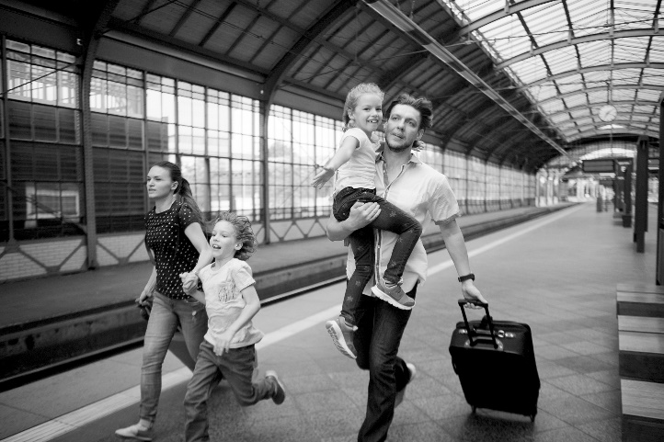

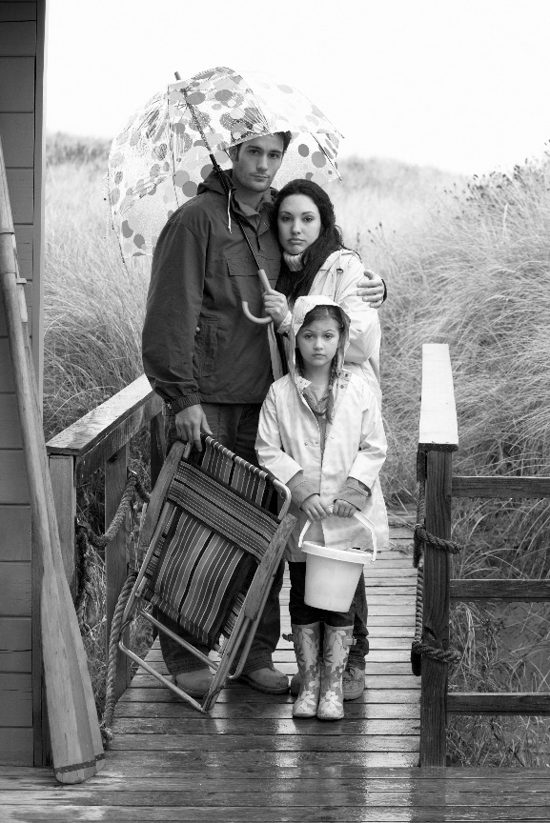
___ / 12
WRITING

4 Complete the sentences with the words (A–G). There are TWO words you do not need.
A conclude
B conclusion
C convenience
D Essentially
E pleasure
F provide
G sum

0 I would be happy to meet you at your _C_.
1 To ___ up, this problem can only be solved by working together.
2 It would be a ___ to tell you more about our product.
3 ___, you need to work hard if you want to get on in life.
4 In ___, there are a number of ways to improve levels of literacy.

___ / 4

5 Write an essay with the following title:

‘Talent is more important than hard work’.

Write 140–190 words.
___ / 16

TOTAL: ___ / 40

