Part A • Grammar, Vocabulary and How to …
GRAMMAR
1 Choose the correct words to complete the sentences.
1 Annelise looks disappointed so she can’t get /
can’t have got the job.
2 They might / must have visited the Eiffel Tower, but I’m not certain.
3 He must have been working / can’t have worked hard because he looks exhausted.
4 The book can’t have been returned /
can’t have returned to the library because it’s not there.
5 Although / On the one hand, you need to be careful about what you hear in the news.
6 Though / On the other hand he doesn’t eat meat, he does eat eggs and cheese.
7 I’m not really into techno. However / Although, I do like some electronic music.
/7

2 Complete the second version of the sentences using the words in brackets.
1 It’s a shame we can’t stay here longer.
I _______________ (wish) here longer.
2 I don’t like them making so much noise at night.
I _______________ (wouldn’t) so much noise at night.
3 I should have learnt to play the guitar.
If _______________ (only) to play the guitar.
4 It was a bad idea to invite them to the party.
We _______________ (have) them to the party.
5 We work a lot because we don’t have much money.
If we had more money, we _______________ (have) to work so much.
6 They didn’t bring their rackets so they couldn’t play tennis.
If _______________ (brought) their rackets, they could have played tennis.
7 If you don’t tidy your room, you can’t watch TV.
You can’t watch TV _______________ (unless) your room.
8 You can use my laptop if you agree to look after it.
You can use my laptop _______________ (condition) it.
/8

3 Complete the second sentences with participle clauses.
1 I stopped writing when I saw him come into the room.
_______________ him come into the room, I stopped writing.
2 I’d finished washing up so I started to cook the dinner.
_______________ washing up, I started to cook the dinner.
3 I looked up at the night sky and I saw a bright star.
_______________ up at the night sky, I saw a bright star.
4 We’d used all the paper, so we couldn’t print anything else.
_______________ all the paper, we couldn’t print anything else.
5 I heard a noise at the window when I was lying in bed.
_______________ in bed, I heard a noise at the window.
/5

VOCABULARY
4 Complete the sentences with the words and phrases in the box. There are three words or phrases you do not need.
accidental fortunate freak life-changing long-lasting second-hand time-consuming unexpected
1 His calm response was completely __________.
I thought he’d be angry.
2 The flight was cancelled because of a(n) __________ snowstorm.
3 She didn’t mean to hurt you. It looked __________ to me.
4 Winning the lottery was a(n) __________ event for her.
5 Writing his last book was __________. It took about three years to complete.
/5

5 Match the sentence beginnings (1–5) with the endings (a–e).
1 I hate reality TV shows. They’re
2 The plan went wrong so it
3 If you don’t hurry up, you’ll
4 I don’t agree that the grass is always
5 The bad weather turned out to be a
a miss the boat.
b not my cup of tea.
c greener on the other side.
d blessing in disguise.
e was back to the drawing board for us.
/5

6 Choose the correct words to complete the sentences.
1 I’d like a more secure / spacious house because I don’t have enough room for my possessions.
2 Only the wealthiest people can afford to live in this character / exclusive neighbourhood.
3 There used to be a lot of literacy / unemployment in the area, but now there are more jobs.
4 A lack of space in the city centre has resulted in housing / overcrowding.
5 We want justice / poverty for everyone who has been treated badly by their employers.
/5
7 Complete the sentences with the correct form of get, go, have or make.
1 I hope you __________ not forgotten to pack our passports!
2 Do you think our campaign has __________ a difference?
3 She had a difficult time, but she is __________ her life back together now.
4 I hope the TV doesn’t __________ wrong again.
5 Can I __________ a go on your electric scooter?
/5

HOW TO …
7 Complete the sentences with the words and phrases in the box.
first point go into go over next step once
one thing on the whole start off
talk it through watch out
1 __________ you’ve finished the test, put your hand up.
2 After that, the __________ is to mix in the eggs.
3 Why don’t we __________ your notes in case you’ve got any doubts?
4 You should __________ with your manager if you have problems at work.
5 __________ for spelling mistakes in your report.
6 There are a few things for you to improve, but __________ your speech was very good.
7 __________ we can be sure of is that few people want to give up their cars.
8 The __________ I’d like to make is that this has been an amazing year for the company.
9 I don’t want to __________ all the details at the moment.
10 I’d like to __________ by thanking you all for coming.
/10

Total: /50

Part B • Listening and Reading
LISTENING
1 [Audio PT4.01] Listen to five people talking about their regrets. Match the speakers (1–5) with the statements (A–E).
1 Larry: ___
2 Nadia: ___
3 Patrick: ___
4 Cara: ___
5 Ian: ___
A I shouldn’t have spent so much on my hobby.
B It's a shame I didn’t know about this in the past.
C I should have bought something when I had the chance.
D I regret throwing away something I’d created.
E I wish I’d taken part in this activity when I was younger.
/5

2 [Audio PT4.01] Listen again. Choose the correct answer (A, B or C).
1 What does Larry say about practising ‘niksen’?
A It has led to him getting more headaches.
B It has helped him to spend less time working.
C It has improved the quality of his life.

2 Why did Nadia refuse to play cricket as a child?
A Her family thought it was a strange sport.
B She was more interested in other things.
C She didn’t want to disappoint her father.

3 What does Patrick say about his bus maps?
A He probably spent a long time creating them.
B He included the makes and models of buses on them.
C He still remembers all the information on them.

4 What point does Cara make about the Penny Black?
A It was the most important stamp in her collection.
B It would be more difficult to find one nowadays.
C It was being sold for too much money at the fair.

5 What does Ian say about amateur radio?
A It was replaced by a different way of talking to people.
B It was a good way of meeting people in other countries.
C It wasn’t as expensive as other hobbies at the time.
/5

3 [Audio PT4.02] Listen to two people, Helena and Marcus, talking about world issues. Are the statements True (T) or False (F)?
1 Helena describes how the media’s reporting of crime might be wrong. T / F
2 Marcus agrees that crime rates are falling around the world. T / F
3 Helena argues that there are fewer poor people nowadays. T / F
4 Marcus argues that the media is sometimes too positive in its reports. T / F
5 Marcus thinks we should believe what we see in the media. T / F
6 Helena thinks that information on social media is mostly reliable. T / F
7 Marcus explains how using social media can cause disagreements. T / F
8 Helena thinks there are too many rules for communicating on social media. T / F
9 Marcus recommends not using social media if people are being unkind. T / F
10 Helena disagrees with the view that community projects are more useful than social media. T / F
/10

READING
4 Read the article about the main issues facing communities. Match the people (1–5) with the issues in the box. There are three issues you do not need.
global warming homelessness justice literacy overcrowding pollution poverty unemployment
1 Alison: _______________
2 Melanie: _______________
3 Richard: _______________
4 Diana: _______________
5 Tatiana: _______________
/5
The big issues
We asked young people about the big issues in their communities and how they can be solved.
Alison
Poverty is an issue in my community, but we have enough to survive. By far the biggest problem is a lack of reading and writing skills, which affects almost 70 percent of the population. The majority of people work in agriculture, and some of them don’t think those skills are important. At the same time, even if you do want to learn to read and write, there aren’t enough places in the schools. The obvious impact of this is that it’s difficult for us to improve our lives. It’s been suggested that the internet could help by allowing people to educate themselves. However, from my perspective, the only solution is to build more schools.

Melanie
I live in a seaside town which has always attracted people with nowhere else to live. They used to come in the summer to take advantage of the warm weather, but now it’s all year round. Some of our residents get angry about it because they don’t like people sleeping on the street. Personally, I don’t blame them for coming here and, more than anything, it makes me sad that they don’t have homes. What they need is our support. Instead of closing temporary accommodation, we should be opening more, and helping them get their lives back to together.

Richard
I’m in no doubt that the difference between rich and poor is growing, and you can see it clearly where I live. Because we’re in the city centre, you’ve got the super-rich living in exclusive apartment blocks, while the poorer residents can hardly afford to live. The worst thing is that many of the poorer people are sometimes doing two or three jobs to pay the bills. There are things we can do locally to help, like providing food banks and other support, but it’s the government’s policies which are making some people poorer. They’re the only ones who can sort out this problem.

Diana
Where I live, people are fed up with the way the laws are so unfair. Everyone knows that the rich and powerful are treated better than the rest of us. They do whatever they want and they never get punished for their crimes. On the other hand, if you’re poor and you’re caught stealing something to eat, you’ll probably be sent to prison. The problem is that politicians don’t do anything, so things never change. Recently, though, we’ve been trying to make people aware of the situation. We’re using a social media campaign to put pressure on the politicians so they’ll have to sort it out.

Tatiana
If you read the national newspapers, there are a lot of articles about poor air quality, but that mostly affects the cities. Living in the countryside, it’s not such a big issue for me, whereas poor water quality is. Unfortunately, the huge agricultural companies that own a lot of the farms around here don’t seem to care at all. Only last summer, it was discovered that the fish in the river were dying because the farms had been allowing chemical waste to get into the water. Despite the fact that we depend on the river for drinking water, the farmers weren’t punished at all. In my opinion, they should stop using those dangerous chemicals and switch to more sustainable farming techniques.

5 Read the article again. Choose the correct answer (A, B, C or D).
1 Alison argues that
A people in her community are finding it hard to survive.
B not having certain skills has a negative effect on the community.
C reading and writing are unnecessary in an agricultural community.
D the internet has improved people’s lives.

2 Melanie is concerned about
A the number of homeless people in her town.
B the fact that homeless people come to her town in the summer.
C the lack of support services for homeless people in her town.
D more temporary accommodation opening in her town.

3 Richard explains how
A poor people in his area are becoming poorer.
B poor people are moving out of the city centre.
C there are not enough jobs for people in his area.
D there is no support for poor people in the area.

4 Diana highlights that
A a lot of poor people are sent to prison for stealing.
B the laws are made by people with wealth and power.
C the rich and powerful treat the poor people badly.
D the problems have not been dealt with by politicians.

5 Tatiana doubts that
A poor air quality is a problem in the majority of cities.
B businesses want to improve the quality of the water.
C chemical waste was responsible for the fish dying.
D more sustainable farming would be an improvement.
/10

6 Read the article about the result of a freak accident. Complete the text by matching the missing sentences (A–H) with the gaps (1–8).
A They treated a wound to his head before taking him to hospital in an ambulance.
B He was well-known at his local gym, where he would do workouts several times a week.
C Collectors from as far away as the United States began to make offers for his unusual works of art.
D At first, he just took some medication and went to work as normal.
E Mikal would spend hours in there every day, producing strange, brightly-coloured pictures.
F As long as they put on warm clothes, Mikal thought they would be OK.
G Although he’d never had a go at it before, he enthusiastically took the brushes and began to paint.
H That was the last thing he remembers before falling to the floor unconscious.
/8
A freak accident
Mikal Smith is a father-of-two from Doncaster in England. Before the accident in 2015, he’d had a successful career as a sales manager, as well as being a fitness fanatic.
1 ___ People that know him have described him as sociable and outgoing before the accident, and that he lived for his daughters and the gym.

One Saturday morning in November 2015, Mikal agreed to take his daughters to the park. They loved playing football and, despite the bad weather, they were desperate to go. Although there had been a storm the night before, it had stopped raining so it didn’t seem like a bad idea.
2 ___ He was also looking forward to getting some fresh air and stretching his legs.

When they got to the park, the girls chose two trees which they could use as goal posts. It was Mikal’s turn to be goalkeeper and he’d just moved into position when he felt a sharp pain on the top of his head. 3 ___ He knows now that he’d been hit by a falling tree branch, which must have come loose in the storm.

When Mikal woke up, he was being looked after by emergency workers. 4 ___ Although he had no memory of what had happened, Mikal described feeling well. When X-rays confirmed that Mikal had suffered no serious injuries, he was allowed to go home.

For the next few days, Mikal almost forgot about the accident, but then he started getting headaches. 5 ___ However, he was finding it increasingly difficult to concentrate at work and he got the feeling that something wasn’t right. He went back to the hospital for more tests and that’s when they discovered that his brain had been slightly injured in the accident.

The doctors hoped that the injury would repair itself in time, but, for the moment, Mikal had to rest at home. Being an active person, he was bored and fed up with having to stay at home. However, when a friend unexpectedly brought him a painting set, Mikal suddenly cheered up. 6 ___ He later said that at that moment, it felt like he was doing the most natural thing in the world.

From that moment, Mikal had the desire to paint all the time. To his family’s surprise, he tidied up his garage, which had been full of junk for years, and created a studio.
7 ___ Despite Mikal’s particular style of painting, he still can’t explain where the inspiration came from. All he knows is that the accident must have led to him developing this new talent.

Mikal had been painting for some time before a local newspaper heard about his story. When they published an article about him, Mikal suddenly became a focus of interest in the art world. 8 ___ Now Mikal thinks that the accident might have been a blessing in disguise. If he hadn’t been hit by that branch, he might never have realised his talent.

7 Read the article again. Are the statements True (T) or False (F)?
1 Mikal enjoyed spending his time with other people before his injury. T / F
2 It was still raining when Mikal took his daughters to the park. T / F
3 Mikal believes that the tree had been damaged in the storm. T / F
4 The emergency workers arrived after Mikal had woken up. T / F
5 Mikal’s mood improved because he was told to stay at home. T / F
6 Mikal doesn’t believe that the accident led to him finding his new talent. T / F
7 Mikal became well-known as a result of a story in the media. T / F
/7

Total: /50

Part C • Speaking and Writing
SPEAKING
1 Make questions and ask your partner.
1 Have / ever / been / to / world-famous monument?
2 If / could / change / one thing in your life, / what / it / be?
3 Have / ever / had to / go back to the drawing board?
4 Which of your friends / have / most in common with?
5 What / the biggest issues / for / young people / in your country?
/5

2 Answer your partner’s questions.
/5

3 Describe and compare the pictures for your partner. How might the people be making a difference?
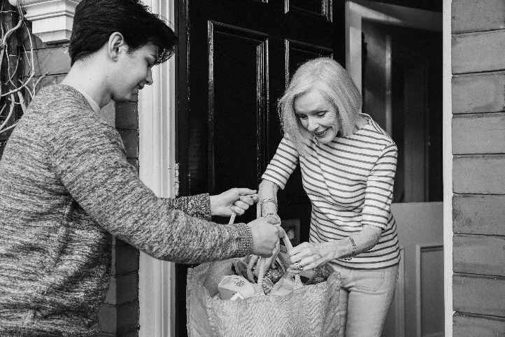
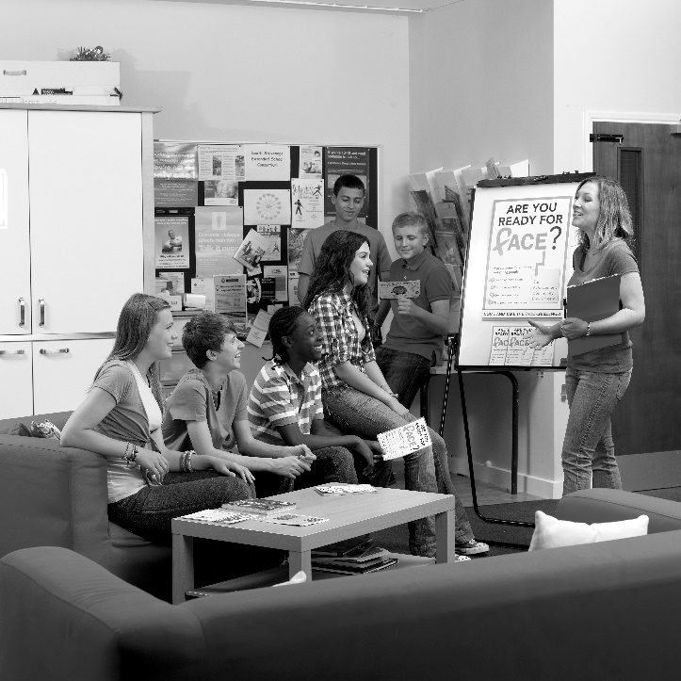
/10
WRITING
4 Complete the sentences with the words and phrases in the box. There are three words or phrases you do not need.
conclude conclusion convenience
look forward pleasure provide sum take
1 To __________, we need to spend more money on reducing crime.
2 I __________ to hearing from you in the near future.
3 I can __________ you with references and would be happy to meet you.
4 __________ it from me, it won’t be easy to solve this problem.
5 I am available to meet you at your __________ .
/5

5 Write an essay with the following title:
Talent is more important than hard work
Write 140–190 words.
/15

Total: /40

