Part A • Grammar, Vocabulary and How to …
GRAMMAR
1 Choose the correct words to complete the sentences.
1 They must stop / must have stopped for a coffee on the way because they haven’t arrived yet.
2 I’m not sure where Oscar is. He can’t / might have gone home because he was tired.
3 She couldn’t / must have been happy when she realised her phone had been stolen.
4 Our apartment must have / must have been built in the 1960s.
5 Her latest film is bound to be a hit. However / Though, it might upset some of her fans.
6 You might have to work long hours. Although /
On the other hand, you’d receive a good salary.
7 Although / On the one hand they’ve had their problems, they still seem happy together.
/7

2 Complete the second version of the sentences using the words in brackets.
1 I should be more confident.
I _______________ (wish) more confident.
2 I should have worked harder at school!
_______________ (only) harder at school!
3 Can you stop complaining about everything?
I _______________ (wish) complaining about everything.
4 It was a bad idea to take this road. We’ll be late now.
We _______________ (have) this road. We’ll be late now.
5 I don’t know how to play. That’s why I need to ask you.
If I knew how to play, I _______________ (need) to ask you.
6 He wasn’t warm because he didn’t wear a coat.
If he’d worn a coat, he _______________ (have) warmer.
7 You can’t stay up late if you make too much noise.
You can stay up late _______________ (provided) too much noise.
8 If we don’t act together, we can’t tackle climate change.
We can’t tackle climate change _______________ (unless) together.
/8

3 Complete the second sentences with participle clauses.
1 I began to feel sick when I was sitting in the back of the car.
_______________ in the back of the car, I began to feel sick.
2 I bought some sunglasses because I’d lost my old ones.
_______________ my old sunglasses, I bought some new ones.
3 I realised I had no money, so I went to the bank.
_______________ I had no money, I went to the bank.
4 We had driven for miles, but we were still lost.
_______________ for miles, we were still lost.
5 I thought I saw my house when we flew over the city.
_______________ over the city, I thought I saw my house.
/5

VOCABULARY
4 Complete the sentences with the words and phrases in the box. There are three words or phrases you do not need.
by chance fortunate life-changing
long-lasting random second-hand
time-consuming unfortunate
1 The participants in our research project were chosen at __________.
2 I came across this article __________ when I was surfing the internet.
3 You were __________ to get an appointment. I’ve been waiting for months.
4 We need a(n) __________ solution and not just a short-term one.
5 I don’t have much money so I try to buy __________ furniture.
/5

5 Match the sentence beginnings (1–5) with the endings (a–e).
1 Don’t worry. The exam will be
2 People say the grass is always
3 I don’t like science fiction. It’s
4 This isn’t working. Let’s go
5 You’re too late! You’ve missed
a back to the drawing board.
b a piece of cake.
c the boat, I’m afraid.
d not my cup of tea.
e greener on the other side.
/5

6 Choose the correct words to complete the sentences.
1 It’s a lovely building with a lot of character / secure.
2 Although it’s old, the house is in excellent / stylish condition.
3 The government has been criticised for not protecting civil rights / overcrowding.
4 As the city’s population grows, we need to make sure enough homelessness / housing is available.
5 Although levels of endangered languages / literacy are low, the situation is improving.
/5

7 Complete the sentences with the correct form of get, go, have or make.
1 Unfortunately, Bob and I don’t __________ anything in common.
2 The fact that he never helps us __________ hand in hand with his selfishness.
3 Everything __________ to plan and the work was finished last Monday.
4 He only __________ to where he is now because his parents helped him.
5 I’d been working late for weeks so I __________ a point of going home early yesterday.
/5

HOW TO …
7 Complete the sentences with the words and phrases in the box.
as far as by far essential figure out
final stage lead to main reasons optional out of slow down
1 This stage is __________. You can leave it out if you want to.
2 I couldn’t __________ how to upload the file so I sent it as an attachment.
3 Your presentation will be clearer if you __________ a bit.
4 It’s __________ that you think of a secure password so your account is protected.
5 The __________ involves presenting the results of the survey.
6 __________ I can see, you need to phone this number.
7 Hotter weather would __________ a lack of water in some parts of the world.
8 His latest film is __________ the best one he’s made.
9 After the match, the crowd got __________ control and the police were called.
10 Her arguments are true for two __________.
/10

Total: /50

Part B • Listening and Reading
LISTENING
1 [Audio PT4.01] Listen to five people talking about their regrets. Match the speakers (1–5) with the statements (A–E).
1 Larry: ___
2 Nadia: ___
3 Patrick: ___
4 Cara: ___
5 Ian: ___

A I wish I’d taken part in this activity when I was younger.
B I should have bought something when I had the chance.
C I shouldn’t have spent so much on my hobby.
D It's a shame I didn’t know about this in the past.
E I regret throwing away something I’d created.
/5

2 [Audio PT4.01] Listen again. Choose the correct answer (A, B or C).
1 What advice did Larry receive from his doctor?
A He should try spending less time working.
B He should try to find some new social activities.
C He should try disconnecting from the world.

2 What does Nadia say about cricket?
A Her family was very passionate about it.
B Her father made her go to cricket practice.
C Her friends enjoyed watching cricket.

3 What talent did Patrick have as a child?
A He could memorise the journeys taken by buses.
B He could name the makes and models of buses.
C He could remember all the bus journeys he had taken.

4 Why was Cara unable to get a Penny Black?
A She couldn’t pay for such an expensive stamp.
B She took too long deciding whether to buy it.
C She could never find one in the stamp fairs.

5 How does Ian feel now about the second-hand radio?
A Disappointed that he couldn’t afford it.
B Pleased that he didn’t buy it.
C Annoyed that he spent so much on it.
/5

3 [Audio PT4.02] Listen to two people, Helena and Marcus, talking about world issues. Are the statements True (T) or False (F)?
1 Helena mentions how the media focus on negative news stories. T / F
2 Helena has heard that there is more crime nowadays.
T / F
3 Marcus believes there is less crime than in the past.
T / F
4 Helena suggests that more people can read and write nowadays. T / F
5 Marcus thinks some reporting in the media is unreliable.
T / F
6 Helena disagrees with Marcus about trusting the media.
T / F
7 Helena thinks the actions of some social media users may lead to bad results. T / F
8 Marcus is concerned about the way people communicate on social media. T / F
9 Helena believes that social media is a good place to discuss difficult topics. T / F
10 Marcus mentions some volunteers who debate issues like homelessness. T / F
/10

READING
4 Read the article about the main issues facing communities. Match the people (1–5) with the issues in the box. There are three issues you do not need.
civil rights endangered languages
global warming homelessness literacy overcrowding poverty unemployment
1 Ursula: _______________
2 Damian: _______________
3 Suzy: _______________
4 Paolo: _______________
5 Selina: _______________
/5
The big issues
We asked young people about the big issues in their communities and how they can be solved.
Ursula
Like many communities, we’ve got unemployment and poverty, but the issue that upsets me most is that Scottish Gaelic is at risk of dying out. I admit not knowing much myself and nearly everyone I know speaks English. In fact, it’s been spoken around here for hundreds of years, but Gaelic has managed to survive until now. The problem is that it’s used by fewer people from each generation, which is why it’s at risk. Fortunately, the majority of children now learn it at school so hopefully they’ll grow up using it. However, unless the government does more to promote its use, its future seems uncertain.

Damian
Until last year, we used to have a big factory on the outskirts of the town, which made car parts. It had been there for many years and it created a lot of jobs for the town. However, when the company was bought out, the factory was closed down and thousands of jobs were lost overnight. It was terrible because nearly everyone in the town was affected and we’ve never recovered. The worst thing is that there are plenty of skilled workers in the town, but there’s nothing for them to do. In my opinion, the solution would be for the government to invest in retraining so they could find work in other industries.

Suzy
My town’s a popular tourist destination and, in the last few years, more and more flats have been turned into tourist accommodation. On the one hand, it’s been great for the local economy, and some people have made a lot of money out of it. On the other hand, a lot of families have been pushed out because there isn’t enough space for everyone. What’s annoyed me most is that the council have never asked us how we feel about it. They just keep building new tourist accommodation. If they did ask us, they’d find out that we don’t want any more tourists here.

Paolo
This is an international problem really, but it affects my community more than most. I live on an island which is very flat, so rising sea levels are a big threat to our way of life. At certain times of the year, parts of the island are covered in water, so we’re really worried about the future. There’s no doubt that rising temperatures are responsible for the problem. Of course, it’s difficult for my community to solve the problem on its own. We can build bigger walls to protect us from the sea, but, unless the whole world comes together to deal with the problem, I’m afraid my island might not survive.

Selina
Something which makes me very angry is that the government is gradually taking away our freedom to protest peacefully. Until not so long ago, we were allowed to express disagreement in public, but the government has introduced new laws making it more difficult. In fact, the police have already stopped us protesting about the new laws, so it’s difficult to know how to get our message across. As far as I can see, our only option is to take our protests online. Hopefully, by using social media we can get our concerns across to the general public.

5 Read the article again. Choose the correct answer (A, B, C or D).
1 Ursula points out that Scottish Gaelic
A is spoken widely where she lives.
B is taught to most young people.
C is unlikely to survive in future.
D is not used at all where she lives.

2 Damian explains how
A he used to be employed in a local car factory.
B a car factory was closed down many years ago.
C people would benefit from learning new skills.
D his town overcame the loss of many jobs.

3 Suzy thinks that
A hardly anyone has benefitted from tourism in the town.
B more tourist apartments should be built in the town.
C the council could do more to attract tourists to the town.
D the council should have consulted the town’s residents.

4 Paolo doubts that his community
A is more affected than others.
B is responsible for rising temperatures.
C can build walls which are bigger.
D can find a solution without help.

5 Selina highlights that
A people were permitted to protest in the past.
B all forms of protest have been forbidden.
C protesting on social media is not an option.
D the general public are not interested in the problem.
/10

6 Read the article about the result of a freak accident. Complete the text by matching the missing sentences (A–H) with the gaps (1–8).
A She had been complaining about headaches, but they told her it was normal after suffering a head injury.
B She’d been planning to go out with a friend, but she’d changed her mind because the weather was awful.
C Since then, it has received positive reviews from critics and been published in fifteen languages.
D She thinks she must have slipped on the wet surface and hit her head on the hard stone floor.
E Although she managed to keep working, she became increasingly distracted by strange thoughts that would appear at random times.
F Although she was well-liked at her school, she led a quiet and unremarkable life.
G So, for the next few months, she kept detailed notes about them in her diary.
H After a moment, the bright lights and the unfamiliar people in uniform made her realise she must be in hospital.
/8
A freak accident
Before the accident, Kathleen Tracy was a teacher living in West London. 1 ___ When she wasn’t working, she spent most of her time looking after her father, who had suffered from a serious illness. Having lost much of his strength, he relied on Kathleen for many of his needs.

One evening in 1995, Kathleen had just put her father to bed and she was about to watch some TV. 2 ___ After making herself comfortable on the sofa, she realised that the image on her TV screen had frozen. She thought the strong winds must have moved the satellite dish so she decided to go outside to check.

Pulling on her raincoat and slippers, she opened the back door and stepped into the garden. The rain was pouring down and the wind was shaking the trees violently. Running to the side of the house where the satellite dish was, she felt a sudden blow to her head before everything went blank. 3 ___

When she woke up, Kathleen had no idea where she was.
4 ___ It turned out that her father had been calling for her and, when she didn’t come, he decided to call the neighbours. Fortunately, they found her in the garden and, seeing that she was unconscious, they called an ambulance.

Having spent a few days in hospital, Kathleen was allowed to go home. The doctors had performed various tests and they hadn’t found any complications. 5 ___ She was advised to take some rest, but they said she’d be able to return to work the following week.

As soon as she went back to work, Kathleen realised that something about her had changed. It was hard to connect to her surroundings and she found herself daydreaming much of the time. 6 ___ One moment she would be talking to her pupils and, the next, different characters and dialogues would be forming in her mind.
Although some people might have been worried about having unusual thoughts, Kathleen was curious about what they meant. 7 ___ What surprised her was that, over time, the characters and dialogues began to form a story. What had appeared at first to be random and unconnected thoughts were actually parts of an epic fantasy story.

Realising that she had the makings of a novel, Kathleen spent the next three years writing it. Having sent copies of the finished novel to various publishers, Kathleen was soon offered a book deal. 8 ___ If it hadn’t been for that freak event, Kathleen’s story may have stayed trapped inside her head forever.

7 Read the article again. Are the statements True (T) or False (F)?
1 Kathleen had stopped working before the accident to look after her father. T / F
2 Kathleen went outside because her television hadn’t been working properly. T / F
3 Kathleen was discovered by her neighbours after the accident. T / F
4 The doctors said Kathleen should take a few weeks off work. T / F
5 Kathleen knew something about her was different when she started working again. T / F
6 Kathleen was worried about the strange thoughts she was having. T / F
7 Kathleen was offered a book deal before she had finished writing her novel. T / F
/7

Total: /50

Part C • Speaking and Writing
SPEAKING
1 Make questions and ask your partner.
1 Have / ever / had / life-changing / experience?
2 What / situations / make / impatient?
3 Who / most talented / person / know?
4 If / could / meet / one famous person, / who / it / be?
5 Why / some people / choose / live / exclusive areas?
/5

2 Answer your partner’s questions.
/5

3 Describe and compare the pictures for your partner. What regrets might these people have?
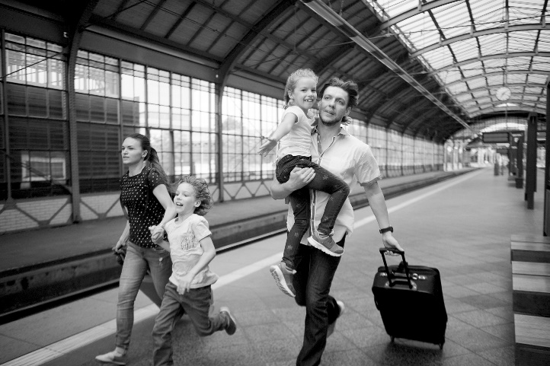
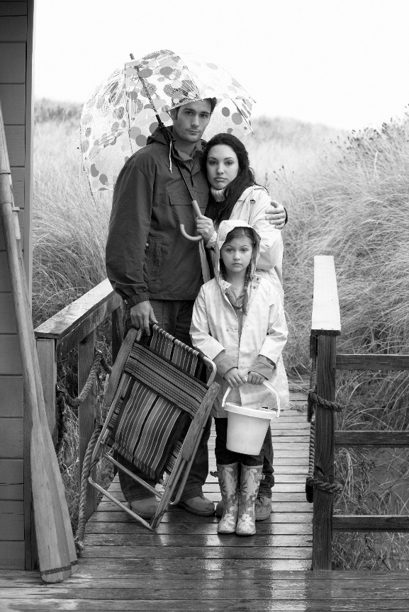
/10

WRITING
4 Complete the sentences with the words and phrases in the box. There are three words or phrases you do not need.
conclude conclusion convenience essentially look forward pleasure provide sum
1 I would be happy to meet you at your __________.
2 To __________ up, this problem can only be solved by working together.
3 It would be a __________ to tell you more about our product.
4 __________, you need to work hard if you want to get on in life.
5 In __________, there are a number of ways to improve levels of literacy.
/5

5 Write an essay with the following title:
Talent is more important than hard work
Write 140–190 words.
/15

Total: /40

