Part A • Grammar, Vocabulary and How to …
GRAMMAR

1 Complete the second version of the sentences. Use the modal verb in brackets.
0 I’m certain they moved because they don’t live there anymore.
- They _must’ve moved_ because they don’t live there anymore. (MUST)
1 It’s possible that she stayed at home yesterday as she wasn’t feeling well.
- She ______________ at home yesterday as she wasn’t feeling well. (MIGHT).
2 They failed the exam so I’m sure they didn’t study very hard.
- They failed the exam so they ______________ very hard. (CAN’T)
3 I’m sure you were watching TV all night if you managed to finish that series.
- You ______________ watching TV all night if you managed to finish that series. (MUST)
4 I’m pretty sure it hasn’t been raining because the ground isn’t wet.
- It ______________ because the ground isn’t wet. (CAN’T)
5 I think someone broke the window when they were playing football.
- The window ______________ when someone was playing football. (MUST)
6 It’s possible Jack was offered a better job, which is why he left.
- Jack ______________ a better job, which is why he left. (MIGHT)
___ / 6
2 Circle the correct words.
0 I wish I could play / had played the drums, but it’s too late to learn now.

1 If only you didn’t mention / hadn’t mentioned the present to Gareth, it would still be a surprise.
2 I wish you wouldn’t leave / aren’t leaving your clothes on the floor. It’s not my job to pick them up.
3 If only I am able to drive / could drive. Then I wouldn’t have to go to work
by bus.
4 I shouldn’t have applied / applied for that job. I didn’t have the right skills.
5 I wish my parents live / lived nearer. They live too far away.
___ / 5

3 Circle the answer (A or B) that best completes each sentence.
0 The training course was difficult. ___, it was very useful.
^{A} Although | ^{B} However

1 ___ we’d planned to paint the bedroom blue, we painted it white in the end.
^{A} On the one hand | ^{B} Though

2 I’d love to invite Chris to the party. ___, I don’t want to invite too many people.
^{A} Although | ^{B} On the other hand

3 The restaurant was lovely, ___ the food was a bit expensive.
^{A} although | ^{B} however

4 ___, I want to live abroad, but, on the other hand, I think I’d miss my family.
^{A} However | ^{B} On the one hand
___ / 4

VOCABULARY

4 Complete the sentences with words related to chance.
0 You were very f o r t u n a t e to get a ticket for the show because they’ve sold out now.
1 Scientists are saying that last week’s snowstorm was a f _ _ _ k event.

2 We chose people at r _ _ d _ _ for our survey into lifestyle habits.

3 She didn’t mean to break your tablet. It was a _ c _ d _ _ t _ _.

4 Kirsty’s email was quite u _ e _ p _ _ t _ d because I hadn’t heard from her for years.
___ / 4

5 Circle the correct words.
0 She is a long-lasting / widely respected psychologist who has published many papers.

1 The birth of a child is a life-changing / twenty-year-old event for many couples.
2 I bought all-consuming / long-lasting batteries so they don’t need replacing too soon.
3 Unfortunately, the book is no longer in print but you should be able to find a second-hand / time-consuming copy.
4 She left her all-consuming / thirty-year-old job because she never had any time for herself.
5 I’ve got a twenty-year-old / time-consuming car, which is in perfect condition.
___ / 5

6 Complete the sentences with the words and phrases (A–E).
0 I’m not a big fan of detective novels. They’re not really my _C_.
A back to the drawing board
B blessing in disguise
C cup of tea
D missed the boat
E piece of cake
1 I tried to make a table, but it fell apart. However, I went ___ and my new design worked!
2 Although I didn’t get tickets for the show, I was sick anyhow, so it was a ___.
3 I spent too long deciding whether to rent the flat and in the end I ___.
4 My driving test was easier than I expected.
It was a ___!
___ / 4

HOW TO …

7 Complete the sentences with the words and phrases (A–G).
0 Let’s _D_ some of the basics so we know you understand them.
A careful
B essential
C figure out
D go over
E optional
F talk it through
G Watch out
1 If you and Connie don’t agree, it’s important that you ___ together.
2 It’s ___ that you don’t tell anyone your password. You must keep it secret.
3 Be ___ not to speak too fast in your presentation.
4 I can’t ___ what they want. Do you have any idea?
5 You don’t have to buy travel insurance. It’s ___.
6 ___ for the traffic. The cars go very fast here.
___ / 12

TOTAL: ___ / 40
x 1.25 = ___ / 50

Part B • Listening, Reading and Writing
LISTENING

1 [Audio UT7.01] Listen to five people talking about things that annoy them. Match the speakers (1–4) with the statements (A–E).
A It bothers me when people don’t care about other passengers on public transport.
B I get annoyed when people don’t stick to an arrangement they have made.
C I don’t like it when people share false information about others.
D I get angry when customers receive poor service.
E It annoys me when people spend too much time on electronic devices.
0 Miriam _C_
1 Ruben ___
2 June ___
3 Andrew ___
4 Chelsea ___

___ / 4

2 [Audio UT7.01] Listen again. Circle the correct answer (A or B).
0 Miriam regrets
^{A} not mentioning her colleague’s behaviour to her manager. | ^{B} not complaining to her colleagues about their behaviour.

1 Ruben wishes he
^{A} hadn’t gone out for dinner with his partner. | ^{B} he hadn’t reacted so angrily to the problem.

2 June feels that she
^{A} should have dealt with the situation more calmly. | ^{B} shouldn’t have got involved in the problem.

3 Andrew wishes he
^{A} hadn’t waited for his friend to arrive at the match. | ^{B} hadn’t bought his friend a ticket for the match.

4 Chelsea regrets the fact that she
^{A} chose a restaurant with disappointing food. | ^{B} didn’t make a complaint in the restaurant.
___ / 4

READING

3 Read the text about the effect someone had on the writer’s life. Match the missing sentences (A–E) with the gaps (1–4).
A The best thing, though, was that I had free time after I’d finished work for the day.
B She’d wanted to meet up before she left, but I was busy setting up an exhibition in New York.
C She’d been walking her dog and she stopped to sit down on a nearby bench.
D My classmates must’ve thought I was a bit strange, but they were never mean to me.
E It was also Anita who suggested going to art college, which I’d never considered until then.
0 _D_
1 ___
2 ___
3 ___
4 ___
___ / 4

A great influence
Artist Jan Simmons remembers someone special.
I never felt that I had much in common with the other kids at school. At
playtime, I’d be busy sketching little pictures in my notebook while
they were running around or excitedly chatting in little groups. 0 ___ In fact,
when I think back to my junior school days, I have fond memories.

Unfortunately, when I started at secondary school, the atmosphere of
warmth and kindness I’d felt at junior school was replaced with one of
discipline and seriousness. The school was widely respected and had a
reputation for high levels of achievement. However, students were
expected to work incredibly hard and we had little time to develop our own
passions. Once I’d finished my homework, I was too exhausted to even
pick up a pencil.

Although I’d done my best to keep up at school, I completely messed
up my leaving exams. My parents were disappointed because they’d been
expecting me to go to university, but I felt a sense of relief as studying
had never been my cup of tea. Fortunately, there were plenty of options for
school leavers in those days and I found a job painting and decorating.
1 ___ School work had been so time-consuming that I’d practically stopped
drawing for the last couple of years. Now, with my evenings free, I
could do it as much as I wanted.

Straight after work, I’d grab my pencils and head down to the river to
sketch out whatever took my fancy. For the first time in years, I felt I could
breathe. Failing my leaving exams seemed like a blessing in disguise.

I was down by the river one afternoon when, by chance, I met Anita. 2 ___
I’d noticed her looking intently at my drawing and that’s when we
started talking. She told me she was an art teacher and recommended
changing the perspective of my sketch. I was surprised at her honesty!

After that meeting, Anita and I stayed in touch and developed a close friendship. She invited me to work in her little studio and encouraged me to explore new ways of working. 3 ___ It was the best piece of advice anyone had ever given me. I ended up going to study art in London, which was really the beginning of my career as an artist.

Unfortunately, I haven’t spoken to Anita for years, and the last time I
heard from her, she was going to live in Australia. 4 ___ I wish I’d gone
back to say goodbye because meeting Anita had been life-changing for
me. After all, if it hadn’t been for her, I might still be decorating people’s
houses in my hometown.

4 Read the text again. Are the statements True (T) or False (F)?
0 Jan didn’t have enough time to draw after he started secondary school. _T_
1 Jan found it difficult to get work when he left school. ___
2 Jan thinks that failing his exams turned out to be positive for him. ___
3 Jan had little contact with Anita after their first meeting. ___
4 Jan thinks he should have gone to see Anita before she left for Australia. ___
___ / 8

WRITING

5 Complete the sentences with the words and phrases (A–E).
0 To _A_, we need to take this problem more seriously.
A conclude
B conclusion
C Overall
D sum
E Take
1 ___ it from me, you won’t be successful if you don’t work hard.
2 ___, there are more pros than cons.
3 In ___, businesses need to take more responsibility for their actions.
4 To ___ up, people should spend more time considering their impact on the environment.
___ / 4

6 Write social media comments in response to the two posts below. Make sure you end with a clear conclusion and give your opinion.
A
Most of us spend too much time worrying about tomorrow and not living for the moment.
B
Schools should do more to help young people develop their talents.
Write 140–190 words.
___ / 12

TOTAL: ___ / 40
x 1.25 = ___ / 50

Part C • Speaking
SPEAKING

1 Put the words in the correct order to make questions.
Ask your partner your questions.
0 to / you mind / unexpected / Do / visitors / having / your home?
____Do you mind having unexpected visitors to your home?____

1 place / second-hand / the best / Where’s / to buy / things / in your town? ________________________________________________________
2 widely / Who’s / person / respected / the most / you know?
________________________________________________________
3 wish / when / What / you’d / do you / you were / done / younger? ________________________________________________________
4 do you / the most / What / find / behaviour / annoying?
________________________________________________________
___ / 4

2 Answer your partner’s questions.
___ / 4
3 Describe the picture to your partner. How are these people using their talent?
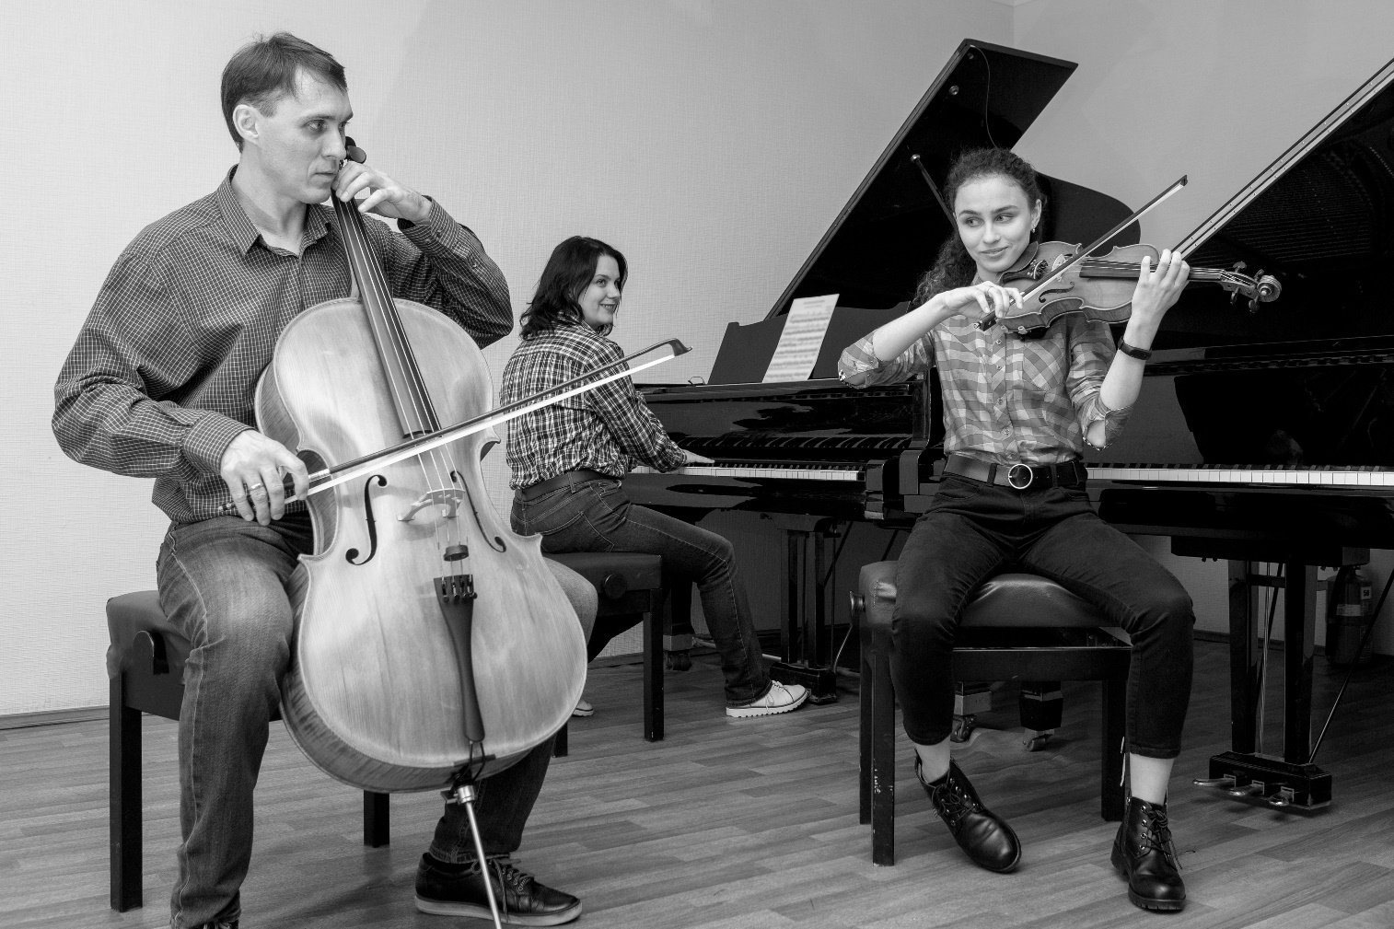
___ / 12

TOTAL: ___ / 20

