Part A • Grammar, Vocabulary and How to …
GRAMMAR

1 Circle the answer (A or B) that best completes each sentence.
0 Is that the song ___ we were listening to in the car?
^{A} what | ^{B} that

1 I met a woman ___ father used to live in my street.
^{A} which | ^{B} whose

2 I’m the technician ___ you spoke to on the phone.
^{A} – | ^{B} what

3 The race, ___ was due to start at 10 a.m., will now
start at 9 a.m.
^{A} which | ^{B} that

4 That’s the famous psychologist ___ I was talking.
^{A} about who | ^{B} about whom

5 I was lucky enough to meet the author, ___ is one
of my favourite crime writers.
^{A} that | ^{B} who
___ / 5
2 Put the words in the correct order to make sentences.
0 to / that / you / need / to / It’s / the doctor / speak
____It’s the doctor that you need to speak to. ____________

1 It / mum / morning / my / this / who / called / was ___________________________________________________.
2 she / an orange / was / asked / for / What / juice
___________________________________________________.
3 should / stay / What / at home / you / is / do
___________________________________________________.
4 that / I / on / visited / holiday / Switzerland / It / was
___________________________________________________.
5 What / you / why / was / you / didn’t / left / me / tell
___________________________________________________.
___ / 5

3 Circle the correct words.
0 I do / don’t want to help you, but I’m really busy right now.

1 She does / doesn’t play the piano, does she?
2 They do / don’t look lovely in their new clothes. So pretty!
3 You did / didn’t try to fix the light, did you?
4 He can’t speak Spanish, but he does / doesn’t speak Catalan.
5 You did / didn’t invite Yannis to the party, didn’t you?
___ / 5

VOCABULARY

4 Complete the sentences with the words and phrases (A–F).
0 The _E_ have cancelled the event because of the bad
A act
B atmosphere
C attend
D line-up
E organisers
F venues
weather.
1 We saw loads of bands but Daft Punk was my favourite ___.
2 I couldn’t go to the festival this year, but I hope to ___ it next year.
3 The ___ doesn’t look very good. I don’t recognise any of the performers.
4 The Apollo is one of my favourite ___ for concerts. It’s a beautiful old building.
5 There was a strange ___ at the concert because no one
was dancing.
___ / 5

5 Complete the sentences with words related to the environment.
0 If you want to reduce your c a r b o n / f o o t p r i n t, you should stop flying.

1 Our company aims to use 100 percent r _ n _ _ a _ l _ energy by 2030.

2 I’ve bought some new garden lights that run on s _ _ a _ / p _ _ _ r

3 The plan for s _ _ t _ _ n _ b _ _ tourism will reduce the impact on the environment.
___ / 3

6 Circle the answer (A or B) that best completes each sentence.
0 I’ve ___ this recipe so I’ll have to start again.
^{A} put up with | ^{B} messed up

1 Why did you ___ the topic of money? You knew it
would cause an argument.
^{A} come up with | ^{B} bring up

2 If you’ve started, why not ___ until you’ve finished?
^{A} carry on | ^{B} end up

3 I hope this plan works because we haven’t got
another one to ___.
^{A} come back with | ^{B} fall back on

4 That man’s horrible eating habits are ___ my dinner.
^{A} putting me off | ^{B} putting up with

5 Thanks for ___ that I hadn’t attached the document.
^{A} moving on | ^{B} pointing out
___ / 5

HOW TO …

7 Complete the sentences with the words and phrases (A–G).
0 I’d say there were _A_ fifteen people at the dinner party.
A around
B kind of
C something
D stuff
E things
F what’s his name
G what’s it called
1 The tutor said there were a few ___ I needed to change in my essay.
2 I saw that boy from your judo class today – ___?
3 They said we had to complete a form or ___ like that.
4 That shop sells breads, cakes, pastries and those ___ things.
5 Do you think we could tidy all this ___ up?
6 I’ve just heard that new Dua Lipa song – ___?

___ / 12

TOTAL: ___ / 40
x 1.25 = ___ / 50

Part B • Listening, Reading and Writing
LISTENING

1 [Audio UT3.01] Listen to five people talking about music festivals. Match the speakers (1–4) with the statements (A–E).
A I wouldn’t go to the same type of festival again.
B The festival wasn’t exactly what I’d expected.
C It was the first time I’d been to a music festival.
D The music wasn’t the most important aspect of the festival for me.
E I’ve been going to the same event for a number of years.
0 Adrian _D_
1 Amanda ___
2 Gabriel ___
3 Lucy ___
4 Seb ___

___ / 4

2 [Audio UT3.01] Listen again. Are the statements True (T) or False (F)?
0 Adrian was disappointed that there weren’t many big acts at
the festival. _F_
1 Amanda was pleased that all of the acts were in the same venue. ___
2 Gabriel is concerned about the amount of pollution created at
the music festival. ___
3 Lucy thought some of the people attending the festival were a bit strange. ___
4 Seb was surprised to find out what the musical instruments were
made from. ___
___ / 8

READING

3 Read the text about making a career in acting. Match the headings (1–4) with the paragraphs (A–E).
0 Carry on learning. _C_
1 Don’t forget your other skills. ___
2 Get yourself out there. ___
3 Don’t let working stop you. ___
4 Make yourself known online. ___
___ / 4

How to make a career in acting
A lot of people dream of becoming a famous actor. Maybe you think you
haven’t got what it takes, but don’t let that put you off. In this article,
we’re going to give you some tips on how to make a career in acting.
A
Firstly, you need to know what’s happening in the acting world. If you don’t
get out and meet people, you won’t know what’s going on. If you’re
living in a big city, there are usually plenty of theatrical productions, as well
as TV and film opportunities. However, if you live in a smaller town,
don’t panic! There might be less happening, but it might be easier to get a
part in a local production. Subscribe to local arts journals and
websites so you don’t miss out on opportunities where you live.
B
Related to the previous point, we’d recommend creating a strong social
media presence for yourself. It’s probably the most effective way to get
yourself known in the acting world. Have you ever noticed how even A-list
celebrities are never off it? It might take time to build up followers, but
try to stay positive. Upload video clips of yourself acting out your favourite
scenes to give your followers a taste of your skills.
C
Nobody ever said acting was easy and even the greatest actors put in a lot
of work to stay at the top. You need to carry on developing your skills
if you want to have an advantage over the competition. One way is to enrol
on an acting course at a local college, but you can also pick things up
in more informal situations. Workshops are a great way to find out about
different acting techniques and you can also look out for online ones.
D
You should also reflect on whether you’ve got any other talents that might
help you get on in your acting career. Don’t forget about the other
things you’re good at as the most successful actors are often the ones who
can sing and dance as well – just think about Ryan Gosling in ‘La La
Land’. So, if you know how to dance a tango or juggle five balls, make sure
you keep practising because it might help get you a role one day.
E
Finally, unless you’ve already been offered a life-changing role, acting
probably won’t be enough to pay the bills. We’ve all heard the stories
about actors working three jobs just to pay the rent. However, it doesn’t have
to be that bad. Just try to find a job which is enjoyable and not too
tiring, so that you’ve got plenty of energy for acting at the end of your shift.
And if you can find an employer who’s flexible about when you work,
it will help when it comes to organising auditions.
4 Read the text again. Circle the answer (A or B) that best completes each sentence.
0 What point is the writer making about acting in the first paragraph?
^{A} Actors are likely to be more successful in a big city. | ^{B} It’s important to be involved in the acting community.

1 What advice does the writer give about social media?
^{A} Create a good impression for your followers. | ^{B} Avoid posting annoying things on social media.

2 What is the writer saying in paragraph C?
^{A} New acting skills can be learnt in a variety of ways. | ^{B} Acting is only easy when you’ve become successful.

3 Why does the writer give the example of Ryan Gosling in the fourth paragraph?
^{A} To show how Ryan Gosling became a succesful actor. | ^{B} To show how having other skills can be useful.

4 What point is the writer making about work in the final paragraph?
^{A} Actors should look for a job with the right conditions. | ^{B} Most actors need to work several jobs to survive.
___ / 8

WRITING

5 Complete the sentences with the words and phrases (A–E).
0 I _A_ that we should take this problem more seriously.
A do think
B feel free
C look forward
D One thing
E require
1 We will be happy to speak to you in person if you ___ any further information.
2 ___ I know is that you can’t believe everything you read.
3 Please ___ to contact us if you have any questions.
4 We ___ to hearing from you in the near future.
___ / 4

6 Read the situation. Write a formal email with your proposal.
Your local authority intends to develop a large open space in your town. Write an email suggesting a sustainable use of the space which will benefit the community.
Write 140–190 words.
___ / 12

TOTAL: ___ / 40
x 1.25 = ___ / 50

Part C • Speaking
SPEAKING

1 Put the words in the correct order to make questions.
Ask your partner your questions.
0 to / you / ever / a music / Have / been / festival?
____Have you ever been to a music festival?_____________

1 do / you’re / What / to relax / when / feeling / do you / nervous? ___________________________________________________
2 a good / tell / you’ve / Can you / me about / book / read?
___________________________________________________
3 in / are / TV programmes / the most / What / popular / your country? ___________________________________________________
4 you / anything / your / Have / done / to reduce / carbon footprint?
___________________________________________________
___ / 4

2 Answer your partner’s questions.
___ / 4
3 Describe the picture to your partner. How do you think the people feel?
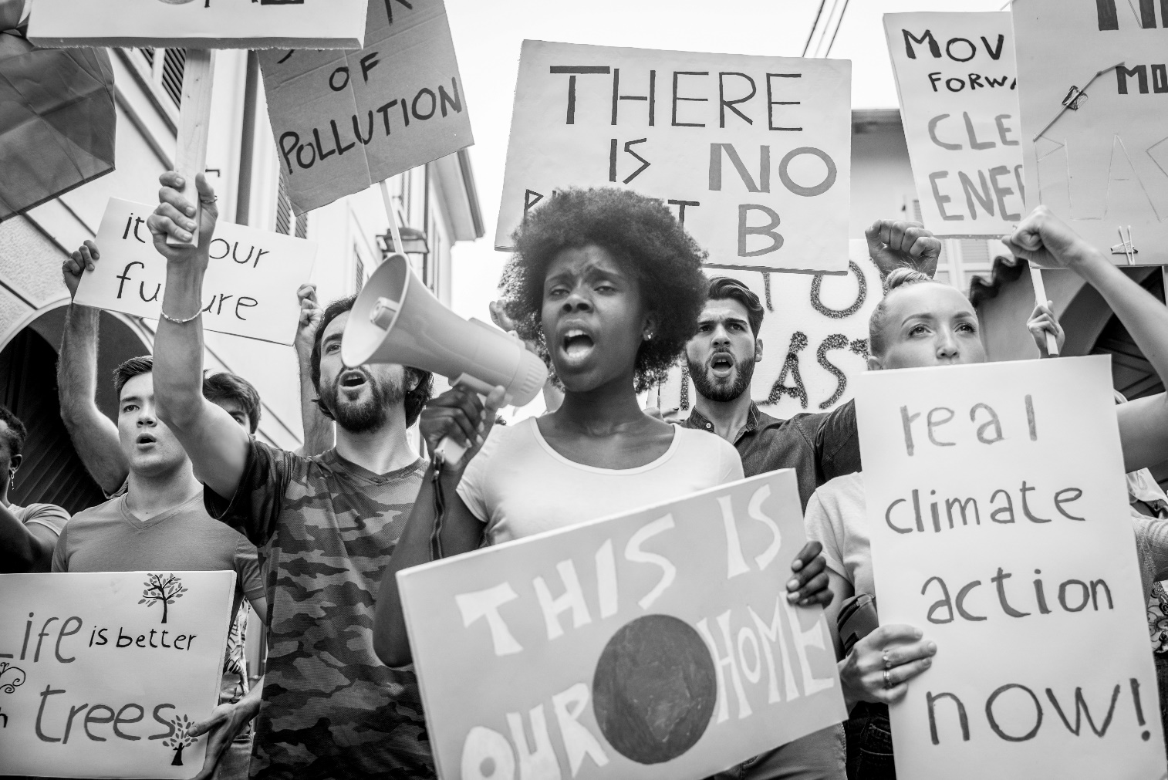
___ / 12

TOTAL: ___ / 20

