**TRANSPORTATION**

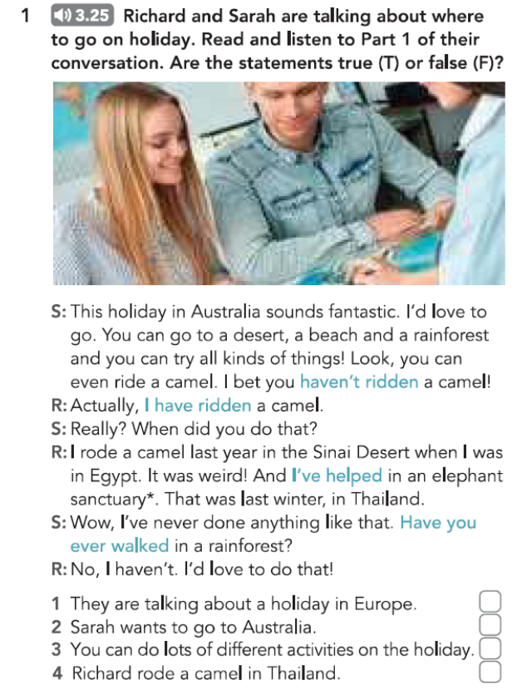

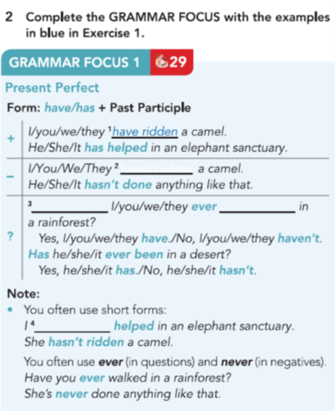





**Part 1**

***1) What kinds of public transport are there where you live?***

We do have a **bus service** in my area. There is also a **train** that goes to the nearest city a few times a day.

**2) *Do you prefer public transport or private transport?***

I definitely like **private transport** best. With my **car**, I can go where I want to whenever I choose to. To make a **journey** on **public transport**, you are not so **independent**.

***3) How do you travel to work?***

In the winter, when it’s cold and wet, I drive my **car** to work but I always get stuck in **a t**raffic jam. As the weather improves, I go by **bike** to avoid the **congestion**.

***4) Is a bicycle a good means of transport?***

Most certainly, because you don’t get held up in **heavy traffic**. Cycling also keeps you fit and is **environmentally-friendly**.

***5) Do you think that there should be a separate lane for bicycles?***

I think that **cycle lanes** are a very good idea as they help to keep cyclists safe from **vehicles**. Since we introduced them in my country, more people have started cycling to work.

**Part 2**

**Describe a method of transport that you enjoy using. You should say:**

* **what kind of transport it is**
* **how often you use it**
* **where you travel using it**

**and explain why you enjoy using it.**

One **form of transport** that I look forward to going on is a **train**. This is because I only use it when I’m going away somewhere exciting, like on holiday or a weekend break.

We have quite a good **rail network** in my country so it’s easy to get where you want to go. However, I live in a rural area and there is just one railway station for the whole region and it only goes to the nearest city. You then have to catch another **train** to go everywhere else. This isn’t very **convenient**. Many people drive 30 miles to the nearest town on the main line and **get on** the **train** there. I sometimes do that too.

I do quite enjoy **train journeys**. They are more relaxing than driving and you can look at the scenery out of the window. The last time I **took the train**, it was very **overcrowded** and I couldn’t get a seat so I had to stand up the whole way.

My last few trips have been up to London for a few days away with a friend. While we’re in the city, we occasionally use the **underground** but mostly get around **on foot**.

I also use the **train** to get to the airport if I’m going abroad. It’s so much easier to plan a trip now that you can see **train** **timetables** online.

I sometimes **travel by train** when I’m visiting other countries. It can be the best way to get around and it’s great if you enjoy meeting the local people. I once went on a **train** in India. It was packed with people but everyone was so friendly and we all shared our snacks.