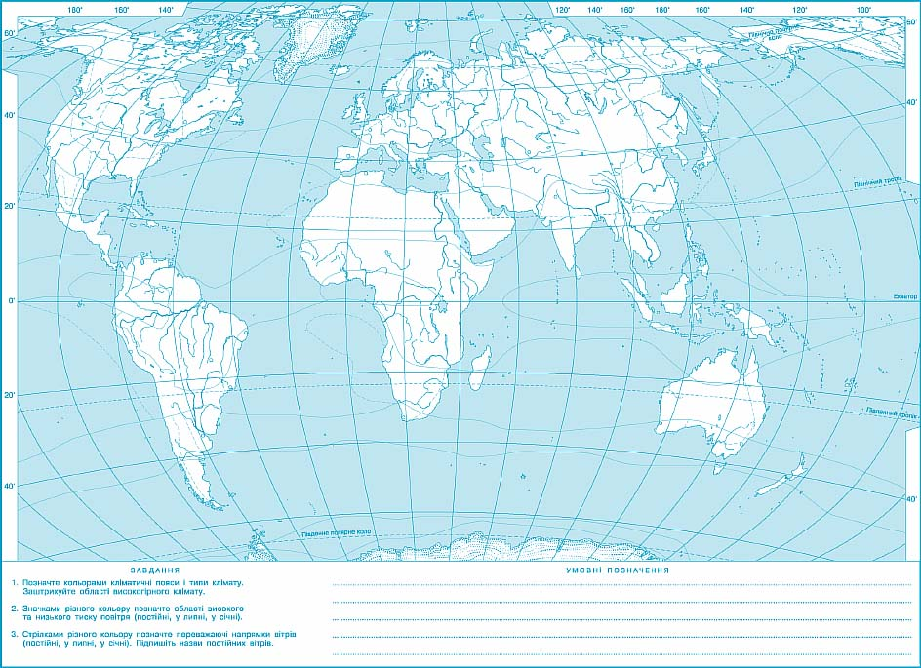Прізвище __________________________

_______________________________________________________________________________________________

Прізвище __________________________

Легенда карти:

__________________________________

__________________________________

__________________________________