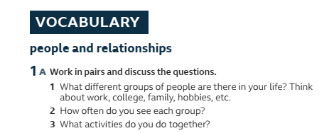









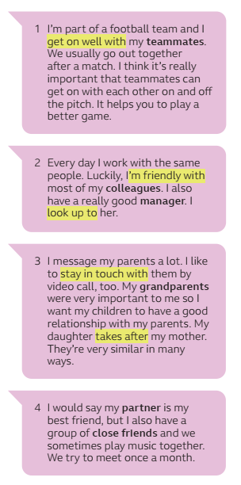

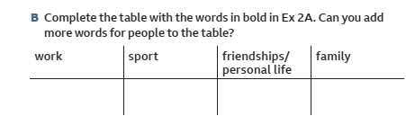

work:

Sport:

friendship/ personal life:

family:













