**1. Read the definitions and write the appropriate term for each. Make up own sentences with these terms.**

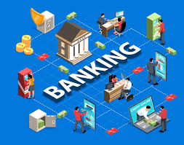

1. the sale of goods in shops to customers, for their own use and not for selling to anyone else
2. the need or desire that people have for particular goods and services
3. someone who buys and sells goods
4. something you buy, or the act of buying it:
5. the activity of buying and selling goods or services on the street
6. the money that you earn from your work
7. an arrangement between a bank and a customer that allows the customer to pay in and take out money:
8. the extra money that you must pay back when you borrow money
9. the system or type of money that a country uses
10. a bank account in which you keep money that you want to save for a period of time, and which pays you interest on the money you have in it
11. when you owe money to someone
12. an object that has been wrapped in paper or put in a special envelope, especially so that it can be sent by post
13. a type of product made by a particular company, that has a particular name or design
14. Person who has marketing responsibilities to develop marketing programs that increase brand identity and awareness for a specific product.
15. a small area of trade within the economy, often involving specialized (= unusual and made for a few people) products
16. a group of shops which belong to a single company, having the same appearance and selling similar goods
17. to meet people who might be useful to know, especially in your job
18. to fail to notice or consider something
19. the total amount of money that a government or person spends
20. they are business expenses that are not dependent on the level of goods or services produced by the business

**2. Choose the necessary word or word combination from suggested below for each empty space.**

|  |  |  |  |
| --- | --- | --- | --- |
| ATM (Automated Teller Machine) | Bank card | ATM card | PIN (Personal Identification Number) |
| transaction | account | saving account | checking account |
| transfer | deposit (n.) | withdraw money | deposit money |
| amount | magnetic card | enter | confirm |
| debit card | low-interest | smart card with clip | swiped out |
| interest | high-interest | receipt |  |

1. I need to find an ATM and _____________________some money. I am short of cash.

2. If you want to put money in, you select__________, or if you want to take out some money, you select___________. But you will have to confirm the _________ of money you enter.

3. I need to _____________ some money to an Internet shop, I just bought a bag from them!

4. You choose the ___________first and then you will get the service you want on ATM.

5. I want to apply for a debit card, because the balance on my _______________is zero.

But the ________________is too high, I am worried about that.

6. My bankcard doesn’t’ work, is it ______________out_?

Oh, ATMs read _______card __________only, not ____________cards.

**3. Answer the following questions.**

1. What is the main function of the bank?
2. How often do you go to the bank?
3. What would you do if a bank deposited millions of dollars into your bank account by accident?
4. Do you carry cash nowadays or do you use credit card more often?
5. Where is a good place to hide money besides the bank?
6. Do you have any good or bad experiences in a bank or with an ATM?

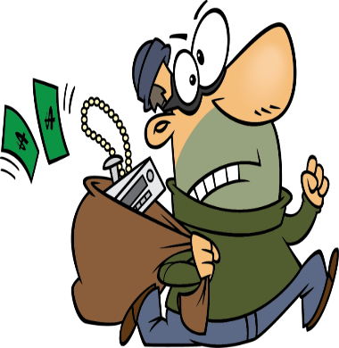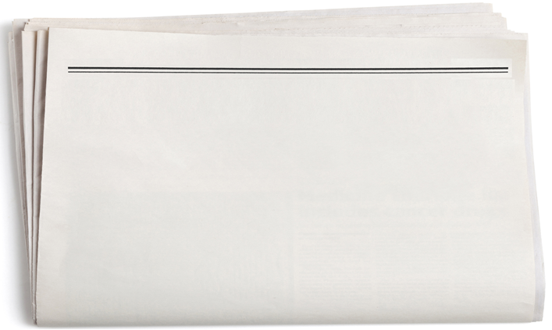

**A BANK ROBBERY**

**▶ READ THIS NEWSPAPER ARTICLE ABOUT A ROBBERY.**

A serious crime was committed yesterday in the centre of London. A million pounds was stolen from the Nat East Bank in Oxford Street by three robbers carrying guns. Customers in the bank were told to lie on the floor while the robbers took the money from the cash. Fortunately, nobody was killed during the robbery, but two people were hurt. They have been in hospital since yesterday morning.

We talked to a policeman after the robbery. This what he said: “We’re going to talk to all the customers in the bank at the time of the robbery and we’re going to start looking for these criminals immediately. They can’t escape from London because we’re going to close all the roads for five kilometres around Oxford Street. If the public help us, we will catch them”.

If you think you can help or if you know something about the robbery, please contact the Central London Police Unit on 207 7646805.

**ANSWER THESE QUESTIONS ABOUT THE TEXT.**

1. How much money was stolen?

2. How many robbers were there?

3. How many people were hurt?

4. How long have they been in hospital?

5. What are the police going to do to the customers?

6. What are they going to do to the roads?

7. What will happen if the public help?