**Money: Vocabulary Quiz!!**





1. A machine used in shops that shows and records the amount of money you have to pay:

3. The money that an organization such as a bank lends and somebody borrows is a:

2. A small flat folding case made of e.g. leather, used for keeping paper money and credit cards:



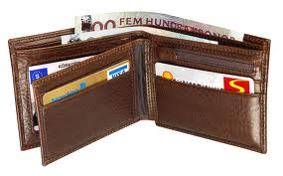

a. moneybags

b. wally

c. wallet

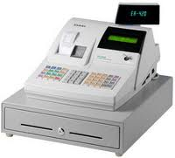

a. cashier

b. cash register

c. cashmere

a. load

b. loan

c. loaf

4. A room with thick walls and a strong door in a bank, used for keeping valuable things safe:

6. A small flat piece of metal used as money:

5. A person who buys and sells things for other people:

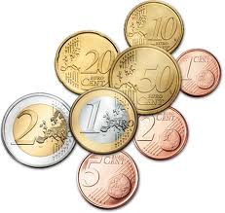

a. monetarist

b. coin

c. copper



a. a beggar

b. a burglar

c. a broker

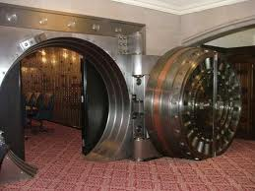

a. voucher

b. vault

c. veal

8. To receive money, property, etc. from somebody when they die:

7. A legal agreement by which a bank lends you money to buy a house:

9. A strong metal box used for storing valuable things in, e.g. money or jewellery:



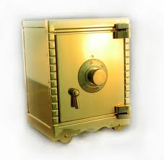

a. safe

b. shell

c. boxer

a. inhibit

b. inherit

c. inhabit



a. mortgage

b. borrowing

c. housing benefit

11. Money that you have to pay to the government so that it can pay for public services:

10. A person whose job is dealing with people arriving at the bank:

12. Any of the units of equal value into which a company is divided and sold to raise money:

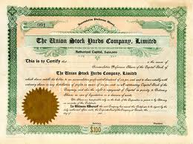

a. shape

b. share

c. shade

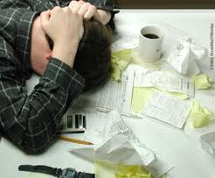

a. debts

b. accounts

c. taxes

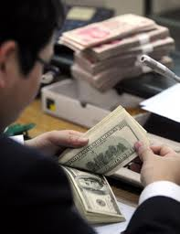

a. clerk

b. banquet

c. banister

14. A person who has a lot of money, possessions, etc. is:

13. A piece of paper that shows how much money you have spent on something:

15. A piece of paper that you can use for paying instead of using money:



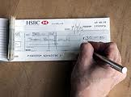

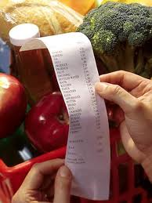

a. cheek

b. cheque

c. chess

a. wealthy

b. healthy

c. filthy

a. recipe

b. receipt

c. recite

18. A piece of paper money:

17. A sum of money you pay regularly to e.g. a bank, until you have returned all the money you owe:

16. To have enough money to be able to buy something:

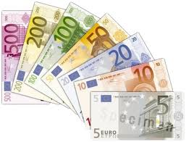



a. note

b. notice

c. nought

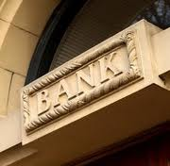

a. repayment

b. rent

c. income

a. affirm

b. afford

c. affair

3. What’s the name of the place where people buy or sell shares in companies?

2. How do you call the small closed box with a narrow opening into which children put coins as a way of saving money?

1. What’s the verb which means “use more money than is necessary or useful”?

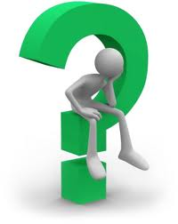2.





7. What’s the verb that means “to give money to somebody which they have to return to you later”?



4. What’s the expression which means “an arrangement that you make with e.g. a shop to pay later for something you buy”?









6. What’s the expression which means “to pay with money in the form of coins or notes”?

5. How do you call the money that employees receive for doing their job, usually paid every month?

9. What’s the verb that means “to take money out of a bank account”?

8. What’s the name of the small plastic card that you can use to buy goods and pay for them later?



**Phrasal Verbs Related to Money**

**Circle the phrasal verbs, translate them.**

|  |  |
| --- | --- |
| My electricity bills are really high. I have to fork out €100 every month. | I can’t go to the theatre this weekend. I’m saving up for my holiday. |
| You have to be careful with credit cards. You can run up huge debts very quickly. | I’m usually very careful with my money but sometimes I splash out on a nice new handbag. |
| If you’re not careful the travel agents will rip you off. You can find cheaper holidays online. | The American government bailed out General Motors. |
| I try to put aside a bit of money each month for emergencies. | My aunt doesn’t like to spend any money. She squirrels it away in the bank instead. |
| I’ve got €10,000 of debt and I don’t know how I’ll pay it off. | I don’t like to send cash through the post. I’ll make out a cheque instead. |

**Match the phrasal verbs with their definitions:**

|  |  |
| --- | --- |
| **Phrasal verb** | **Definition** |
| 1. **make out ____** 2. **save up ____** 3. **put aside ____** 4. **fork out ____** 5. **rip off ____** 6. **splash out ____** 7. **bail out ____** 8. **pay off ____** 9. **run up ____**   **10.squirrel away ____** | 1. Spend a lot on something you like. 2. Pay for something that you don’t want to. 3. Pay your debts 4. Accumulate money in a bank or money box. 5. A con/ Charge a ridiculous amount of money. 6. Rescue someone financially. 7. Complete (a cheque or a document) 8. Store money in a safe place. 9. Accumulate debts. 10. Reserve money to spend later |

**Complete the text:**

|  |  |  |  |  |
| --- | --- | --- | --- | --- |
| **made out** | **saving up** | **fork out** | **rip off** | **splashed out** |
| **put aside** | **bail out** | **run up** | **pay off** |  |

I can’t believe how much weddings cost. It’s a complete ___________. The average couple has to __________£20,000.

We’ve been ___________ since last year. We _________ about £500 each month and so far we have £5000. I ___________ £1000 on a designer wedding dress. I’ve also _______________a cheque for £500 to the church. I hope we don’t ___________ too many debts because they will be difficult to ___________ and we don’t want to ask our parents for a ___________.

**Your turn:**

1. When was the last time you **splashed out** on something you liked?
2. Did you **fork out** a lot for bills last month?
3. What’s the biggest **rip off** ever?
4. Are you **saving up** for anything special at the moment?
5. What type of person are you? Do you like to **put aside** money each month or do you spend your salary in the first week?
6. If one of your friends asked you to **bail them out** what will you say?
7. Are designer clothes a **rip off** or are they worth it?

**Money Mini Test**

**Money vocabulary**

1. When you work you ________ money
2. People write ________ to distribute their money after they die.
3. You can´t buy books at the library but you can ________ them.
4. The library won´t sell you a book but it will ________ you one.
5. If you´re very lucky you will ______ the lottery.
6. If you receive money and it´s a complete surprise you receive a _________.
7. ____________ is a synonym of rich.
8. _____________ and ____________ are synonyms of poor.
9. Some people ___________ in shares and property.
10. If you want to keep money and jewellery secure at home you can put them in a _______.

**Money phrasal verbs**

1. If you spend a lot of money on a treat for yourself you _______ _____.
2. If you buy a lot of things on credit you _______ _______ debts.
3. If you pay your bills you _______ _______ your debts.
4. Your parents have to ______ ______ lots of money for bills each month.
5. If you put money in the bank you ______ _______.
6. If a shop charges too much for something they _______ people _______.
7. If you don´t want to pay for something in cash you can _______ ______ a cheque.