https://m.youtube.com/watch?v=4bkr5lpKGUM&pp=ygUOc2FmZXR5IGF0IHdvcms%3D 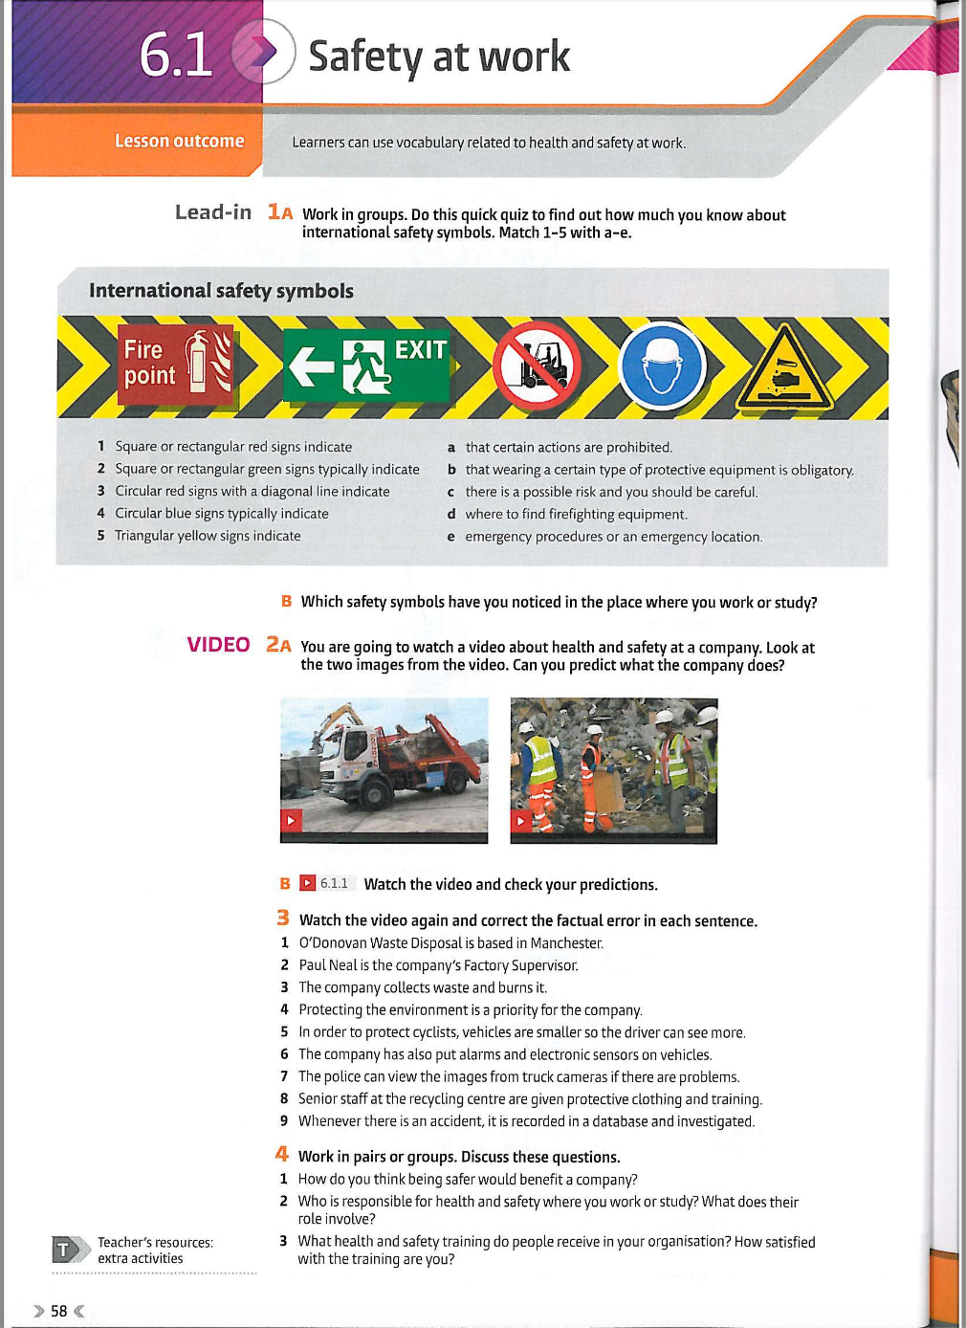

https://m.youtube.com/watch?v=4bkr5lpKGUM&pp=ygUOc2FmZXR5IGF0IHdvcms%3D 