Тема | Джерело  (література, посилання) | Завдання
Практичне заняття 3  Тема “Travel” | 1) “Англійська мова” для студентів 1-го року навчання. “English” for First Year Students: навч.-метод. посіб. для студ. всіх спец. вищ. навч. закл. / І. С. Ковальчук, О. Б. Сивак. – Житомир : ЖДТУ, 2017. – 148 с. | 1) Speaking: “The worst holiday in my life”  2) TEXT “Different types of transport”  3) GRAMMAR revision  HOLIDAYS  Ex. 2, 3, 4 + 6, 7, 10 – p.66-69

Different types of transport
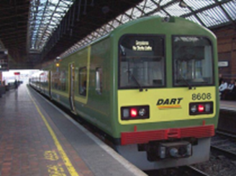
There are lots of different types of transport today.
Some types of transport that we can all use are trains, trams, buses, airplanes, boats, cars, horses, bicycles, motorbikes and others.
In the past, some of these types of transport did not exist. Can you think about how your grandparents travelled?
The most popular means of transport is a car. Nowadays there are so many car producers and brands that a car becomes the most popular and comfortable type of transport. You can travel by car everywhere. The only thing that can stop you is your driving license and the foreign country rules. А dream of many people is to buy a car and for most of them it comes true.
Another popular transport is a bus. Not everyone can drive or many people just want to enjoy the view and concentrate on their thoughts while travelling. And the bus allows all these. The cost of travelling by bus is much lower than that of a car.
Bicycle is popular among young people. They use it during the warm seasons to travel around the city or the nearby places. It’s healthy and affordable for most of people.
Train is popular for its low cost and cozy atmosphere. You can make a long travel on the train and don’t need to pay a lot for it.
Planе is popular for its speed but the cost is quite high. It is thought to be the safest means of transport among all.
The most luxurious means of transport is a ship. I mean not those small ordinary ships, but the ones that travel across the oceans with thousands of tourists. They are often called liners.
So, we just need to pick up the one we like and completely enjoy it.

NOUNS VERBS ADJECTIVES
types of transport  means of transport  producer = manufacturer  brand  driving license  thought (s)  cost  speed  rules  view  opinion | to use  to exist  to become  to enjoy  to think  to pay  to need  to call  to cost  to afford  to allow  to mean  to find | different  popular  comfortable  low (high)  healthy  affordable  cozy  safe  luxurious
Answer the questions:
Did electrocars exist 100 years ago?
What type of transport did our ancestors use before?
What kind of transport is not available in Zhytomyr?
What are the advantages of travelling by car?
Name the advantages of other transport types.
Where did you travel last summer?
Did you enjoy your last trip?
What transport do you use to get to the university?
What is the fare in public transport?

How would you decide what transport to take?
You need to consider your choices and weigh up your options according to the following:
- How fast do you want to get there?
- What degree of comfort do you wish to travel in?
- The cost of the form of transport, perhaps you want the cheapest?
- What is its impact on the environment?

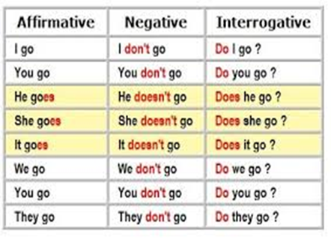 | 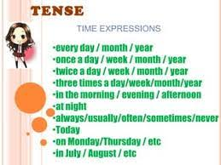
Present simple with regular verbs: yes / no questions  Make present simple questions.  1. _______________ (you / want) a new car?  2. _________________ (she / wear) glasses?  3. ______________ (she / buy) many books?  4. ________ (you / make) dinner every night?  5. _________________ (he / do) the cleaning?  6. _____________________ (it / rain) a lot?  7. __________________ (we / stay) in hotels?  8. _____ (they / go) swimming in the summer?  9. ___________________ (I / need) shoes?  10. ________________ (he / play) the violin?  11. ________________ (he / live) in Sydney?  12. ___________ (we / have) a lot of friends?  13. ____________ (you / make) a lot of cakes?  14. ________________ (we / walk) to work?  15. ________________ (they / study) French?  16. ________________ (they / eat) at school?  17. __________________ (I / like) chocolate?  18. ___________ (it / snow) in the mountains?  19. ________________ (I / sleep) too much?  20. ____________________ (she / drink) tea? | Make the present simple. Don’t use short forms.  1. Where _________________ (she / work)?  2. She ___________ (not / go) to the cinema.  3. He _________________ (hate) cold weather.  4. You _______________ (read) a lot of books.  5. When ________________ (he / go) home?  6. How ____________ (they / arrive) so early?  7. ___________________ (I / call) John?  8. I _______________ (not / study) Japanese.  9. Why _________________ (we / need) this?  10. __________________ (she / have) a dog?  11. They _____________ (not / live) in China.  12. He ______________ (not / pay) for the flat.  13. I __________________ (love) children.  14. We ________________ (use) the Internet.  15. _____________ (he / go) swimming often?  16. ________________ (you / like) ice cream?  17. ________________ (they / want) a drink?  18. They ___________ (buy) coffee every day.  19. What instrument __________ (you / play)?  20. You ____________ (not / eat) chicken.

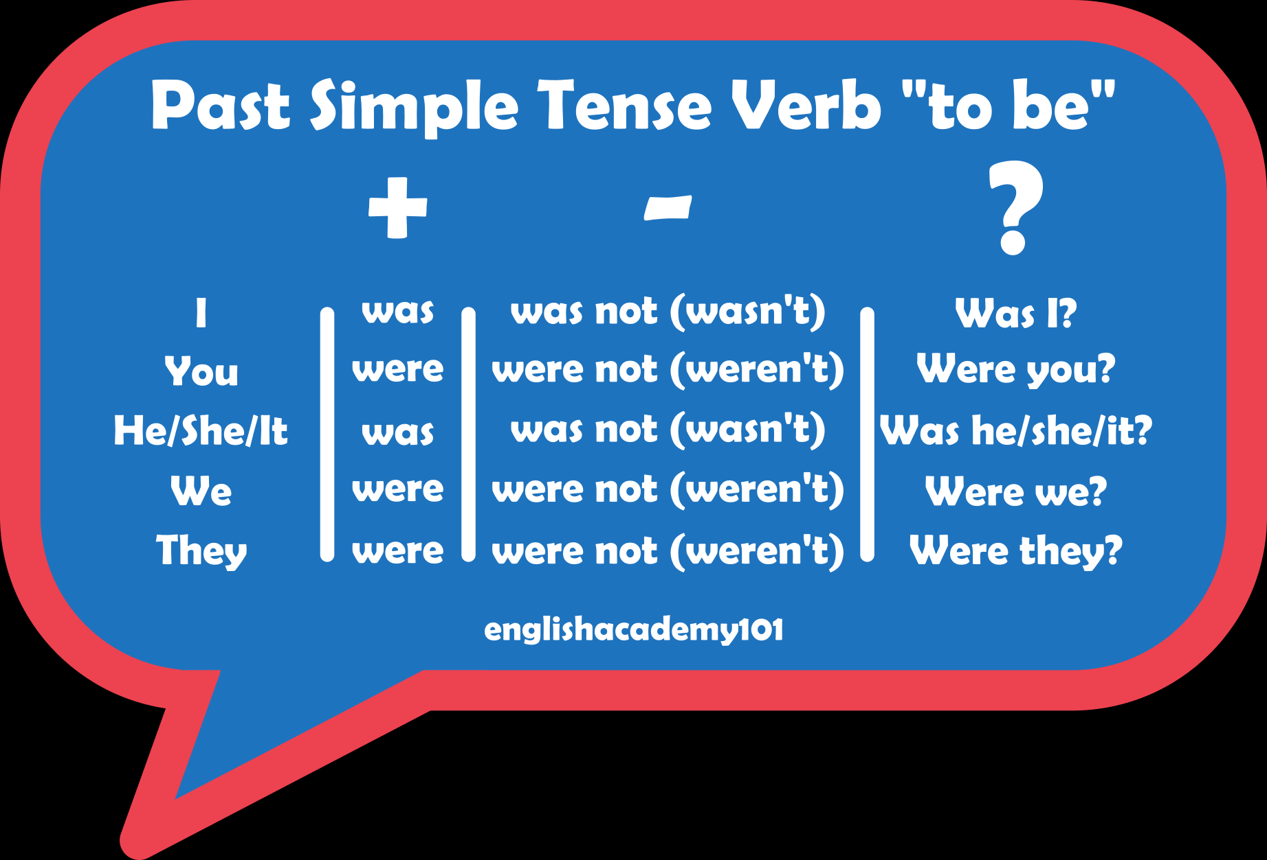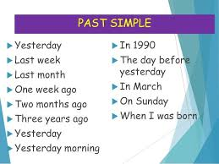

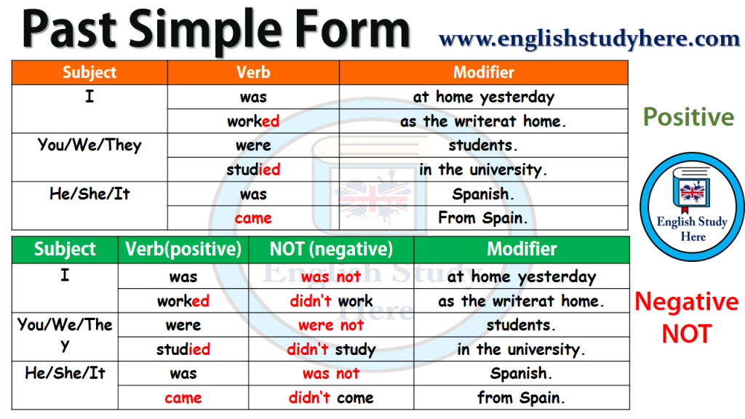

Complete the sentences with the SIMPLE PAST of the verbs in parentheses:
- They ____________________ (watch) TV last night.
- Priscila ____________________ (talk) to her friends all day.
- I ___________________ (have) a terrible headache yesterday.
- Bob _____________________ (come) home from school late.
- They ____________________ (arrive) late and ___________________ (miss) the bus.
- She ____________________ (study) hard and ___________________(pass) the exam.
- He ____________________ (call) the office to tell them he was sick.
- I ___________________ (speak) to the director as he was leaving the room.
- Johnson ______________________ (get up) early this morning.
- Mary ______________ (do) her homework and _____________ (go) to school.
- Chris ____________________ (find) a ten-dollar bill.
- The dog ___________________ (follow) us down the road.
- Those students _________________ (work) hard last semester.
- Lucy _____________ (stop) at the corner and __________________ (call) us.
- I _________________ (try) to talk to Helen last night.
- I ________________ (pay) the phone bill yesterday.
- My dad ___________ (catch) a cold when he ___________ (be) in Canada.
- She ________________ (leave) home early yesterday.
- They ____________ (know) each other very well when they ____________ (be) kids.
- I __________________ (meet) some nice people at the party last weekend.

Write questions
1. She visited her parents last weekend.
2. He cleaned his room before school.
3. Tom wanted to go to the movies alone.
4. Helena offered Henrique a piece of cake.
5. Alexandre helped Anita with her homework.
6. My little brother ate cookies after dinner.
7. They turned off the TV after the news.
8. He drank only a coke at the party.

