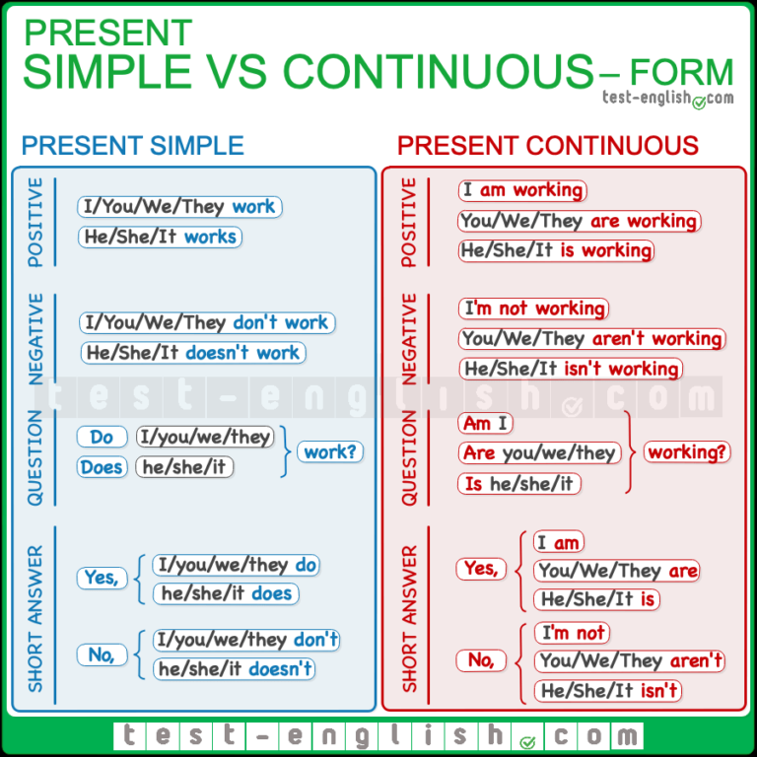
SIGNAL WORDS
PRESENT SIMPLE | PRESENT CONTINUOUS
always, never  often, sometimes  from time to time  seldom, rarely  usually, regularly  every day (week, year) | at the moment  at this moment  right now  currently = nowadays  Look!  Listen!

Choose the present simple or the present continuous - it could be positive, negative or question
1) __________ (you/come) tonight?
2) _____________ (he/eat) rice every day?
3) I _____________ (work) at the moment.
4) _______________ (he/come) to London often?
5) He _________________ (play) tennis now.
6) ________________ (you/come) to the cinema later?
7) They ______________ (not/come) to the party tomorrow.
8) He _____________ (not/play) golf now.
9) _____________ (you/play) tennis this Sunday?
10) They _____________ (go) to a restaurant every Saturday.
11) She ____________ (not/go) to the cinema very often.
12) You usually ____________ (arrive) late.
13) He normally ______________ (eat) dinner at home.
14) ______________ (you/study) every night?
15) ___________________ (they/work) late usually?
16) I ___________(not/work) tonight.
17) ______________ (she/work) at the moment?
18) I _______________ (not/drink) coffee very often.
19) Julie ___________ (sleep) now.

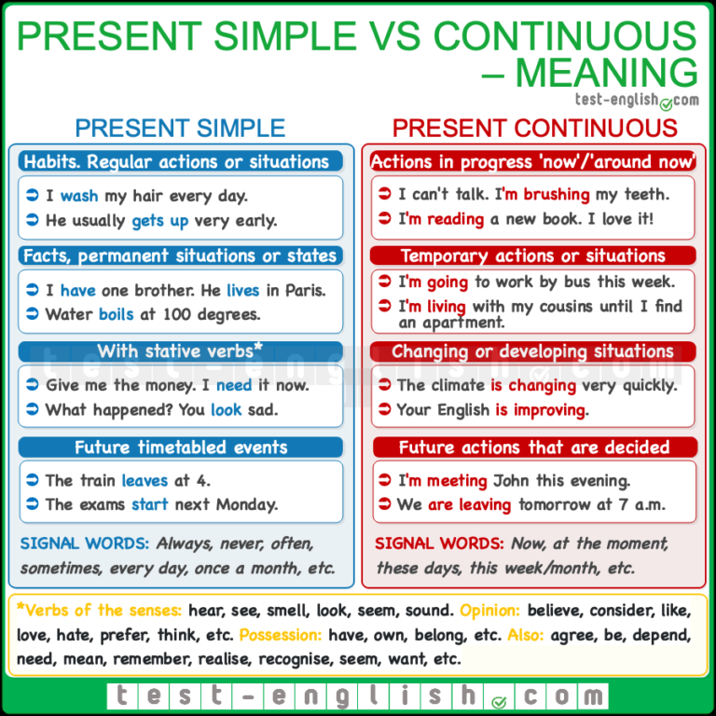

1. What is he doing? He at his desk. (sit)  2. Listen, someone at the door. (knock)  3. On my way home I usually to drink a cup of coffee. (stop)  4. Architects plans of the buildings. (make)  5. Look at Betty: she the piano. (play)  6. At this moment I my pupils' exercises. (correct)  7. Where are you? I my lessons in the study. (prepare)  8. She a lot of money. (earn)  9. Chris near the table. (stand)  10. We often tea for breakfast. (take)  11. William to our workshop on Mondays. (come)  12. Let's wait a moment still. Tom soon. (come)  13. I must run home, mother for me. (wait) | 14. The telephone often during supper. (ring)  15. Stephen a cigarette now. (smoke)  16. It hard at the moment. (snow)  17. I always to my office early. (go)  18. Two and two four. (make)  19. What are you doing here? I for my book. (look)  20. It in autumn. (rain)  21. Look, a man across the street. (run)  22. Listen: Sting ! (sing)  23. Henry's letters by air mail. (come)  24. We many roads nowadays. (build)  25. They usually the ten o'clock bus. (catch)

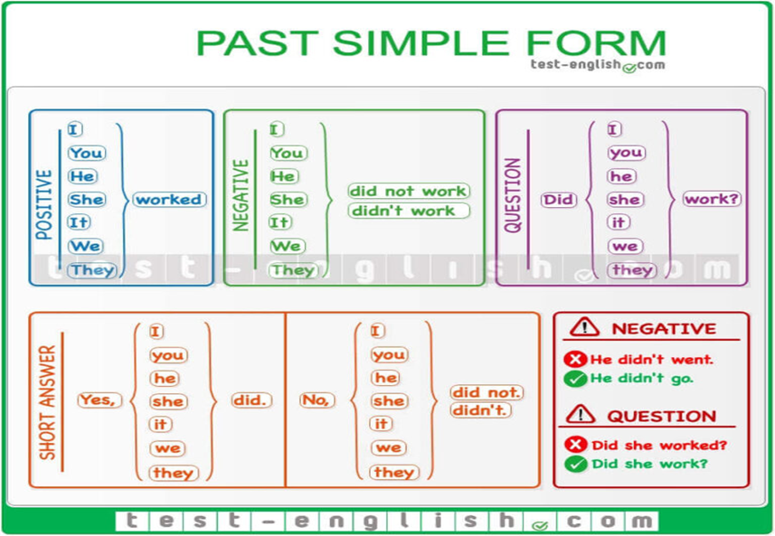 | SIGNAL WORDS  yesterday  last week (year)  10 days ago  20 minutes ago  in 2015  when  The Simple Past is used for actions that started and finished at a specific time in the past.
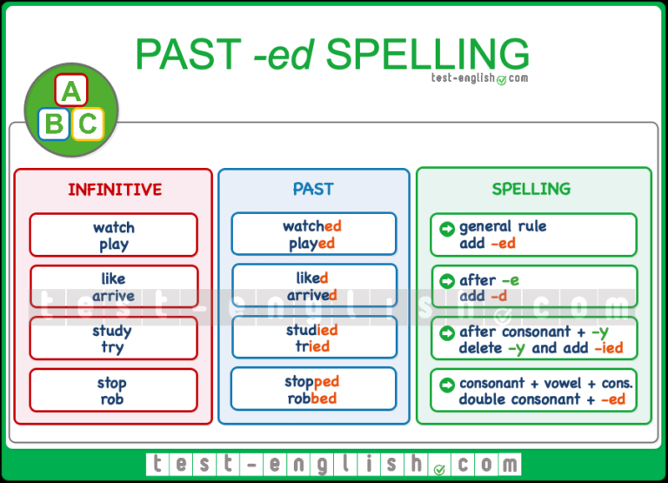
Make the past simple: positive, negative or question.
1. I _________________ (not / drink) any beer last night.
2. She _________________ (get on) the bus in the centre of the city 2 minutes ago.
3. What time _________________ (he / get up) yesterday?
4. Where _________________ (you / get off) the train?
5. I _________________ (not / change) trains at Victoria.
6. We _________________ (wake up) very late.
7. What _________________ (he / give) his mother for Christmas?
8. I _________________ (receive) £300 when my uncle ______________ (die).
9. We _________________ (not / use) the computer last night.
10. _________________ (she / make) good coffee?
11. They _________________ (live) in Paris 5 years ago.
12. She _________________ (read) the newspaper yesterday.
13. I _________________ (not / watch) TV yesterday.
14. He _________________ (not / study) for the exam.
15. _________________ (he / call) you?
16. _________________ (I / forget) something?
17. What time _________________ (the film / start)?
18. He _________________ (have) a shower.
19. Why _________________ (you / come)?
20. _________________ (he / go) to the party?

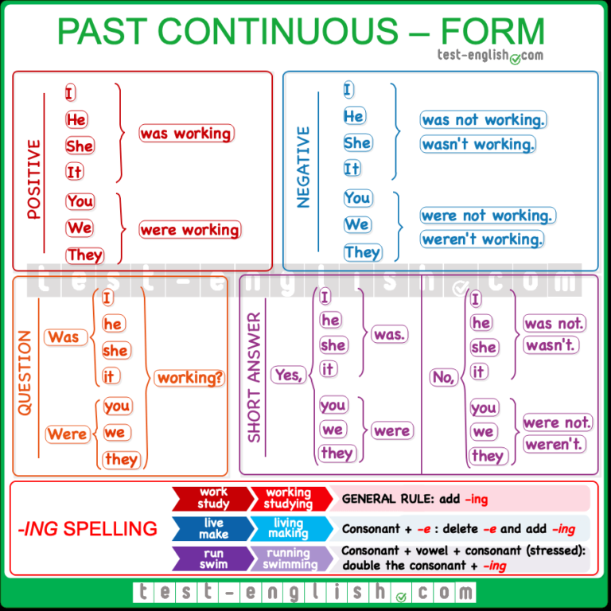

Use the past continuous tense to show a past action that has been interrupted or a habitual action that no longer occurs. You can also use it to emphasize the duration of time an action took or to set the background for a story.

SIGNAL WORDS: Yesterday at 7 o’clock I was watching a film.
We were playing football from 5 till 7 yesterday.
I was translating the text for (during) 30 minutes.
We were enjoying the party the whole evening.

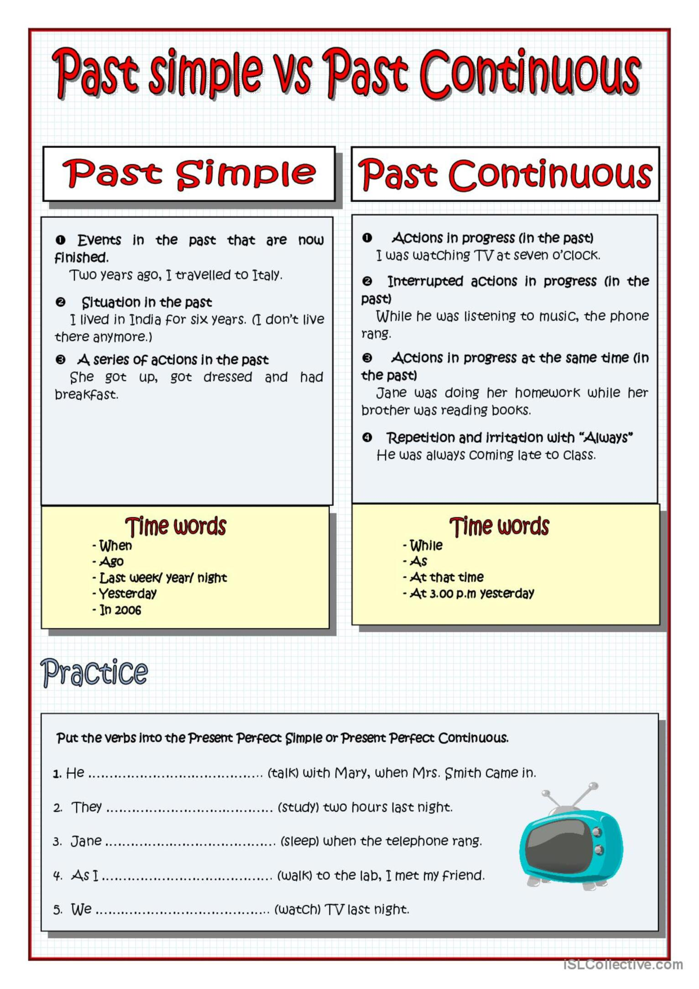

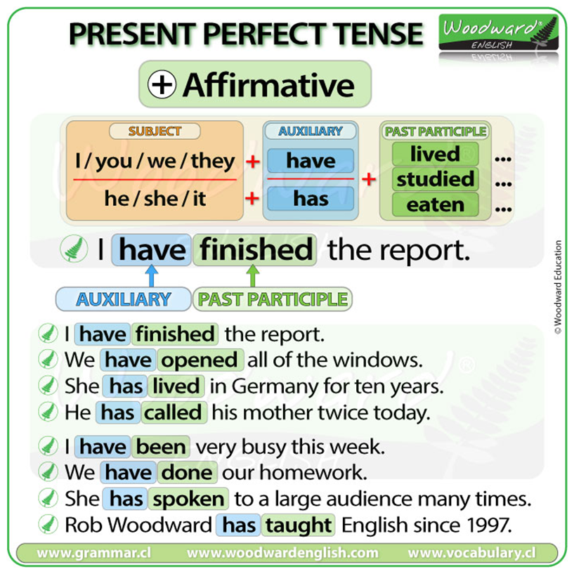 | Present perfect tense is used to describe an action that has taken place in the past but has a connection with the present. We do not specify the exact time that the action had taken place in when using this tense.  SIGNAL WORDS of PRESENT PERFECT  ever  never  just  already  not yet  so far  lately  recently  once, several times  this year (week)  since, for

Choose the correct verb from the list below to complete the following sentences. Put the verb in the present prefect tense.
take / work / find / see / speak / know / begin
do / learn / eat / have / write / give / live / buy / be
1. I met Barbara when we were in elementary school. We ________ each other for over
twenty years.
2. We _______________ many new words since we started this course.
3. That’s a wonderful movie. I __________________ it three times.
4. Mr. and Mrs. Tonner __________________ married for 10 years.
5. You are late! The class ____________ already ______________.
6. Robert is my neighbour. He ________________ next door to me for five years.
7. Mary ___________________ several letters to her parents since she left home.
8. We ___________________ in that restaurant several times.
9. Our teacher __________________ us a lot of help with the homework assignment.
10. She ________________ to her landlord many times about the broken window.
11.We have a new camera. We ___________ some beautiful pictures of the grandchildren.
12. They ____________________ all their homework already.
13. Mrs. Baxter _________________________ all her groceries for the week.
14.Tommy ______________________ a bad cold for two weeks.
15. Frank _____________________ for that company for many years.
16. After three months of looking, she _____________ a beautiful apartment to rent.

Rewrite the following sentences using since or for and the verb provided. You may have to change some of the words, but keep the same meaning.
Example: Bill and Rita got married twenty years ago.
Bill and Rita have been married for twenty years. (be)

1. Jordan moved into this apartment in 2005.
_______________________________________________________________ (live)
2. Ellen and Rose met each other 40 years ago.
______________________________________________________________ (know)
3. The teacher came to school at 8:00 this morning.
_________________________________________________________________ (be)
4. Robbie grew a beard six months ago.
_______________________________________________________________ (have)
5. Dennis bought his car four years ago.
_______________________________________________________________ (own)
6. Maria started to wear glasses when she was five years old.
_______________________________________________________________ (wear)
7. David fell in love with Patricia when they were teenagers.
_________________________________________________________________ (be)
8. Mark started to work at the bank three years ago.
_______________________________________________________________ (work)
9. Sam learned how to swim three years ago.
______________________________________________________________ (know)

