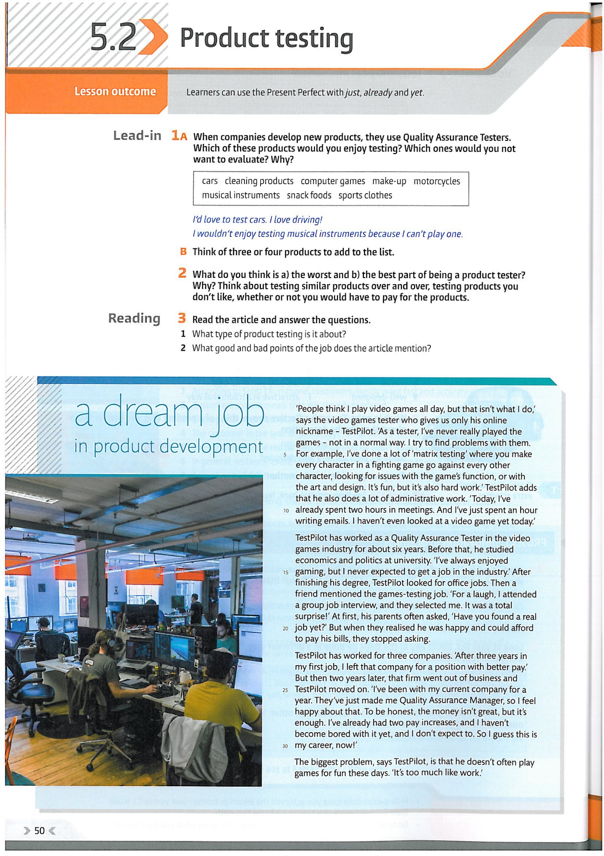

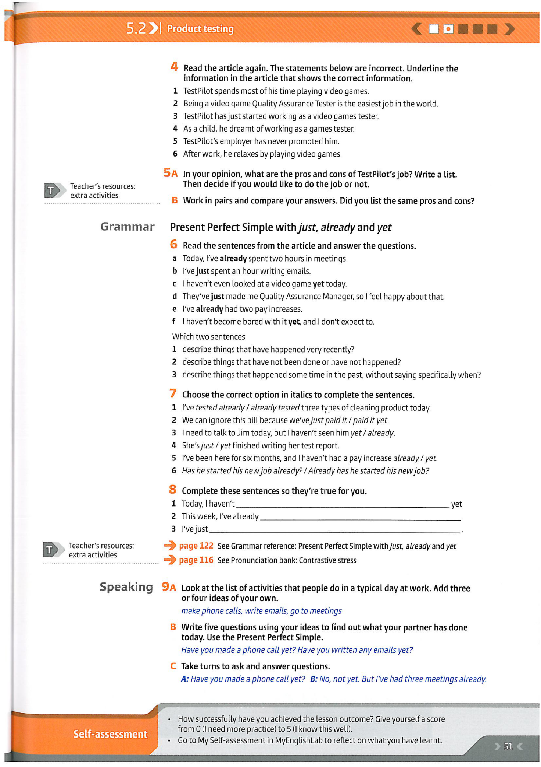

https://fluencyspace.com/exercises/present-perfect-or-past-simple/quiz

https://test-english.com/grammar-points/a2/present-perfect-or-past-simple/

https://www.oxfordlearnersdictionaries.com/grammar/online-grammar/practice/present-perfect-simple-and-past-simple_10

