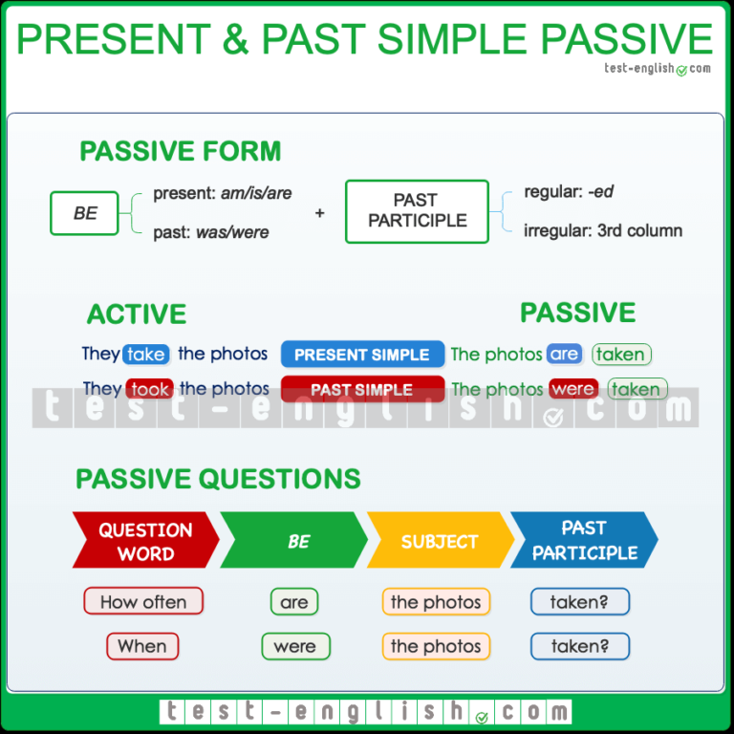
1. Put in the correct form of the verb in Passive into the gaps. Use Simple Present.
Example: Tests ___________. (to pass) - Tests are passed.

Files ______________. (to delete)  A party ____________. (to celebrate)  Forms _____________. (to return)  Ice cream ____________. (to freeze)  The turkey __________. (to roast) | Animals ______________. (to kill)  Beds ________________. (to make)  Service ______________. (to include)  Rumours ______________. (to hear)  Fruits ________________. (to sell)

2. Rewrite the given sentences in Passive voice.
Example: Frank builds a house. - A house is built by Frank.

1. Mr Jones watches films.  2. The people speak English.  3. He reads comics.  4. We play volleyball.  5. They sing the song. | 6. I take photos.  7. She does the housework.  8. The policemen help the children.  9. He writes poems.  10. Mother waters the flowers.

3. Complete the sentences with the present or past simple passive of the verb in brackets.

1. How many newspapers_________ (print) in Britain every day?
2. Who ________________ (this play / write) by?
3. German _________ (speak) in Germany, Austria, and part of Switzerland.
4. The royal wedding __________ (watch) by millions of people in 2011.
5. Nowadays, a lot of computers __________ (make) in Korea.
6. The Harry Potter films ___________ (not direct) by Steven Spielberg.
7. How much __________ (paper / recycle) in Poland each year?
8. In the UK, alcohol ________ (not sell) to anyone under 18. It's against the law.

4. Complete the sentences with the present simple or past simple form of the verb in brackets.
1. Tennis on a clay, grass or hard court. (PLAY)
2. In this hospital small injuries by assistant doctors. (TREAT)
3. The wheel thousands of years ago (INVENT)
4. English in many countries all over the world. (SPEAK)
5. India independence after the end of World War II (GIVE).
6. The goals in the first 15 minutes of the match (SCORE).
7. New medicine for many diseases every year. (FIND)
8. America by Christopher Columbus in 1492 (DISCOVER)
9. Breakfast from 7 a.m. to 10 a.m. (SERVE)
10. The thief to the nearest police station. (TAKE)
11. Every day CNN by millions of people . (WATCH)
12.Coffee to Europe by the Turks (BRING)
13. In Britain, tons of litter away every day. (THROW)
14. Many houses by the flood last week. (DESTROY)

Put the verb in brackets into the correct form of the Future Simple Passive. (will be + ed, III)
1. My flat ____________ next month. (to repair)
2. The children __________ from the window, don't worry! (to see)
3. The documents ___________ as soon as possible. (to sign)
4. The old house ____________ soon. (to destroy)

