Past Simple  V+ed / V(II)  Finishe-finished, work-worked  Go-went, meet-met | Present Perfect  have (has)+ V+ed / V(III)  have (has) finished  have (has) done
Завершені дії, стани або звички у минулому, коли у нас є часова позначка: in 1999, at 5 p.m., last month, yesterday.  We met at a local bar yesterday.  She worked as a waitress in 2012. | для завершених і незавершених дій, станів, звичок у минулому у таких випадках:  Дія, що почалася у минулому і триває дотепер.  У реченні ми часто можемо помітити такі часові позначки, як:  since — для фіксованого часу у минулому: 2022, June, 28th, last month,  for — для певного періоду: 2 weeks, 15 years, 7 hours.  We have known each other since high school.  He has managed the company for 5 years.
Коли нам відомо, що дія закінчилась у минулому, включно із фактами, що стосуються людей, які померли:  The Hundred Years’ War lasted more than 116 years. | Завершені події, що трапилися у житті певної особи, тобто, досвід. Ми часто вживаємо ever або never у таких реченнях:  They have been to Greenland with an expedition.  I have never tried papaya.
Коли переказуємо події та історії:  They entered the hall. The music was playing, and people were dancing. They felt relaxed and joined the party. | Коли період тривалості дії ще не завершений, на що вказують часові позначки today, this week / month / year:  You haven’t trained this week.  She has called him 12 times today.
Події, що трапились нещодавно, наприклад, коли повідомляємо новини. (just / yet / already / recently):
We have just arrived.
I haven’t seen Kate yet.

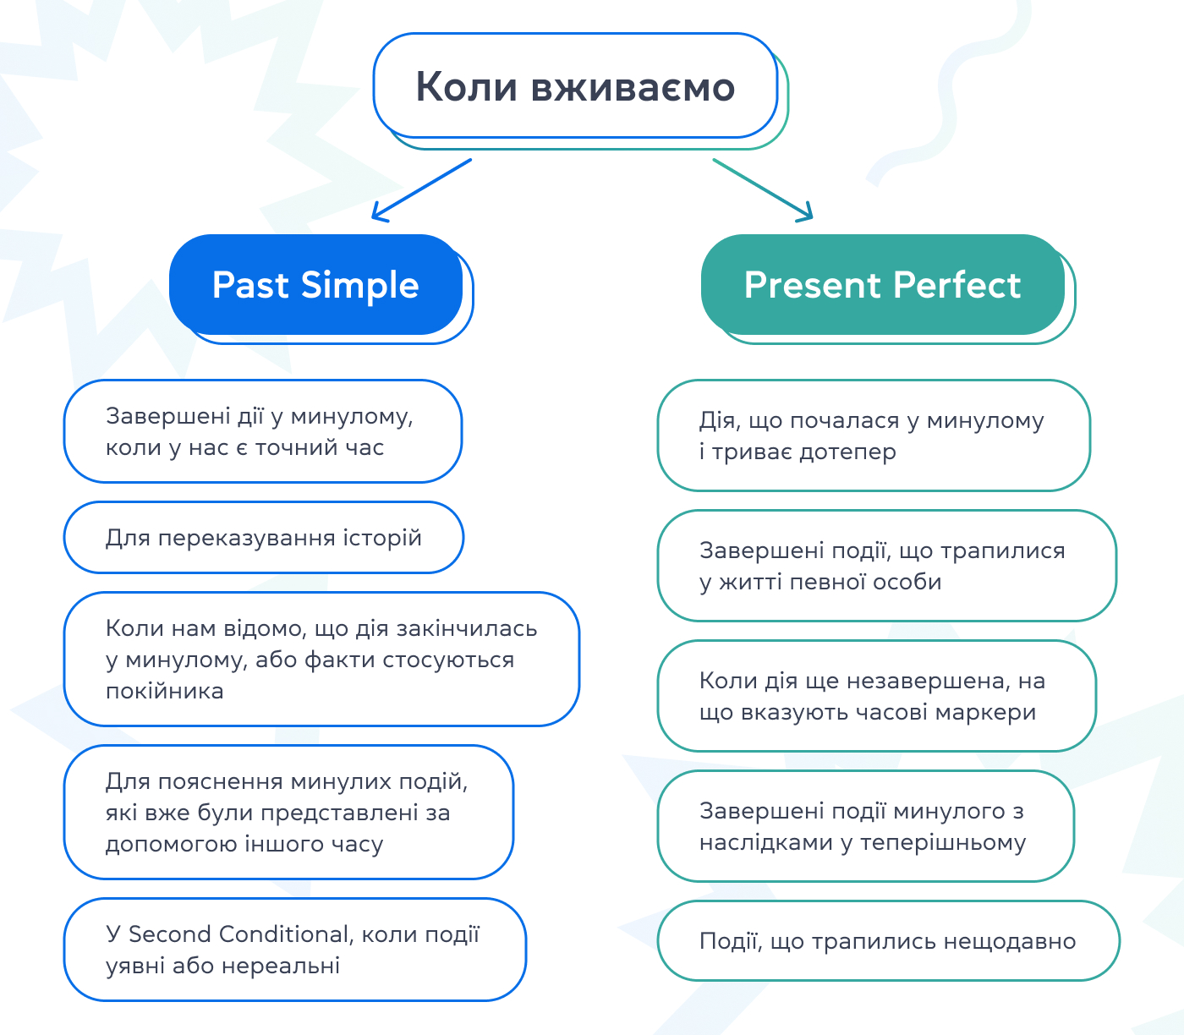
Fill in the correct form of the verb in brackets: Past Simple or Present Perfect Simple
1. The weather around here ___________ terrible in the last few weeks. (BE)
2. Maria ____________ her suitcase last night. (PACK)
3. I ___________ volleyball since I was a teenager. (NOT PLAY)
4. We ____________ wash the dishes. They're all clean now. (HELP)
5. They __________ the factory. – Really? When _______________? (CLOSE, THAT HAPPEN)
6. ____________________ yet? (YOUR BUSINESS COURSE – START)
7. How long ___________ that camera? – About a month. I ___________ it because it was on sale just before Christmas. (YOU HAVE, BUY)
8. ______________ last week's magazine? – It must be here because I ___________ it on Monday. (YOU SEE, BUY)
9. The books you ordered __________. The delivery service _________ them an hour ago. (ARRIVE, BRING)
10. The Queen __________ her two-week tour through Australia yesterday. (START)
11. The plane from New York _________. The passengers are getting out. (JUST LAND)
12. We ____________ a party at school for ages. (NOT HAVE)
13. I ____________ a cold in school a few days ago. (CATCH)
14. Dinosaurs ____________ around the earth millions of years ago. (WANDER)
15. Prices __________ up last year, but they ______ by 8% already this year. (NOT GO, INCREASE)
16. I'm so tired. I ____________ all the way to the underground station. (WALK)
17. We __________ home from our holidays and getting ready to settle in. (JUST COME)
18. She _________ in London for three years. (LIVE)
19. Dusty _______ a match so far this year. He is more successful than last year, when he ________________ the first three matches. (NEVER LOSE, LOSE)
20. He ____________________ off the ladder and ____________________ his ankle. (FALL, BREAK)

https://www.liveworksheets.com/w/en/english-second-language-esl/605137

https://www.liveworksheets.com/w/en/english-second-language-esl/1188731

iplsgmq2xr

