Лекція № 5. Word composition. Classification of compound words.

• Conversion.
• Shortening and its types.
• Non-productive means of word formation:
- blending;
- back-formation;
- onomatopoeia;
- sound and stress interchange.
As English compounds consist of free forms, it is difficult to distinguish them from phrases. The combination top dog ‘a person occupying foremost place’, for instance, though formally broken up, is neither more nor less analysable semantically than the combination underdog ‘a person who has the worst of an encounter’, and yet we count the first (top dog) as a phrase and the second (underdog) as a word. How far is this justified? In reality the problem is even more complex than this isolated example suggests. Separating compounds from phrases and also from derivatives is no easy task, and scholars are not agreed upon the question of relevant criteria. The following is a brief review of various solutions and various combinations of criteria that have been offered.
The problem is naturally reducible to the problem of defining word boundaries in the language. It seems appropriate to quote E. Nida who writes that “the criteria for determining the word-units in a language are of three types: (1) phonological, (2) morphological, (3) syntactic. No one type of criteria is normally sufficient for establishing the word-unit. Rather the combination of two or three types is essential."¹
E. Nida does not mention the graphic criterion of solid or hyphenated spelling. This underestimation of written language seems to be a mistake. For the present-day literary language, the written form is as important as the oral. If we accept the definition of a written word as the part of the text from blank to blank, we shall have to accept the graphic criterion as a logical consequence. It may be argued, however, that there is no consistency in English spelling in this respect. With different dictionaries and different authors and sometimes even with the same author the spelling varies, so that the same unit may exist in a solid spelling: headmaster, loudspeaker, with a hyphen: head-master, loud-speaker and with a break between the components: head master, loud speaker. Compare also: airline, air-line, air line’, matchbox, matchbox, match box’, break-up, breakup. Moreover, compounds that appear to be constructed on the same pattern and have similar semantic relations between the constituents may be spelt differently: textbook, phrase-book and reference book. Yet if we take into consideration the comparative frequency of solid or hyphenated spelling of the combinations in question, the criterion is fairly reliable. These three types of spelling need not indicate different degrees of semantic fusion. Sometimes hyphenation may serve aesthetic purposes, helping to avoid words that will look too long, or purposes of convenience, making syntactic components clearer to the eye: peace-loving nations, old-fashioned ideas.
This lack of uniformity in spelling is the chief reason why many authors consider this criterion insufficient. Some combine it with the phonic criterion of stress. There is a marked tendency in English to give compounds a heavy stress on the first element. Many scholars consider this unity of stress to be of primary importance. Thus L. Bloomfield writes: “Wherever we hear lesser or least stress upon a word which would always show a high stress in a phrase, we describe it as a compound member: ice-cream ['ajs-krijm] is a compound but ice cream ['ajs'krijm] is a phrase, although there is no denotative difference in meaning."¹
It is true that all compound nouns, with very few exceptions, are stressed on this pattern. Cf. ‘blackboard : : ‘blackboard’, ‘blackbird : : ‘black'bird; ‘bluebottle : : ‘blue'bottle. In all these cases the determinant has a heavy stress, the determinatum has the middle stress. The only exception as far as compound nouns are concerned is found in nouns whose first elements are all- and self-, e. g. ‘All-'Fools-Day, ‘self-con'trol. These show double even stress.
The rule does not hold with adjectives. Compound adjectives are double stressed like ‘gray-'green, ‘easy-'going, ‘new-'born. Only compound adjectives expressing emphatic comparison are heavily stressed on the first element: ‘snow-white, ‘dog-cheap.
Moreover, stress can be of no help in solving this problem because word-stress may depend upon phrasal stress or upon the syntactic function of the compound. Thus, light-headed and similar adjectives have a single stress when used attributively, in other cases the stress is even. Very often the stress is structurally determined by opposition to other combinations with an identical second element, e. g. ‘dining table : : ‘writing table. The forestress here is due to an implicit contrast that aims at distinguishing the given combination from all the other similar cases in the same series, as in ‘passenger train, ‘ freight train, ex'press train. Notwithstanding the unity stress, these are not words but phrases.
Besides, the stress may be phonological and help to differentiate the meaning of compounds:
'overwork ‘extra work'
'over'work ‘hard work injuring one’s health'
'bookcase ‘a piece of furniture with shelves for books'
'book'case ‘a paper cover for books'
'man'kind ‘the human race'
'mankind ‘men’ (contrasted with women)
'toy,factory ‘factory that produces toys'
'toy'factory ‘factory that is a toy’.
It thus follows that phonological criterion holds for certain types of words only.²
H. Paul, O. Jespersen, E. Kruisinga¹ and many others, each in his own way, advocate the semantic criterion, and define a compound as a combination forming a unit expressing a single idea which is not identical in meaning to the sum of the meanings of its components in a free phrase. From this point of view dirty work with the figurative meaning ‘dishonorable proceedings’ is a compound, while clean work or dry work are phrases. Сf. fusspot, slow-coach. The insufficiency of this criterion will be readily understood if one realises how difficult it is to decide whether the combination in question expresses a single integrated idea. Besides, between a clearly motivated compound and an idiomatic one there are a great number of intermediate cases. Finally, what is, perhaps, more important than all the rest, as the semantic features and properties of set expressions are similar to those of idiomatic compounds, we shall be forced to include all idiomatic phrases into the class of compounds. Idiomatic phrases are also susceptible to what H. Paul calls isolation, since the meaning of an idiomatic phrase cannot be inferred from the meaning of components. For instance, one must be specially explained the meaning of the expressions (to rain) cats and dogs, to pay through the nose, etc. It cannot be inferred from the meaning of the elements.
As to morphological criteria of compounds, they are manifold. Prof. A. I. Smirnitsky introduced the criterion of formal integrity.² He compares the compound shipwreck and the phrase (the) wreck of (a) ship comprising the same morphemes, and points out that although they do not differ either in meaning or reference, they stand in very different relation to the grammatical system of the language. It follows from his example that a word is characterised by structural integrity non-existent in a phrase. Unfortunately, however, in the English language the number of cases when this criterion is relevant is limited due to the scarcity of morphological means.
“A Grammar of Contemporary English” lists a considerable number of patterns in which plural number present in the correlated phrase is neutralised in a compound. Taxpayer is one who pays taxes, cigar smoker is one who smokes cigars, window-cleaner is one who cleans windows, lip-read is to read the lips. The plural of still-life (a term of painting) is still-lifes and not still lives. But such examples are few. It cannot be overemphasised that giving a mere description of some lexicological phenomenon is not enough; one must state the position of the linguistic form discussed in the system of the language, i.e. the relative importance of the type. Therefore the criterion of structural integrity is also insufficient.
The same is true as regards connective elements which ensure the integrity. The presence of such an element leaves no doubt that the combination is a compound but the number of compounds containing connective elements is relatively insignificant. These elements are few even in languages morphologically richer than English. In our case they are -s- (craftsman), -o- (Anglo-Saxon), -i- (handiwork.)
Diachronically speaking, the type craftsman is due either to the old Genitive (guardsman, kinsman, kinswoman, sportsman, statesman, tradesman, tradeswoman, tradesfolk, tradespeople) or to the plural form.
The Genitive group is kept intact in the name of the butterfly death’s head and also in some metaphorical plant names: lion’s snout, bear’s ear, heart’s ease, etc.
The plural form as the origin of the connective -s- is rarer: beeswax, woodsman, salesman, saleswoman. This type should be distinguished from clothes-basket, goods-train or savings-bank, where the singular form of the word does not occur in the same meaning.
It has already been pointed out that the additive (copulative) compounds of the type Anglo-Saxon are rare, except in special political or technical literature.
Sometimes it is the structural formula of the combination that shows it to be a word and not a phrase. E. g. starlit cannot be a phrase because its second element is the stem of a participle and a participle cannot be syntactically modified by a noun. Besides the meaning of the first element implies plurality which should have been expressed in a phrase. Thus, the word starlit is equivalent to the phrase lit by stars.
It should be noted that lit sounds somewhat, if a very little, obsolete: the form lighted is more frequent in present-day English. This survival of obsolete forms in fixed contexts or under conditions of fixed distribution occurs both in phraseology and composition.
To some authors the syntactical criterion based on comparing the compound and the phrase comprising the same morphemes seems to ,be the most promising. L. Bloomfield points out that “the word black in the phrase black birds can be modified by very (very black birds) but not so the compound-member black in blackbirds."¹ This argument, however, does not permit the distinguishing of compounds from set expressions any more than in the case of the semantic criterion: the first element of black market or black list (of persons under suspicion) cannot be modified by very either.²
This objection holds true for the argument of indivisibility advanced by B. Bloch and G. Trager who point out that we cannot insert any word between the elements of the compound blackbird.³ The same example black market serves H. Marchand to prove the insufficiency of this criterion.⁴ Black market is indivisible and yet the stress pattern shows it is a phrase.
² Prof. R. Lord in his letter to the author expressed the opinion that black market and black list could be modified by very in order to produce an ironically humorous effect, although admittedly this kind of thing would not occur in normal speech. The effect of the deviation therefore proves the existence of the norm.
Some transformational procedures that have been offered may also prove helpful. The gist of these is as follows. A phrase like a stone wall can be transformed into the phrase a wall of stone, whereas a toothpick cannot be replaced by a pick for teeth. It is true that this impossibility of transformation proves the structural integrity of the word as compared with the phrase, yet the procedure works only for idiomatic compounds, whereas those that are distinctly motivated permit the transformation readily enough:
a toothpick ↔ a pick for teeth tooth-powder → powder for teeth a tooth-brush → a brush for teeth
In most cases, especially if the transformation is done within the frame of context, this test holds good and the transformation, even if it is permissible, brings about a change of meaning. For instance, ...the wall-papers and the upholstery recalled ... the refinements of another epoch (Huxley) cannot be transformed without ambiguity into the papers on the wall and the upholstery recalled the refinements of another epoch.
That is why no one type of criteria is normally sufficient for establishing whether the unit is a compound or a phrase, and for ensuring isolation of word from phrase. In the majority of cases we have to depend on the combination of two or more types of criteria (phonological, morphological, syntactic or graphical). But even then the ground is not very safe and the path of investigation inevitably leads us to the intricate labyrinth of “the stone wall problem” that has received so much attention in linguistic literature.

Pseudo-compounds
The words like gillyflower or sparrow-grass are not actually compounds at all, they are cases of false-etymology, an attempt to find motivation for a borrowed word: gillyflower from OFr giroflé, crayfish (small lobster-like fresh-water crustacean, a spiny lobster) from OFr crevice, and sparrow-grass from Latin asparagus.
May-day (sometimes capitalised May Day) is an international radio signal used as a call for help from a ship or plane, and it has nothing to do with the name of the month, but is a distortion of the French m'aidez ‘help me’ and so is not a compound at all.
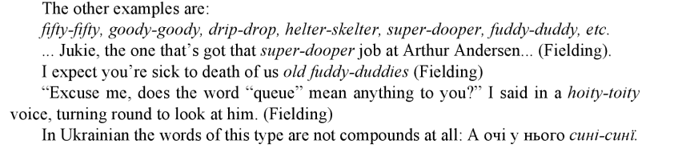
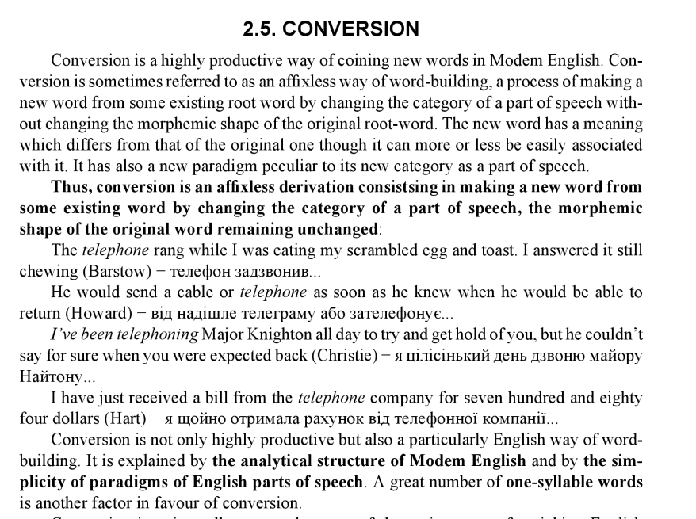
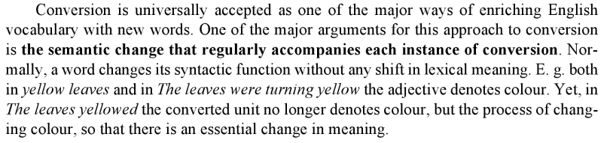
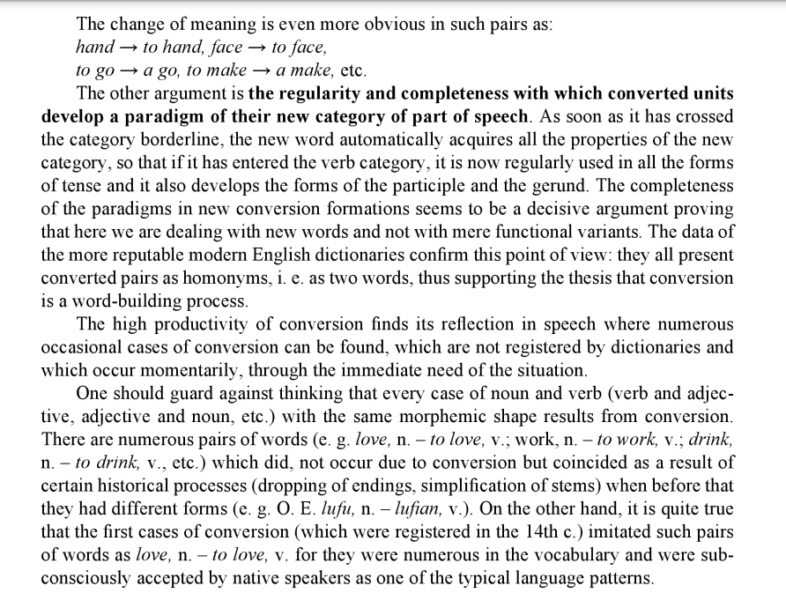
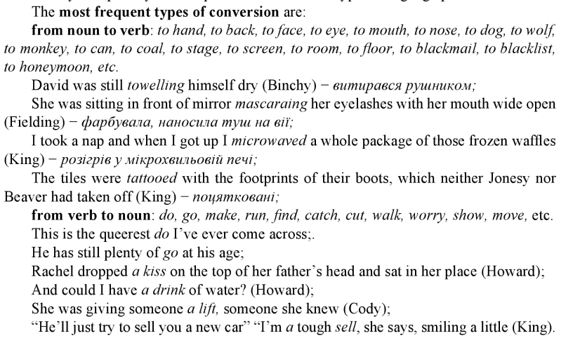
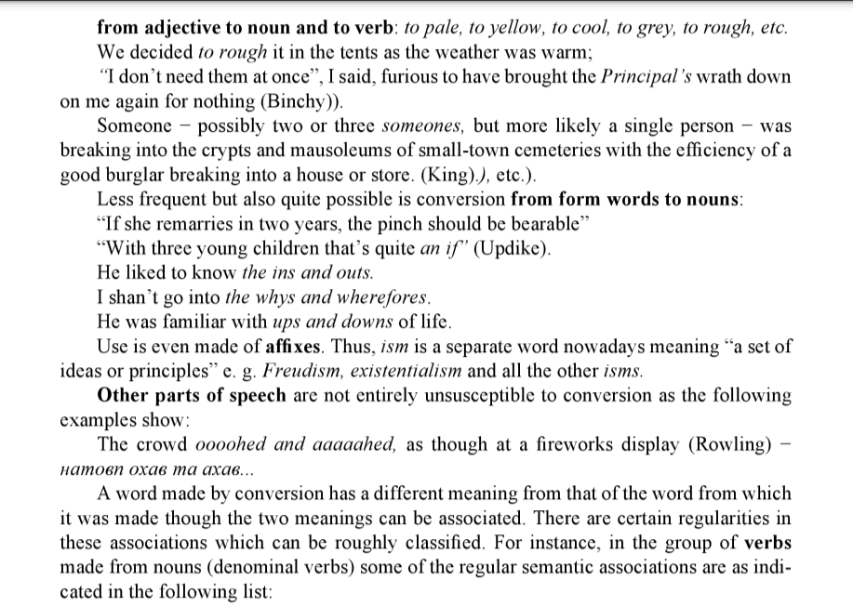
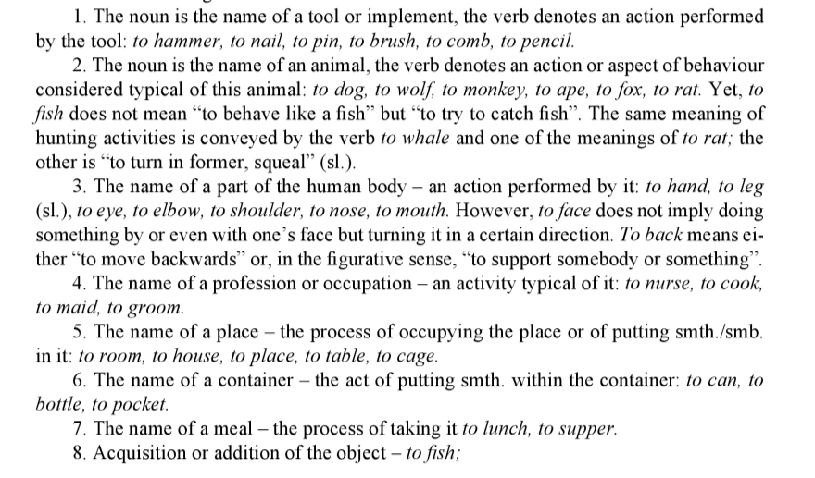

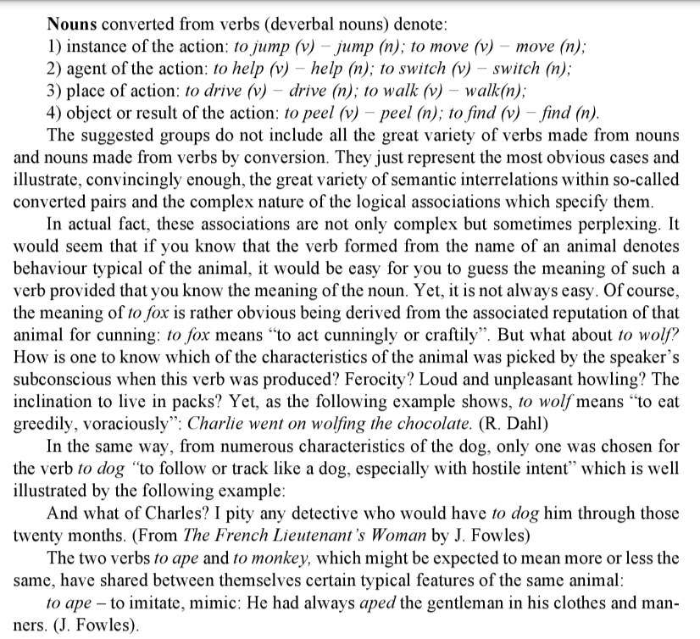
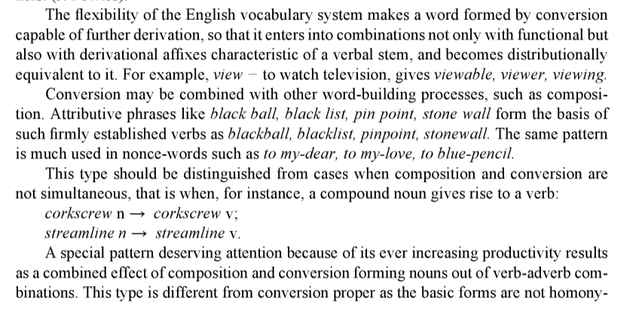
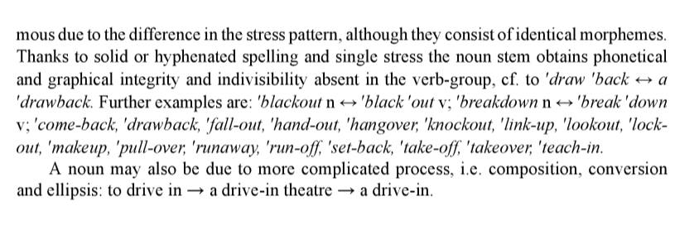

Shortening. Lexical abbreviations. Acronyms. Clipping.
The shortening of words involves the shortening of both words and word-groups. Distinction should he made between shortening of a word in written speech (graphical abbreviation) and in the sphere of oral intercourse (lexical abbreviation). Lexical abbreviations may be used both in written and in oral speech. Lexical abbreviation is the process of forming a word out of the initial elements (letters, morphemes) of a word combination by f simultaneous operation of shortening and compounding.
This comparatively new way of word-building has achieved a high degree of productivity nowadays, especially in American English.
Shortenings (or contracted/curtailed words/clipping) are produced in two different ways. The first is to make a new word from a syllable (rarer, two) of the original word. The latter may lose its beginning (as in phone made from telephone, fence from defence), its ending (as in hols from holidays, vac from vacation, props from properties, ad from advertisement) or both the beginning and ending (as in flu from influenza, fridge from refrigerator):
It was remarkable that the prisoners were so brain-dulled by their conditions that the onset of flu symptoms caused no special reaction at first. (Clancy).
Words that have been shortened at the end are called apocope (vet (veterinary); doc (doctor); prof (professor); prep (preparatory); mayo (mayonnaise); polio (poliomyelitis); pro (professional); hi-fi (high fidelity); hi-tech (high technology); sci-fi (of or pertaining to science fiction); UA. міськрада, (міська рада) мінекономіки (міністерство економіки), генпрокуратура (генеральна прокуратура), aдмінресурс (адміністративний ресурс); Мін 'юст (Міністерство юстиції); Мінфін (Мініcmерcmво фінансів); держдеп (державний департамент США); універмаг (універсальний магазин); нардеп (народний депутат); комп (комп'ютер); клава (клавіатура); універ (університет); лаби (лабораторні роботи)):
Next he opened the jar of mayonnaise, and using his finger as a knife, began to slather the slices of bread with mayo.(King).
“It was a bomb, essentially, a Molotov cocktail, gas and motor oil” the fire marshal said. “Not a pro job, but a pro couldn't have done it any better” (Sandford).
There must have been thousands of people with minicams (minicamera) at the scene (Clancy).
It had taken him just five years to turn Tech-Electric, a failing electronics firm that he'd bought for a song in 1979, into a leading manufacturer of business and personal computer products (Clancy).
Тоді можуть бути закриті або обмежені коррохунки українців в іноземних банках (кореспондентський рахунок).
Відмова від євроінтеграції, навіть як від стратегічної, бодай і віддаленої мети...(європейська інтеграція).
Words that have been shortened at the beginning are called aphaeresis (phone (telephone);bus (omnibus); copter (helicopter); cute (acute):
One by one the other copters rogered. Only Kurtz did not, but he also stayed put (King).
And at the radio station, the DJ picked up a phone, said “OK”, looked through the glass of the broadcast booth at the engineer and the general manager behind him and nodded (Sandford).
There's a little girl out there, about four years old, cute as devil (King).
Words in which some syllables or sounds have been omitted from the middle are called syncope (ma 'm - madam, specs - spectacles). Sometimes a combination of these types is observed (tec − detective, frig − refrigerator).
The second way of shortening is to make a new word from the initial letters of a word group (UNO ['ju:neu] from the United Nations Organisation). This type is called initial shortenings. They are found not only among formal words, but also among colloquialisms and slang. So, g. f. is a shortened word made from the compound girl-friend.
It is commonly believed that the preference for shortenings can be explained by their brevity and is due to the ever-increasing tempo of modern life. Confusion and ambiguousness are quite natural consequences of the modern overabundance of shortened words, and initial shortenings are often especially enigmatic and misleading as the following conversation between two undergraduates clearly shows:
- Who's the letter from?
- My g. f.
- Didn't know you had girl-friends. A nice girl?
- Idiot! It's from my grandfather!
Here are some more examples of informal shortenings:
moving-picture → movie
gentleman → gent
spectacles → specs
circumstances → circs
a written acknowledgement of debt, made from I owe you → I. O. Y.
liberty → lib
certainty → cert
metropoly → metrop
exhibition → exhibish
Undergraduates' informal speech abounds in words of the type: exam, lab, prof, vac, hol, co-ed (a girl student at a coeducational school or college).
The term abbreviation may be also used for a shortened form of a written word or phrase used in a text in place of the whole for economy of space and effort. Abbreviation is achieved by omission of letters from one or more parts of the whole:
abbreviation → abbr  building → bld  government → govt  word → wd | dozen → doz/dz  limited → ltd  Bachelor of Arts → BA  New York State → N.Y.
Sometimes the part or parts retained show some alteration, thus, oz denotes ounce and Xmas denotes Christmas. Doubling of initial letters shows plural forms as for instance pp for pages, ll for lines or cc for chapters. These are in fact not separate words but only graphic signs or symbols representing them.
Abbreviations are often used in Internet communication:
AFAIK − As far as I know;  BTW − By the way;  DH − Dear husband;  DIY − Do it yourself;  FYI − For your information;  HTH − Hope this helps; | ICBW − I could be wrong;  (sometimes it could be worse);  ISWYM − I see what you mean;  SCNR − Sorry, could not resist;  TIA − Thanks in advance;  TTFN − Та ta for now;  TWIMC − To whom it may concern;
A specific type of abbreviations having no parallel in Ukrainian is represented by Latin abbreviations which sometimes are not read as Latin words but substituted by their English equivalents:
ad lib (Lat ad libitum) — at pleasure;
a.m. (Lat ante meridiem) — in the morning
cf. (Lat conferre) — compare;
cp. (Lat comparare) — compare;
e.g. (Lat exempli gratia) — for example;
ib(id) (Lat ibidem) — in the same place;
i.e. (Lat id est) — that is;
loc.cit. (Lat locus citato) — in the passage cited;
ob. (Lat obiit) — he (she) died;
q.v. (Lat quod vide) — which see;
p.m. (Lat post meridiem) — in the afternoon;
viz (Lat videlicet) — namely.
An interesting feature of present-day English is the use of initial abbreviations for famous persons’ names and surnames. Thus, George Bernard Shaw is often alluded to as G.B.S. ['dзi:'bi:'es], Herbert George Wells as H.G. The usage is clear from the following example: “Oh, yes ... where was I?” “With H.G.’s Martians,” I told him (Wyndham).
UA. ЛМ − Леонід Макарович);
Російські політтехнологи радять своєму президенту розбавляти офіціоз гумором і сатирою, тож ВВП і пожартував... (Україна молода № 2067 29.01.2003)
Journalistic abbreviations are often occasioned by a desire to economise head-line space:
the Campaign for Nuclear Disarmament → CND.
the NATO multilateral nuclear force → MLF
CND Calls Lobby to Stop MLF (Daily Worker).
The Americans claim that, so long as legislation elsewhere falls sport of their own Foreign Corrupt Practices Act (FCPA) of 1977, they are at a disadvantage in bidding for international contracts. The FCPA outlaws the payment of bribes by American firms to foreign officials, political parties, party officials and candidates.(The Economist Feb 28th 2002)
UA. ПІК “Політика і культура”;
СІЧ “Слово і Час”;
УМ “Україна молода”;
It must be emphasised that initial abbreviation, no less than other types of shortening, retains the valency, i.e. the combining possibilities of the prototypes. The difference in distribution is conditioned only by a change of meaning (lexical or more rarely lexico-grammatical). Abbreviations receive the plural and Possessive case inflections: G.I.’s, M.P.’s, P.O.W.’s (from prisoner of war), also the verb paradigm: okays, okayed, okaying. E. g. A hotel’s no life for you... Why don’t you come and P.G. with me? (A. Wilson) Here P.G. is an abbreviation for paying guest. Like all nouns they can be used attributively: BBC television, TV program, UN vote.
A specifically English word pattern almost absent in the Ukrainian language must be described in connection with initial abbreviations in which the first element is a letter and the second a complete word:
A-bomb − atomic bomb;
H-bomb − hydrogen bomb;
x-ray − translation of German X-Strahl the name orig. given to the rays by Roentgen, x signifying their unknown nature;
H-hour − the time, usually unspecified, set for the beginning of a planned attack; H (for hour)+hour);
D-day − D (for day) + day);
UA. Час Х;
час Ч.
There is no uniformity in semantic relationships between the elements: Z-bar is a metallic bar with a cross section shaped like the letter Z, while Z-hour is an abbreviation of zero-hour meaning “the time set for the beginning of the attack”, U is standing for upper classes in such combinations as U-pronunciation, U-language. Cf.: U-boat “a submarine”. Non-U is its opposite. So Non-U speakers are those whose speech habits show that they do not belong to the upper classes.
If the abbreviated written form lends itself to be read as though it were an ordinary English word and sounds like an English word, it will be read like one. The words thus formed are called acronyms (from Gr across − “end'”+onym “name”). This way of forming new words is becoming more and more popular in almost all fields of human activity, and especially in political and technical vocabulary:
English | Ukrainian
UN − United Nations ;  USA − United States of America;  NATO − North Atlantic Treaty Organization;  UNICEF − United Nations International Children's Emergency Fund;  UNESCO − United Nations Educational, Scientific, and Cultural Organization;  OPEC − Organization of Petroleum Exporting Countries;  BBC − British Broadcasting Corporation;  M.P. − Member of Parliament;  VIP − very important person;  SOS − save our souls;  GI − government issue (американський солдат);  POW − prisoner of war;  AIDS − acquired immune deficiency syndrome;  HIV − human immunodeficiency virus. | ООН − Організація Об'єднаних Націй;  США Сполучені Штати Америки  НАТО;  ЮНІСЕФ;  ЮНЕСКО;  ОПЕК;  ОБСЄ − Організація з безпеки та співробітництва в Європі;  УНР − Українська народна республіка;  СБУ − Служба безпеки України;  УРП − Українська республіканська партія;  СДПУ − соціал-демократична партія України; СНД − союз незалежних держав;  ДПА − державна податкова адміністрація;  ЧАЕС − Чорнобильська атомна електростанція;  ЗМІ − засоби масової інформації.
Borrowed acronyms are not deciphered in both in English and Ukrainian though they may have dictionary entries:
G.P. (for General Purpose Vehicle) → jeep (UA. джип)
lightwave amplification by stimulated emission of radiation → laser (UA. лазер, лазерний)
microwave amplification by stimulated emission of radiation → maser (UA. Мазер)
young urban professional + -ie – yuppy (UA. япі).
gulag 1. the system of forced-labor camps in the Soviet Union. 2. any prison or detention camp, esp. for political prisoners. [Rus. Гулаг, acronym from Главное управление исправительно-трудовьіх лагарей − Main Directorate of Corrective Labor Camps]
Elmer Durgin gave him a look which suggested that, should the ELFFS succeed in their goal of world domination, Bissonette would be aboard the first gulag-bound boxcar. (King)
Acronyms present a special interest because they exemplify the working of the lexical adaptive system. In meeting the needs of communication and fulfilling the laws of information theory requiring a maximum signal in the minimum time the lexical system undergoes modification in its basic structure: namely it forms new elements not by combining existing morphemes and proceeding from sound forms to their graphic representation but the other way round — coining new words from the initial letters of phrasal terms originating in texts.
7. Non-productive means of word formation.

7.1. Blending.
Blendings (blends, fusions or portmanteau words) may be defined as formation that combine two words and include the letters or sounds they have in common as a connecting element:
bio (logical) + (electro)nic → bionic
wash + (caf)eteria → washeteria
sk(ateboard) + (s)urfing → skurflng
slim+gymnastics → slimnastics;
miserable+flimsy → mimsy;
gallop+triumph → galumph;
new+utopia → neutopia
UA. банківський + автомат → банкомат
The process of formation is also called telescoping. The analysis into immediate constituents is helpful in so far as it permits the definition of a blend as a word with the first constituent represented by a stem whose final part may be missing, and the second constituent by a stem of which the initial part is missing. The second constituent when used in a series of similar blends may turn into a suffix. A new suffix -on is, for instance, well under way in such terms as nylon, rayon, formed from the final element of cotton.
Depending upon the prototype phrases with which they can be correlated two types of blends can be distinguished. One may be termed additive, the second restrictive. Both involve the sliding together not only of sound but of meaning as well. Yet the semantic relations which are at work are different.
The additive type, is transformable into a phrase consisting of the respective complete stems combined by the conjunction and:
smoke and fog → smog − a mixture of smoke and fog.
The elements may be synonymous, belong to the same semantic field or at least be members of the same lexico-grammatical class of words:
French+English → Frenglish;
smoke+haze → smaze;
Panjab+Afghania+Kashmir+Singh+Baluchistan → Pakistan;
breakfast and lunch → brunch
transmitter and receiver → transceiver
The restrictive type is transformable into an attributive phrase where the first element serves as modifier of the second:
cine(matographic pano) rama → cinerama.
medical care → medicare
positive electron → positron
television broadcast → telecast
An interesting variation of the same type is presented by cases of superposition, formed by pairs of words having similar clusters of sounds which seem to provoke blending:
motorists’ hotel →motel;
sham bamboo (imitation bamboo) → shamboo;
slang +language → slanguage;
spiced ham → spam.
Blends, although not very numerous altogether, seem to be on the rise, especially in terminology and also in trade advertisements: Reaganomics» Irangate, blackspiloitation, workaholic, foodoholic, scanorama etc..

7.2. Back-formation.
Back-formation (also called reversion) is a term borrowed from diachronic linguistics. It denotes the derivation of new words by subtracting a real or supposed affix from existing words through misinterpretation of their structure.
The earliest examples of this type of word-building are the verb to beg that was made from the French borrowing beggar, to burgle from burglar, to cobble from cobbler. In all these cases the verb was made from the noun by subtracting what was mistakenly associated with the English suffix -er. The pattern of the type to work — worker was firmly established in the subconscious of English-speaking people at the time when these formations appeared, and it was taken for granted that any noun denoting profession or occupation is certain to have a corresponding verb of the same root. So, in the case of the verbs to beg, to burgle, to cobble the process was reversed: instead of a noun made from a verb by affixation (as in painter from to paint), a verb was produced from a noun by subtraction. That is why this type of word-building received the name of back-formation or reversion.
Later examples of back-formation are to butle from butler, to baby-sit from baby-sitter, to force-land from forced landing, to blood-transfuse from blood-transfuing.
Back formation is mostly active in compound verbs, and is combined with word-composition. The basis of this type of word-building are compound words and word-combinations having verbal nouns, gerunds, participles or other derivative nouns as their second component (rush-development, finger-printing, well-wisher). These compounds and word-combinations are wrongly considered to be formed from compound verbs which are nonexistent in reality. This gives a rise to such verbs as; to rush-develop, to finger-print, to well-wish.
Structural changes taking place in back-formation became possible because of semantic changes that preceded them. The change of meaning resulted in demotivation, and this paved the way for phonic changes, i.e. assimilation, loss of sound and the like, which in their turn led to morphemic alternations that became meaningful. Semantic changes often influence the morphological structure by modifying the relations between stems and derivational affixes. Structural changes, in their turn, depend on the combined effect of demotivation and analogy conditioned by a higher frequency of occurrence of the pattern that serves as model. Provided all other conditions are equal, words following less frequent structural patterns are readily subjected to changes on the analogy of more frequent patterns.
The very high frequency of the pattern verb stem+-er (or its equivalents) is a matter of common knowledge.
Back-formation may be also based on the analogy of inflectional forms as testified by the singular nouns pea and cherry. Pea (the plural of which is peas and also pease) is from ME pese<OE pise, peose<Lat pisa, pl. of pesum. The ending -s being the most frequent mark of the plural in English, English speakers thought that sweet peas(e) was a plural and turned the combination peas(e) soup into pea soup. Cherry is from OFr cerise, and the -se was dropped for exactly the same reason.
The most productive type of back-formation in present-day English is derivation of verbs from compounds that have either -er or -ing as their last element:
thought-reading n → thought-reader n → thought-read v;
air-conditioning n → air-conditioner n → air-condition v;
turbo-supercharger n. → turbo-supercharge v
Other examples of back-formations from compounds are the verbs baby-sit, beachcomb, house-break, house-clean, house-keep, red-bait, tape-record etc.
The semantic relationship between the prototype and the derivative is regular. Baby-sit, for example, means to act or become employed as a baby-sitter, that is to take care of children for short periods of time while the parents are away from home.

7.3. Onomatopoeia
Onomatopoeia (sound-imitation, echoism) is the naming of an action or thing by a more or less exact reproduction of a natural sound associated with it (babble, crow, twitter).
Words coined by this interesting type of word-building are made by imitating different kinds of sounds that may be produced by animals, birds, insects, human beings and inanimate objects.
It is of some interest that sounds produced by the same kind of animal are frequently represented by quite different sound groups in different languages. For instance, English dogs bark (cf. the Rus. лаять, UA. гавкати) or howl (cf. the Rus. выть, UA. вити). The English cock cries cock-a-doodle-doo (cf. the Rus. ку-ка-ре-ку, UA. ку-ка-рі-ку). In England ducks quack and frogs croak (cf. the Rus. крякать UA. крякати said about ducks and Rus. квакать, UA. квакати, said about frogs). It is only English and Russian/Ukrainian cats who seem capable of mutual understanding when they meet, for English cats mew or miaow (meow). The same can be said about cows: they moo (but also low).
Some names of animals and especially of birds and insects are also produced by sound-imitation:
crow, cuckoo, humming-bird, whip-poor-will, cricket.
The following desperate letter contains a great number of sound-imitation words reproducing sounds made by modern machinery:
The Baltimore & Ohio R. R. Co.,
Pittsburg, Pa.
Gentlemen:
Why is it that your switch engine has to ding and fizz and spit and pant and grate and grind and puff and bump and chug and hoot and toot and whistle and wheeze and howl and clang and growl and thump and clash and boom and jolt and screech and snarl and snort and slam and throb and soar and rattle and hiss and yell and smoke and shriek all night long when I come home from a hard day at the boiler works and have to keep the dog quiet and the baby quiet so my wife can squawk at me for snoring in my sleep?
Yours
(From Language and Humour by G. G. Pocheptsov.)
The great majority of motivated words in present-day language are motivated by reference to other words in the language, to the morphemes that go to compose them and to their arrangement. Therefore, even if one hears the noun wage-earner for the first time, one understands it, knowing the meaning of the words wage and earn and the structural pattern noun stem + verbal stem+ -er as in bread-winner, skyscraper, strike-breaker. Sound imitating or onomatopoeic words are on the contrary motivated with reference to extra-linguistic reality, they are echoes of natural sounds (e. g. lullaby, twang, whiz.) Sound imitation (onomatopoeia or echoism) is consequently the naming of an action or thing by a more or less exact reproduction of a sound associated with it. For instance words naming sounds and movement of water: babble, blob, bubble, flush, gurgle, gush, splash, etc.
The term onomatopoeia is from Greek onoma ‘name, word’ and poiein ‘to make → ‘the making of words (in imitation of sounds)’.
It would, however, be wrong to think that onomatopoeic words reflect the real sounds directly, irrespective of the laws of the language, because the same sounds are represented differently in different languages. Onomatopoeic words adopt the phonetic features of English and fall into the combinations peculiar to it. This becomes obvious when one compares onomatopoeic words crow and twitter and the words flow and glitter with which they are rhymed in the following poem:
The cock is crowing,
The stream is flowing.
The small birds twitter,
The lake does glitter,
The green fields sleep in the sun (Wordsworth).
The majority of onomatopoeic words used to name sounds or movements are verbs easily turned into nouns: bang, boom, bump, hum, rustle, smack, thud, etc.
They are very expressive and sometimes it is difficult to tell a noun from an interjection. Consider the following:
Thum — crash! “Six o'clock, Nurse,” — crash! as the door shut again. Whoever it was had given me the shock of my life (M. Dickens).
Sound-imitative words form a considerable part of interjections: bang! hush! pooh!
Semantically, according to the source of sound, onomatopoeic words fall into a few very definite groups. Many verbs denote sounds produced by human beings in the process of communication or in expressing their feelings:
babble, chatter, giggle, grunt, grumble, murmur, mutter, titter, whine, whisper, etc.
Then there are sounds produced by animals, birds and insects:
buzz, cackle, croak, crow, hiss, honk, howl, moo, mew, neigh, purr, roar etc.
Some birds are named after the sound they make, these are the crow, the cuckoo, the whippoor-will and a few others. Besides the verbs imitating the sound of water such as bubble or splash, there are others imitating the noise of metallic things: clink, tinkle, or forceful motion: clash, crash, whack, whip, whisk, etc.
The combining possibilities of onomatopoeic words are limited by usage. Thus, a contented cat purrs, while a similarly sounding verb whirr is used about wings. A gun bangs and a bow twangs.
R. Southey’s poem “How Does the Water Come Down at Lodore” is a classical example of the stylistic possibilities offered by onomatopoeia: the words in it sound an echo of what the poet sees and describes.
Here it comes sparkling,
And there it flies darkling ...
Eddying and whisking,
Spouting and frisking, ...
And whizzing and hissing, ...
And rattling and battling, ...
And guggling and struggling, ...
And bubbling and troubling and doubling,
And rushing and flushing and brushing and gushing,
And flapping and rapping and clapping and slapping ...
And thumping and pumping and bumping and jumping,
And dashing and flashing and splashing and clashing ...
And at once and all o'er, with a mighty uproar,
And this way the water comes down at Lodore.
Once being coined, onomatopoeic words lend themselves easily to further word-building and to semantic development. They readily develop figurative meanings. Croak, for instance, means “to make a deep harsh sound”. In its direct meaning the verb is used about frogs or ravens. Metaphorically it may be used about a hoarse human voice. A further transfer makes the verb synonymous to such expressions as “to protest dismally”, “to grumble dourly”, “to predict evil”.
There is a hypothesis that sound-imitation as a way of word-formation should be viewed as something much wider than just the production of words by the imitation of purely acoustic phenomena. Some scholars suggest that words may imitate through their sound form certain unacoustic features and qualities of inanimate objects, actions and processes or that the meaning of the word can be regarded as the immediate relation of the sound group to the object. If a young chicken or kitten is described as fluffy there seems to be something in the sound of the adjective that conveys the softness and the downy quality of its plumage or its fur. Such verbs as to glance, to glide, to slide, to slip are supposed to convey by their very sound the nature of the smooth, easy movement over a slippery surface. The sound form of the words shimmer, glimmer, glitter seems to reproduce the wavering, tremulous nature of the faint light. The sound of the verbs to rush, to dash, to flash may be said to reflect the brevity, swiftness and energetic nature of their corresponding actions. The word thrill has something in the quality of its sound that very aptly conveys the tremulous, tingling sensation it expresses.
Some scholars have given serious consideration to this theory. However, it has not yet been properly developed.

7.4. Sound and stress interchange.
Sound interchange may be defined as an opposition in which words or word forms are differentiated due to an alternation in the phonemic composition of the root. The change may affect the root vowel, as in food n → feed v; or root consonant as in speak v → speech n; or both, as in life n → live v. It may also be combined with affixation: strong a → strength n; or with affixation and shift of stress as in 'democrat → de'mocracy.
The process is not active in the language at present, and oppositions like those listed above survive in the vocabulary only as remnants of previous stages. Synchronically sound interchange should not be considered as a method of word-building at all, but rather as a basis for contrasting words belonging to the same word-family and different parts of speech or different lexico-grammatical groups.
The causes of sound interchange are twofold and one should learn to differentiate them from the historical point of view. Some of them are due to ablaut or vowel gradation characteristic of Indo-European languages and consisting in a change from one to another vowel accompanying a change of stress. The phenomenon is best known as a series of relations between vowels by which the stems of strong verbs are differentiated in grammar (drink → drank → drunk and the like). However, it is also of great importance in lexicology, because ablaut furnishes distinctive features for differentiating words: abide v → abode n; bear v → burden n; bite v → bit n; ride v → road n; strike v → stroke n.
The other group of cases is due to an assimilation process conditioned by the phonemic environment. One of these is vowel mutation, otherwise called umlaut, a feature characteristic of Germanic languages, and consisting in a partial assimilation to a succeeding sound, as for example the fronting or raising of a back vowel or a low vowel caused by an [i] or [j] originally standing in the following syllable but now either altered or lost:
full a ↔ fill v;  whole a ↔ heal v; | knot n ↔ knit v;  tale n ↔ tell v.
The consonant interchange was also caused by phonetic surroundings. Thus, the oppositions speak v ↔ speech n; bake v ↔ batch n; or wake v ↔ watch n are due to the fact that the palatal OE [k] very early became [tS] but was retained in verbs because of the position before the consonants [s] and [θ] in the second and third persons singular.
A voiced consonant in verbs contrasting with an unvoiced one in nouns results from the fact that in ME verbs this final of the stem occurred in intervocalic positions which made it voiced, whereas in nouns it ended the word or was followed by a consonant ending. After the loss of endings the voicedness was retained and grew into a distinctive feature:
advise v ↔ advice n;  bathe v ↔ bath n;  believe v ↔ belief n;  clothe v ↔ cloth n;  glaze v ↔ glass n;  halve v ↔ half n; | live v ↔ life n;  loathe v ↔ loath n;  lose v ↔ loss n, loose a;  prove v ↔ proof n and a;  serve v ↔ serf n; shelve v ↔ shelf n;  wreathe v ↔ wreath n.
As to the difference in the root vowels of these verbs and nouns, it is caused by the fact that the root syllable in verbs was open, whereas in nouns it was closed. Observe the analogy between plurals in [-vz] correlated with singulars in [-f] and verbs in [-v] correlated with nouns in [-f ]: shelf n sing. — shelves n pl. — shelve v. It will be recalled in this connection that the systematic character of the language may manifest itself in the analogy between word-building processes and word inflection. It is worthy of note that not only are these processes similar, but they also develop simultaneously. Thus, if some method is no longer productive in expressing grammatical categories, we shall also observe a parallel loss of productivity in expressing lexical meaning. This is precisely the case with root inflection:
goose → geese; foot → feet;
tooth → teeth; sing → sang → sung;
drive → drove → driven, tear → tore → torn.
The same may be said about word-building by sound interchange. The type is not productive. No new words are formed in this way, yet sound interchange still stays in the language serving to distinguish one long-established word from another.
Synchronically, it differentiated parts of speech: full a ↔ fill v; food n ↔ feed v; or to different lexico-grammatical sets within the same part of speech: fall intransitive v ↔ fell causative v; lie ↔ lay, sit ↔ set, rise ↔ raise.
Derivation often involves phonological changes of vowel or consonant: strong a ↔ strength n; heal v ↔ health n; steal v ↔ stealth n; long a ↔ length n; deep a ↔ depth n.
Some long vowels are retained in quality and quantity; others are shortened, and there seems to be no fixed rule: [a:] tends to be retained: artist n ↔ artistic а; [э:] is regularly shortened: 'permit n ↔ per'mit v.
Some otherwise homographic, mostly disyllabic nouns and verbs of Romanic origin have a distinctive stress pattern. Thus, 'conduct n “behaviour” is forestressed, whereas con'duct v “to lead or guide (in a formal way)” has a stress on the second syllable. Other examples are:
accent, affix, asphalt, compact, impact, compound, compress, impress, conflict, contest, contract, extract, contrast, convict, digest, essay, export, import, transport, increase, insult, object, subject, project, perfume, permit, present, produce, progress, protest, rebel, record, survey, torment, transfer.
Examples of words of more than two syllables are very few: 'attribute n ↔ a'ttribute v. Historically this is probably explained by the fact that these words were borrowed from French where the original stress was on the last syllable. Thus, ac'cent comes through French from Latin ac'centus. Verbs retained this stress all the more easily as many native disyllabic verbs were also stressed in this way: be come, be'lieve, for'bid, for'get, for'give. The native nouns, however, were forestressed, and in the process of assimilation many loan nouns came to be stressed on the first syllable.
A similar phenomenon is observed in some homographic pairs of adjectives and verbs:
'absent a ↔ ab'sent v; 'frequent a ↔ fre'quent v;
'perfect a ↔ per'fect v; 'abstract a ↔ ab'stract v.
This stress distinction is, however, neither productive nor regular. There are many denominal verbs that are forestressed and thus homonymous with the corresponding nouns. For example, both the noun and the verb comment are forestressed, and so are the following words: exile, figure, preface, quarrel, focus, process, program, triumph, rivet and others.
There is a large group of disyllabic loan words that retain the stress on the second syllable both in verbs and nouns: accord, account, advance, amount, approach, attack, attempt, concern, defeat, distress, escape, exclaim, research, etc.
It is worth noting that stress alone, unaccompanied by any other differentiating factor, does not seem to provide a very effective means of distinguishing words. And this is, probably, the reason why oppositions of this kind are neither regular nor productive.

