Практичне заняття № 2 Borrowings. Translation loans.
The etymological peculiarities of the English vocabulary.
Etymological doublets.
International words.
Authors’ neologisms

Exercises
Ex.1 Explain the etymology of the following words. Write them out in three columns: a) fully assimilated words; b) partially assimilated words; c) unassimilated words. Explain the reasons for your choice in each case:
pen, hors d’oeuvre, ballet, beet, butter, skin, take, cup, police, distance, monk, garage, phenomenon, wine, large, justice, lesson, criterion, nice, coup d’etat, sequence, gay, port, river, loose, autumn, low, uncle, law, convenient, lunar, experiment, skirt, bishop, regime, eau-de-Cologne.
Ex.2 Compare the meaning of the following etymological doublets. State their origin and translate into Ukrainian:
eatable-edible, naked-nude, nine-noon, bench-bank, name-noun, ward-guard, hale-hail, shabby-scabby, cathedral-chair, chief-chef, hostel-hotel, suit-suite, inch-ounce, canal-channel, card-chart.
Ex.3 From the list below pick up international words, words which have partial equivalents in Ukrainian and false friends of translator:
test, address, objective, pilot, novel, scholar, expertise, coupe, concern, control, object, figure, collection, data, negative, complement, specialization, selection, anonymous, intelligence, decade, faculty, notation, model, license, problem, regular, routine, formalism, concrete, process, minister, journal, expression, order, category, academic, presentation, final, technique

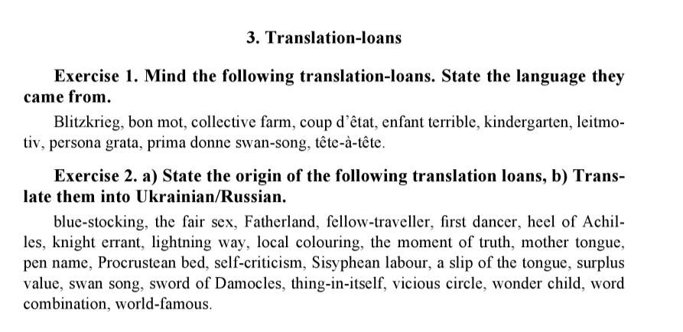
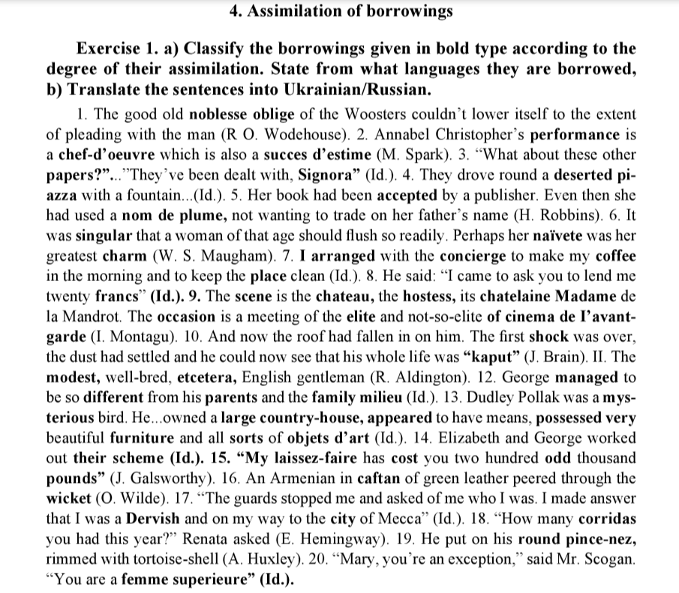

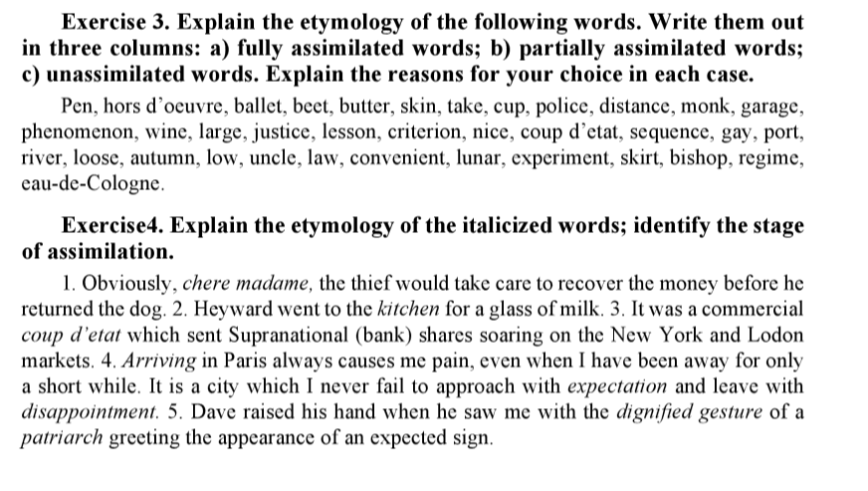
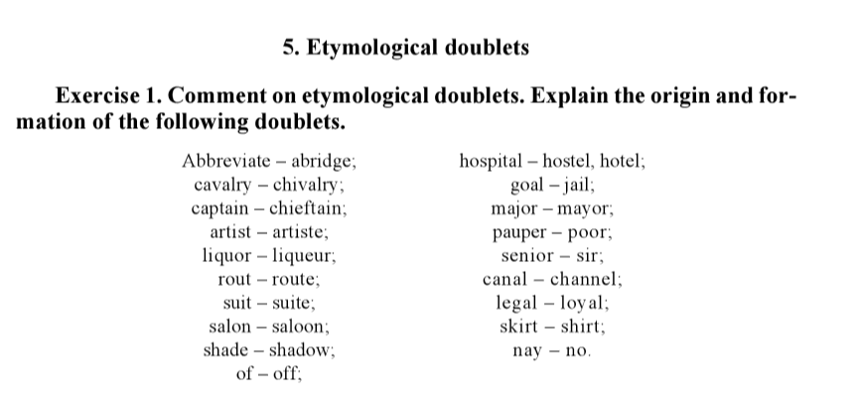
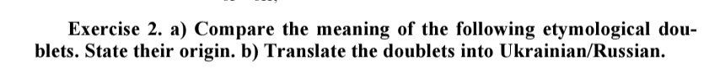
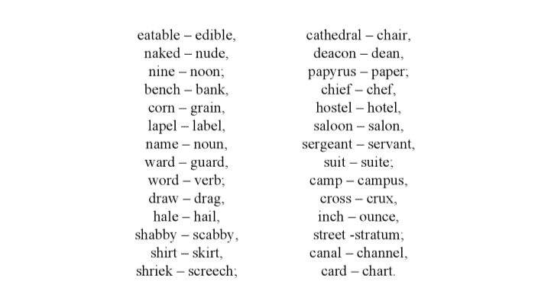
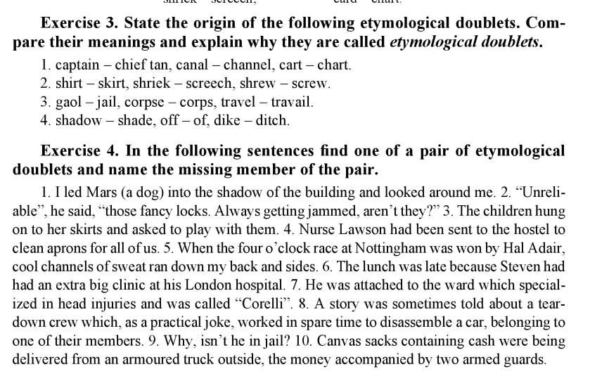
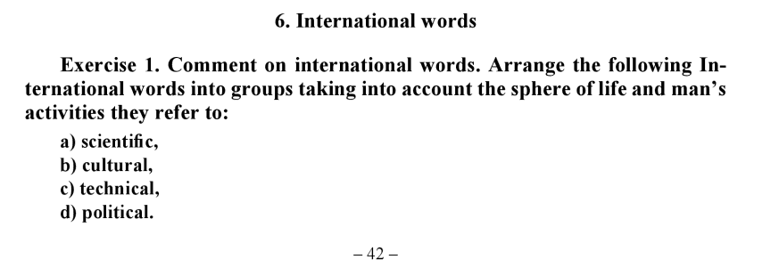
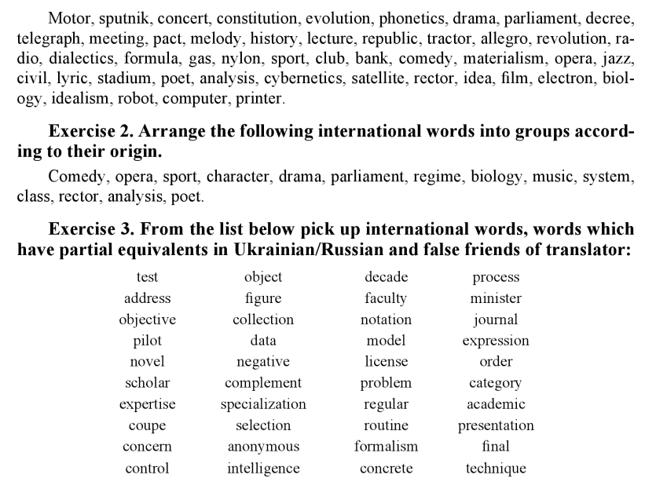
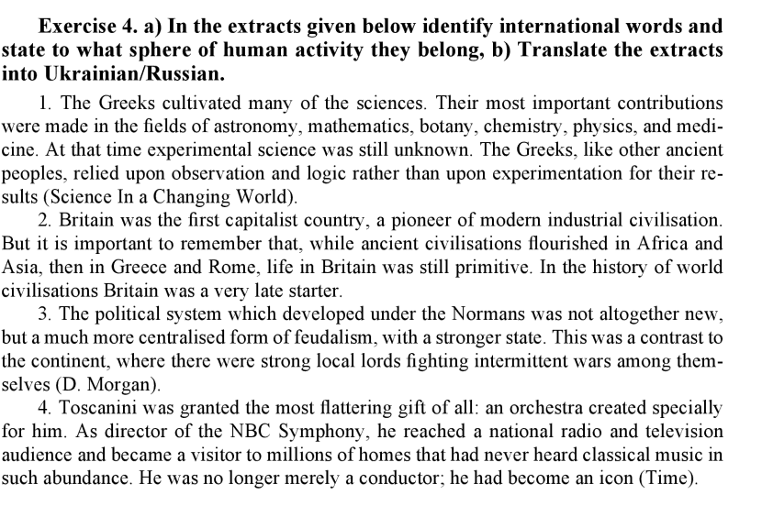
Authors often create neologisms (newly coined words or expressions) to convey specific concepts or ideas in their works. Here are some examples of neologisms coined by famous authors in English literature:
- Hobbit (J.R.R. Tolkien): J.R.R. Tolkien is known for creating many neologisms in his works, but perhaps the most famous is "hobbit." This word refers to the small, human-like creatures who are the central characters in "The Hobbit" and "The Lord of the Rings" series.
- Muggle (J.K. Rowling): J.K. Rowling introduced the term "muggle" in the Harry Potter series to describe non-magical people. It has since become a part of popular culture and is often used to refer to someone who lacks knowledge or skill in a particular area.
- Newspeak (George Orwell): In his dystopian novel "1984," George Orwell coined the term "Newspeak" to describe a controlled language created by the totalitarian government to limit freedom of thought and expression.
- Doublespeak (George Orwell): George Orwell also introduced the term "doublespeak" in his essay "Politics and the English Language." It refers to the use of language to deceive, obscure, or manipulate meaning, often by using euphemisms or vague language.
- Unobtainium (James Cameron): In the movie "Avatar," director James Cameron used the term "unobtainium" to describe a fictional, rare mineral with special properties. This term is now sometimes humorously used to refer to any rare or hard-to-obtain material.
- Frabjous (Lewis Carroll): Lewis Carroll coined the word "frabjous" in his poem "Jabberwocky" from "Through the Looking-Glass." The word's exact meaning is unclear, but it's often interpreted as a whimsical adjective meaning wonderful or fabulous.
- Quark (James Joyce): Although the term "quark" predates James Joyce, he popularized it in "Finnegans Wake," and it later became the name of a type of subatomic particle in particle physics.
- Grok (Robert A. Heinlein): In his science fiction novel "Stranger in a Strange Land," Robert A. Heinlein introduced the word "grok," which means to understand something deeply and completely, often on an intuitive or emotional level.
- Vorlon (J. Michael Straczynski): In the science fiction series "Babylon 5," the term "Vorlon" is used to describe an enigmatic and ancient alien species.
- Cyberspace (William Gibson): William Gibson is credited with popularizing the term "cyberspace" in his novel "Neuromancer." It refers to the virtual reality of computer networks and the internet.

Homework:
