|  |  |  |
| --- | --- | --- |
| *Тема* | *Джерело*  *(література, посилання)* | *Завдання* |
| Практичне заняття 2  Тема “Inventions” | **“Англійська мова” для студентів 2-го року навчання. “English” for Second Year Students: навч.-метод. посіб. / І. С. Ковальчук, О. Б. Сивак. – Житомир: ЖДТУ, 2018. – 156 с.**  **Grammarway 2, Jenny Dooley – Virginia Evans, Express Publishing** | **1) Ex. 5, 7,8,9,11 – p. 12**  **2) PASSIVE: Inventors and Inventions (attachment)**  **Відкрита книга**  **VIDEO Inventions (attached)** |

<https://www.youtube.com/watch?v=bNUfZ3_VkuE> Watch the video and complete the table.

|  |  |  |
| --- | --- | --- |
| **INVENTION** | **WHERE AND WHEN WAS IT INVENTED?** | **USE** |
| **Paper** | In China, 2nd century BC | Books, money, etc. |
| **The compass** |  |  |
| **Refrigerator** |  |  |
| **The printing press** |  |  |
| **Plumbing** |  |  |
| **Medicines and vaccination** |  |  |
| **Engines** |  |  |
| **The wheel** |  |  |
| **Communication** |  |  |
| **Electricity** |  |  |

**2) Try to guess the invention.**

You need to make a definition for each invention so your partners can guess which object you are referring to.

For example: *This is a machine which washes dishes automatically. What is it?*

* *A dishwasher.*
* *Yes, it is. Well done*

**3) An invention which I can't live without**

You are going to read a text in which Emily, a thirteen-year old British student, tells us about an invention which she cannot live without.

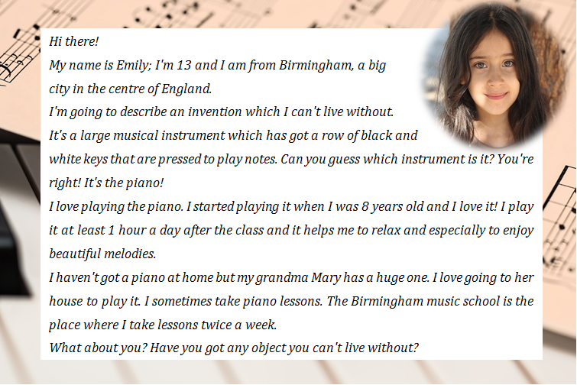

**Say if the statements below are true or false**:

1. Emily is British

2. Emily's been playing the piano for 8 years

3. Emily plays the piano 1 hour before school

4. Emily loves the piano because she has fun playing songs which she likes

5. The piano at the house of Emily's grandmother is small

6. Emily goes to a music school every day

**4) An invention which I can't live without**

Write a reply to Emily describing an invention which you can't live without. Write a maximum of 200 words. You **must** include these points:

* Definition of the invention
* Why you can't live without it
* How often you use it; when and where