Тема | Джерело  (література, посилання) | Завдання
Практичне заняття 11  Тема “Gadgets” | “Англійська мова” для студентів 2-го року навчання. “English” for Second Year Students: навч.-метод. посіб. / І. С. Ковальчук, О. Б. Сивак. – Житомир: ЖДТУ, 2018. – 156 с.  Grammarway 2, Jenny Dooley – Virginia Evans, Express Publishing | The gadgets that changed our lives  (attachment)  HOMEWORK  VIRTUAL Reality Essential Vocabulary p. 36  Ex. 3,4,5-p.37

The gadgets that changed our lives

3-D television
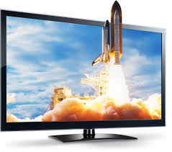
The first film in 3D was shown in the cinema in 1922. No, this is not a typo. It was really in 1922. And in the year 1928 the first 3D television was made. It was made by the inventor of the normal television John Logie Baird. But no one was interested in the 3D technology for a long time because it was extremely expensive. In the 1950s several 3D films were made but they were considered as something unusual. The real breakthrough came with the invention of the format IMAX 3D which was introduced in 1986. Nowadays all the TV producers make 3D televisions. However, for some people 3D doesn't exist because their eyes are bad and they cannot see it.

Digital camara
Nowadays hardly anyone has an analogue camera. Most people have digital cameras because you can take hundreds and thousands of snaps at no cost. The memory cards are small, and you can save more photographs there than it was possible on a normal film. While the films were expensive, digital photos are really cheap. You can upload the pictures to your computer and then choose the best ones. Moreover, digital photography doesn’t change, and you can edit it on your computer. The disadvantage of digital cameras is the fact that they develop really quickly and there are so many machines now that it is difficult to know which one is good for you. The first digital camera was introduced in 1988 and it was made by Fuji.

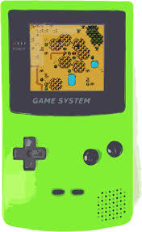
Game Boy Nintendo
Game Boy was the first digital game which was commercially successful. The first game which was played on Game Boy was Tetris. The first Game Boy was introduced in 1989. Recently the company Nintendo introduced its Wii U machine which can play video and the internet content. There are many other gadgets like this for example PlayStation or Xbox, but Game Boy was the first.

Webcam
The first Webcam was used on the premises of Cambridge University. This happened in 1991 and the same camera was used till 2001. Nowadays, Webcam is a common part of computers. You can see nearly all interesting places online. Moreover, they are used to monitor the traffic on highways and streets and all the drivers can see which places they should avoid. The skiers can see whether there is enough snow in the place where they would like to go skiing.

Smartphone
Do you remember? In 1990s the businessmen boasted with mobile phones which were big and heavy. Nowadays the smart phones are thin, and light and they can do a lot of things. Besides telephoning you can listen to music, connect to the internet, and you can play games there too. The first smart home was introduced by IBM at the beginning of 1990s. This phone had a calendar, address book, clock, calculator, notebook, email and a few games. It had a touch display, but it was only black and white. But at the beginning everyone thought that phones like this where unnecessarily expensive and useless. It was only 10 years later when Steve Jobs introduced iPhone and smart phones became incredibly popular.

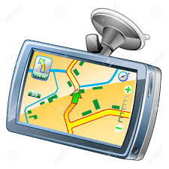
GPS
GPS stands for global positioning system which is a positioning system run by the Army of the United States. It is possible to find the exact position and time wherever on the Earth. Originally this system was planned to be used only for the Army. The system was started in 1994 when all 24 satellites were placed on the orbit. Normal people started using GPS in 2000. Nowadays GPS has 32 satellites which are 20 km above the Earth.

Which gadget …?
1. is the oldest
2. can take photos
3. is not for everyone
4. was planned to be used only by the army
5. was forgotten for many years
6. is only for playing games.
7. is nowadays common part of every computer
8. was introduced by Apple

Answer the questions
Which of these devices do you use regularly? Why?
Which of these devices do you use the most? Why?
How long have you been using each of these devices?
Which of these devices do you find the most useful? Why?
Do you think you are addicted to one of these devices? If yes, which one?
Which device could you give up for some time? Why?
Which device would you miss the most? Why?
Have you seen films in 3D? Which?
Do you find films in 3D better than normal films? Why? Why not?
Do you play games online? Which? Alone or with friends?
Do you like taking photos?
Do you have a digital camera?
Do you edit your photos on the computer? Why? Why not?
Do you always buy the latest model of smartphone?
What can you do with a smart phone besides phoning?
Do you communicate more texting or phoning? Why?
What other gadgets (not mentioned in the text do you use?
If you are a teen. Can you imagine how your grandparents lived without all these devices?
If you are an adult and did not have these devices. Was it difficult to adapt? Why? Why not?
What gadget would you like to be invented? Why?

