Тема | Джерело  (література, посилання) | Завдання
Практичне заняття 9  Тема “Health Problems” | 1) “Англійська мова” для студентів 2-го року навчання. “English” for Second Year Students: навч.-метод. посіб. / І. С. Ковальчук, О. Б. Сивак. – Житомир: ЖДТУ, 2018. – 156 с. | 1) Allergy (2 att)  2) Allergy (text)  - Watch the video and do exercises.  Can eating fruit be bad for you?  PHYSICAL FITNESS Active Vocabulary + Useful Phrases p.103  Ex. 3-6, p. 104

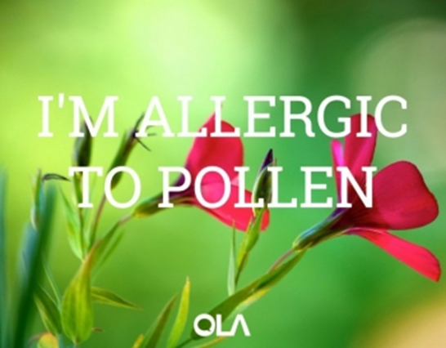
Allergy
1. What are you allergic to? Have you ever had an allergic reaction?
2. What are the most common allergies that you know of?
3. First explain the meaning, and then say whether you agree or disagree:
About 20% of population believe themselves to have a food allergy and only about 5% actually do.
4. What new allergies might be found in the future?

5. Listen to Streaming Well as they discuss what hay fever really is, and answer the questions in the following listening exercise.
Questions:
1. Hay fever is an ___ reaction to pollen.
2. …which affects one in ___ people.
3. Symptoms include sneezing, a runny nose and _____ ____.
4. …and are usually brought on when this very fine ______ is released by _____.
5. The chemicals in turn cause the ______ of an allergic reaction, such as fits of _______.
6. In England, most people with hay fever are allergic to ______ pollen.
7. Research suggests that pollution, such as cigarette smoke or ___ exhaust fumes can make allergies _____.
8. From January to April pollen from trees are the most common _______ of hay fever.
9. Pollen levels will typically spread easily on ______ and windy days, whilst levels are usually low _______ rain.
10. On sunny days the pollen count is _______ in the early evening.

Allergy is a condition in which the body reacts with unusual sensitivity to a substance or substances. A runny nose and watering or itching eyes are common to many persons who suffer each year from hay fever. In asthma, there is wheezing; with eczema and hives there is itching, redness, and lumps. An inflammation of the skin (contact dermatitis) may occur from wearing rubber gloves or touching a certain chemical, such as some kinds of soap. A reaction to antibiotics, particularly penicillin, may take the form of a rash.
2. Allergy
This is due partly to hereditary factors; some families seem to be more susceptible to allergies than others, although particular allergies are not necessarily inherited. Emotional disturbances can also set off allergic conditions, and many physicians believe that an emotional factor may be one factor that triggers an asthma attack.
The physician usually gets a detailed history from the patient to find the most likely source of the problem and may then carry out a skin test. A weak solution of the substances that are suspected is injected into the skin. A red reaction indicates an allergy to that particular substance. Sometimes a patch test is done for the same reason.
If the cause of the allergic reaction is not known, a physician may prescribe antihistamine pills or corticosteroid nasal and lung sprays to control the symptoms.
An allergic reaction to an insect sting or antibiotic drug, such as penicillin, is potentially dangerous and can even be fatal. A mild reaction usually causes a rash. In a violent reaction, which is called anaphylactic shock, the patient finds breathing increasingly difficult. This is an emergency condition, and medical attention should be obtained immediately. Fortunately, the condition is rare.
Answer the questions:
- How is allergy manifested?
- What are the most common symptoms of allergy? Have you ever had such symptoms?
- Why does an inflammation of the skin appear? Give examples.
- What is the easiest form of allergy to antibiotics?
- Is the allergy necessarily inherited?
- What is necessary to do to find the source of the problem?
- In what cases is the medical attention immediate?

3. VIDEO

Watch the video and do the exercises. https://youtu.be/zhUzxcg04IM

- Match the definitions (a–h) with the vocabulary (1–8).
Vocabulary | Definition
1. …… a fizzy drink / a soft drink  2. …… a teaspoon  3. …… junk food  4. …… to gain weight  5. …… ripe  6. …… whole  7. …… to overload  8. …… veg | a. entire; in one piece  b. an uncount. noun which is the colloquial form of ‘vegetables’  c. to get heavier  d. to give too much work to someone or something  e. a drink which contains bubbles and is usually sweet  f. pre-prepared food which is bad for you because it has a lot of sugar, salt or fat  g. finished growing and ready to eat  h. a small spoon typically used for putting sugar in a cup of coffee or tea

2. Are the sentences true or false?
1. An apple contains about half as much sugar as a can of fizzy drink.  2. Fructose is better than glucose for providing our body with energy.  3. The sugar in fruit is a little different from the sugar in fizzy drinks.  4. Some types of sugar don’t cause people to gain weight.  5. A banana generally contains more sugar than a kiwi fruit.  6. The amount of sugar in a piece of fruit decreases as it gets older.  7. It is better for you if you cut fruit into little pieces before eating it.  8. If we don’t eat fruit, it is impossible to get certain vitamins. | True  True  True  True  True  True  True  True | False  False  False  False  False  False  False  False
3. Write a word to complete the sentences.
1. A regular-sized soft drink contains about seven to eight …………of sugar.
2. These are chemically identical to the sugars you get in ……………… food.
3. Sugar is sugar. And you’re going to gain …………… if you eat too much of it.
4. The ………… the fruit, the more sugar it contains.
5. You should eat most of your fruit …………………… .
6. There is no vitamin or mineral in fruit that you can’t get from …………… .

Discussion
Were you surprised by any of the information in the video?

