Тема | Джерело  (література, посилання) | Завдання
Практичне заняття 8  Тема “Health Problems” | 1) “Англійська мова” для студентів 2-го року навчання. “English” for Second Year Students: навч.-метод. посіб. / І. С. Ковальчук, О. Б. Сивак. – Житомир: ЖДТУ, 2018. – 156 с. | - TEST Present Perfect Simple vs Present Perfect Continuous  - Health Advice (att)  - Eye Damage (att)  Be ready to speak about ways of protecting your eyesight  (DIALOGUE\MONOLOGUE)

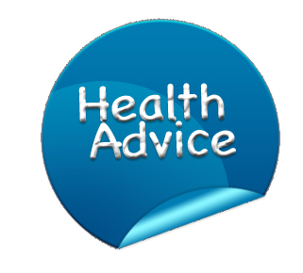
Complete the sentences to give advice to your groupmates.
1. If you are feeling ill, you …………………….
If you are feeling ill, you should see a doctor.
If you are feeling ill, it is advisable to …………….
If you are feeling ill, it would be better to …………..
2. If you want to be healthy, you ………………………
3. If you want to lose weight, ……………………………
4. If you are feeling stressed, you ………………………
5. If you want to lower your blood pressure, you …………………………………
6. If you have asthma, you …………………………………………………………
7. If you have heart problems, you …………………………………………………
8. If you are feeling under pressure, you ..…………………………………………
9. If you want to lower your cholesterol, you ………………………………………
10. If you are feeling not well, you …………………………………………………
11. If you have dry skin, you ………………………………………………………
12. If your headache is getting worse, you …………………………………………
13. If you want to improve your diet, you .…………………………………………
14. If you suffer from stress, you .…………………………………………………
15. If you have difficulty sleeping, you ……………………………………………

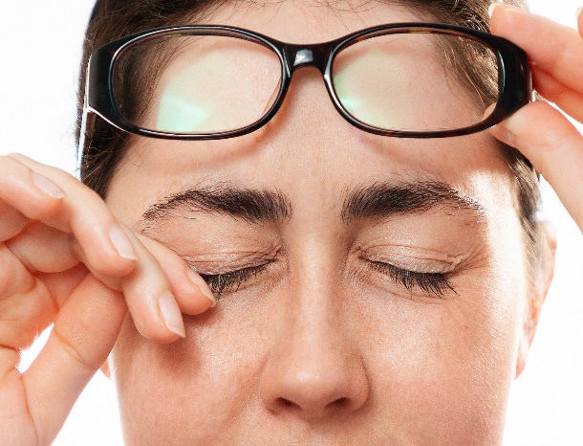
EYE DAMAGE
Before reading: TRUE / FALSE: Read the headline. Guess if 1-8 below are true (T) or false (F).
- Smokers are twice as likely of damaging their eyes as non-smokers. T / F
- The article says not many people know smoke can damage eyesight. T / F
- A campaign to get people to quit smoking is called "Stab It Out". T / F
- Just one in five people thinks that smoking causes eye damage. T / F
- Smoke worsens existing eye problems. T / F
- The article says smoke contains metals such as iron and silver. T / F
- The article says there is not cure for cataracts. T / F
- Smokers are ten times likelier to damage eye muscles. T / F

2. SYNONYM MATCH: Match the following synonyms from the article.
warning  damaging  campaign  awareness  stop  worsens  toxic  pieces  cloudy  encouraged | poisonous  understanding  urged  harming  adds to  cautioning  bits  misty  drive  quit

Scientists are warning that people who smoke are in danger of damaging their eyes. Scientists say smokers are two times more likely to lose their vision than non-smokers. Everyone knows that smoking can damage the lungs and heart, but not many people know it could damage eyesight. The scientists are from the Association of Optometrists (AOP) in the United Kingdom. The AOP has started a campaign to raise awareness of the danger of smoking to the eyes. The campaign is called "Stub it out". The word "stub" means to put out a cigarette by pushing the end against something hard; "stub it out" is saying, "stop smoking". The AOP said only one in five people thinks smoking can damage the eyes.
The AOP explained why smoking is so harmful to the eyes. Cigarette smoke gets in the eyes and causes or worsens a number of different eye problems. Cigarette smoke contains toxic chemicals that can irritate and damage the eyes. Smoke contains tiny pieces of metals like lead and copper. These can get into the eyes and lead to cataracts - a condition that causes the eye lens to become cloudy. People with cataracts usually need an operation to restore their sight. Smoke can also increase the chance of worsening sight problems for people with diabetes. The AOP said smokers are also three times more likely to damage the eyes' muscles. The AOP has encouraged smokers to quit.

3. BAD FOR OUR EYES: Rank these with your partner. Put the worst things for our eyes at the top. Change partners often and share your rankings.
rubbing your eyes | smartphone use | poor diet
reading by torchlight | smoke | sunlight
not enough sleep | TV screens

Vocabulary: Explain the meaning of the following words. Choose 6 of them and write your own sentences.
1. | warning | 8 | worsen
2. | damaging | 9 | irritate
3. | likely | 10 | tiny
4. | vision | 11 | lead
5. | campaign | 12 | condition
6. | awareness | 13 | operation
7. | stub | 14 | encouraged

Comprehension questions
Who is warning of the dangers of smoke to the eyes?
How much likelier are smokers to damage their eyes?
What is the name of the campaign to raise awareness of the dangers?
Out of five people, how many think smoking can damage the eyes?
What kind of chemicals does smoke contain?
What two metals can be found in smoke?
What eye problem was mentioned that needs an operation?
What has a group called the AOP encouraged people to quit?

