|  |  |  |
| --- | --- | --- |
| *Тема* | *Джерело*  *(література, посилання)* | *Завдання* |
| Практичне заняття 7  Тема “Health Resorts” | **1) “Англійська мова” для студентів 2-го року навчання. “English” for Second Year Students: навч.-метод. посіб. / І. С. Ковальчук, О. Б. Сивак. – Житомир: ЖДТУ, 2018. – 156 с.** | 1. **Ex. 8-9 p. 95** 2. **Grammar Revision: Present Perfect Continuous**   **Відкрита книга**  **HEALTH PROBLEMS Active Vocabulary + Useful Phrases**  **Ex.3-5, p. 98** |

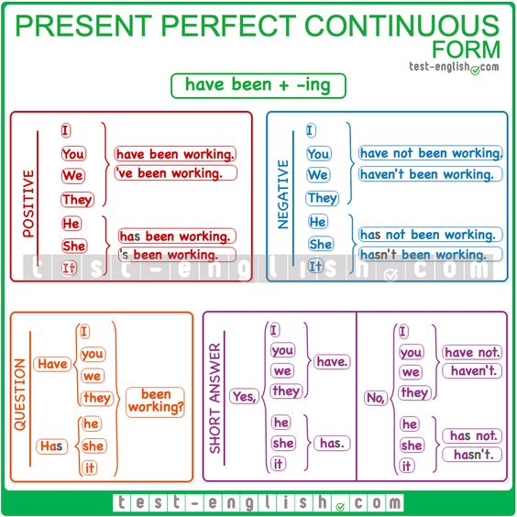



**Ex. 1. Choose the correct verb forms to complete the sentences.**

1. I ___ the windows all day without any help! Two more and I can have a rest.

*Початок форми*

*'ve been washing 've washed*

Кінець форми

2. You look nice! Have you ___ your hair cut?

*Початок форми*

*been having had*

Кінець форми

3. Has someone ___ my special bread? There's only a little bit left.

*Початок форми*

*been eating eaten*

Кінець форми

4. ___ four goals and it's only half-time!

*Початок форми*

*They've been scoring They've scored*

Кінець форми

5. I've ___ English for three years and soon I'm going to use it at work.

*Початок форми*

*been learning learned*

Кінець форми

6. A: Are you OK? B: Yeah, I'm fine! I'm not crying. I've ___ onions!

*Початок форми*

*been chopping chopped*

Кінець форми

7. Finally! We ___ our house!

*Початок форми*

*'ve been selling 've sold*

Кінець форми

8. Sorry, I'm late! How long ___?

*Початок форми*

*have you been waiting have you waited*

**Ex. 2. Fill in the present perfect simple or the present perfect progressive.**  
1. Jane (write) a letter to a magazine. She (not finish) it yet.  
2. Ben (look) for his penknife, but he (not find) it yet.  
3. Jenny (wait) for the bus for half an hour, but it (not arrive) yet.  
4. Nick (play) a computer game for two hours and he is still playing.  
5. Mike (not finished) painting his car yet. He (work) on it for two weeks.  
6. Amanda (not come) home yet. She (shop) in town since 10 o'clock.  
7. Mike's car (make) strange noises. Nick and Jane (clean) all the parts.  
8. Ben (draw) cartoons for two hours. He (not finish) yet.  
9. Greg (wait) for Jenny in town. Jenny (not arrive) yet.  
10. Jane (knit) a pullover. She (not finish) yet.  
11. It (rain) all day and it (not stop) yet.  
12. Mr Blake (make) tests all evening, but he (not find) a perfect one yet.

Кінець форми