Тема | Джерело  (література, посилання) | Завдання
Практичне заняття 5  Тема “Food” | 1) “Англійська мова” для студентів 2-го року навчання. “English” for Second Year Students: навч.-метод. посіб. / І. С. Ковальчук, О. Б. Сивак. – Житомир: ЖДТУ, 2018. – 156 с. | 1) Vegetarianism (attachment)  2) EATING HABITS questions  1) HEALTH RESORTS Ex. 3-6, p. 92  2) Attachment (General terms and expressions  relating to spa treatments and services)

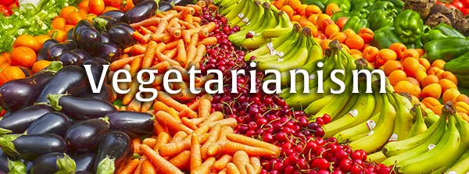
Until recently, vegetarianism was fairly uncommon in Britain, and it is still considered strange by some. But since the 1960s, its popularity has increased greatly, to the (1) ___________ that high street stores stock a huge variety of products for vegetarians.
The reasons people give for not eating meat are (2) ___________. Perhaps most vegetarians do it for moral reasons, arguing that it is (3) ___________ to kill. The opposing point of view is that it is (4) ___________ for us to kill for food, and that we have evolved to do so. Still, there are societies where eating meat is not allowed because it is (5) ___________ their religion.
There are other good reasons to (6) ___________ meat, one of which is the inefficiency of livestock farming. A simple (7) ___________ of soya bean plants can actually (8) ___________ 200 times as much protein as the number of cattle which could be raised on the same (9) ___________ of land, so a vegetarian world might be a world without hunger.
Although it is, in theory, cheaper to eat only vegetables, vegetarianism is most (10) ___________ in richer countries such as Germany and Britain, where many people (11) ___________ meat for health reasons. In these countries, at least, it (12) ___________ to be a matter of choice rather than a necessity.

1. | A) measure | B) distance | C) length | D) extent
2. | A) numerous | B) lots | C) several | D) dozens
3. | A) false | B) faulty | C) wrong | D) mistaken
4. | A) real | B) natural | C) physical | D) genuine
5. | A) across | B) beside | C) opposite | D) against
6. | A) give up | B) put down | C) cut off | D) turn away
7. | A) pitch | B) place | C) farm | D) field
8. | A) achieve | B) produce | C) create | D) establish
9. | A) amount | B) total | C) area | D) size
10. | A) popular | B) famous | C) known | D) liked
11. | A) exclude | B) prevent | C) escape | D) avoid
12. | A) finishes off | B) goes through | C) turns out | D) comes up

2. General terms and expressions
relating to spa treatments and services

Choose the correct word.
- The use of all our facilities/faculties sauna, pool, fitness centre, etc. is included in the price.
- There are licensed health professionals/pros available on site. (at our spa)
- This treatment will cleanse/clarify your skin by removing/exfoliating dead skin cells.
- This massage is perfect for those who have never had a massage before. In other words, it’s a great beginner/premier massage.
- The two main reasons people go to spas are to relieve some kind of discomfort/comfort, and to promote physical well-being.
- Since you have dry skin, it’ll be best to include treatments that will hydrate/water it.
- This brochure describes the different types of massage/message that we offer in our spa centre.
- We only hire certificate/licensed massage therapists.
- You can have/receive about two treatments daily/day.
- I recommend our hydrate/water therapy treatments.
- A day/daily spa is a place where one can come for a quick treatment.
- You will begin your treatment after one of our physicians/staff examines you.
- People come from all over to experience the therapeutic/standard power of these mineral waters.
- After this treatment you will feel refreshed and rejuvenated /new.
- Apart from the outdoor pool we have a sauna and a state-of-the-art/good (very modern) gymnasium.
- Our physiotherapists specialize in treating back problems/trouble.
- You might require as many as 10 sessions/cycles before you see any visible improvement.
- Some of our clients aren’t interested in treatments. They just want some peace/pace and quiet.
- We offer a wide range/selection of treatments for the face, body, hands and feet.
- You’ll find our prices to be quite reasonable/good (not very expensive).

