Тема | Джерело  (література, посилання) | Завдання
Практичне заняття 3  Тема “Sports” | 1) “Англійська мова” для студентів 2-го року навчання. “English” for Second Year Students: навч.-метод. посіб. / І. С. Ковальчук, О. Б. Сивак. – Житомир: ЖДТУ, 2018. – 156 с. | 1) Grammar: Future Perfect  2) Test Sports Part I  https://learn.ztu.edu.ua/mod/quiz/view.php?id=163934  Essential Vocabulary p. 85  Ex. 3,8 – pp.86-88  Test Sports Part II  https://learn.ztu.edu.ua/mod/quiz/view.php?id=164576

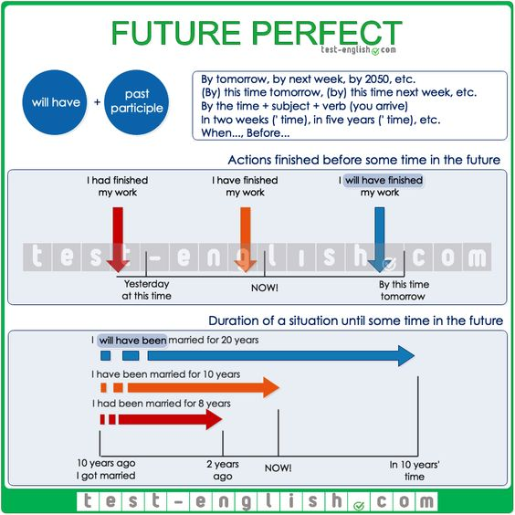
Change the verb into the correct form.
1. By this time tomorrow, I (finish) the project.
2. By 8 o'clock, the kids (fall) asleep.
3. By tomorrow morning, he (sleep) wonderfully.
4. By next year, she (receive) her promotion.
5. Robin (sell) his car by next Sunday.
6. Morgan (clean) the entire house by lunch.
7. We (dance) a few dances before midnight.
8. At this time next week, we (catch) the thief.
9. By 2013, I (live) in Madrid for 5 years.
10. By September, Julie (teach) us for over a year.
11. By October, I (study) English for 3 months.
14. On Monday, she (wait) for 2 weeks.
15. Before Saturday, you (do) all of your homework.

Make the future perfect
1) I (leave) by six.

2) (you/finish) the report by the deadline?

3) When (we/do) everything?

4) She (finish) her exams by then, so we can go out for dinner.
5) You (read) the book before the next class.

6) She (not/finish) work by seven.

7) When (you/complete) the work?

8) They (arrive) by dinner time.

9) We (be) in London for three years next week.

10) (she/get) home by lunch time?

11) (you/do) everything by seven?

12) We (not/eat) before we come, so we'll be hungry.

13) (he/finish) his exams when we go on holiday?

14) (we/arrive) by the time it gets dark?

15) How long (you/know) your boyfriend when you get married?

