|  |  |  |
| --- | --- | --- |
| *Тема* | *Джерело*  *(література, посилання)* | *Завдання* |
| Практичне заняття 1  Тема “Sports” | **“Англійська мова” для студентів 2-го року навчання. “English” for Second Year Students: навч.-метод. посіб. / І. С. Ковальчук, О. Б. Сивак. – Житомир: ЖДТУ, 2018. – 156 с.**  **Grammarway 2, Jenny Dooley – Virginia Evans, Express Publishing** | 1. **SPORTS - Reading about sports** 2. [**https://www.engvid.com/english-vocabulary-play-go-do-sports/**](https://www.engvid.com/english-vocabulary-play-go-do-sports/) **+ Quiz**   **2) Grammar Revision: Future forms**  **Відкрита книгаEx. Essential Vocabulary p. 80**  **Ex.3-5, p. 81-82** |

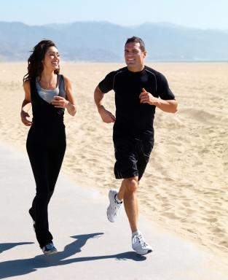**READING about Sport**

Sport holds an important place in our life. When we listen to the radio in the morning, we can always hear sport news. When we open a newspaper, we can always find information about some game or other or an article about our favorite kind of sports. Television programmers about sport are also very popular, and we can watch something interesting every day. Sport helps people to keep in good health. Sport also makes us more organized in our daily activities. National game and sports competitions are popular in our country. People go in for many kinds of sports. There are sports grounds near every school, every institute, every factory and plant. Besides there are sports clubs and sport school in every town. Many people go there for training.

**QUESTIONS**

1. What is the importance of sport in your life?
2. Is it interesting for you to read news about the achievements of our and foreign sportsmen?
3. Do you watch any Sport programs?
4. What kind of sport is popular in our country? Why is it so popular? What do you know about it?
5. Did you like PT lessons at school? Do you like them at the University?
6. Are you a member of any sport club or school?

**Sports in Ukraine**

There are different sporting societies and clubs in Ukraine. Many of them take part in different international tournaments and are known all over the world. A great number of world records have been set by Ukrainian sportsmen: weightlifters, tennis players, swimmers, figure skaters, high jumpers. Our sportsmen also participate in the Olympic Games and always win a lot of gold, silver and bronze medals. There are also a lot of amateur clubs and keep-fit centers in Ukraine where people go in for aerobics, yoga, body-building, swimming, skating, jogging.

**QUESTIONS**

1. **What famous Ukrainian sportsmen do you know? What kind of sport do they represent?**
2. **What do you need to be a winner? Look through the phrases below. Add to this list your own ideas and share them with your partner.**

***It is important…***

***I think one of the most important things is ……..***

***– to be confident***

***– to be at one’s best in all situations***

***– to be an active participant***

***– to do morning exercises***

***– to train hard***

