Тема | Джерело  (література, посилання) | Завдання
Практичне заняття 9  Тема “Health Problems” | 1) “Англійська мова” для студентів 2-го року навчання. “English” for Second Year Students: навч.-метод. посіб. / І. С. Ковальчук, О. Б. Сивак. – Житомир: ЖДТУ, 2018. – 156 с. | 1) Allergy (text)  1) Write your own sentences with the words marked in yellow colour.  2) Food allergy and intolerance
Read and complete.
Allergic - ambulance- sneeze- pollution -allergy
During your life you may suffer from an ....................... This is when,
because of ...................... for example, or plants and flowers, your
eyes are red and you ..................... There are different kinds of
allergies and some allergies can be dangerous. If you have a very bad
allergic reaction, you should always call an ............... or go to the
hospital. The doctor can give you medicine to help you feel better.

Allergy is a condition in which the body reacts with unusual sensitivity to a substance or substances. A runny nose and watering or itching eyes are common to many persons who suffer each year from hay fever. In asthma, there is wheezing; with eczema and hives there is itching, redness, and lumps. An inflammation of the skin (contact dermatitis) may occur from wearing rubber gloves or touching a certain chemical, such as some kinds of soap. A reaction to antibiotics, particularly penicillin, may take the form of a rash.
Allergy
This is due partly to hereditary factors; some families seem to be more susceptible to allergies than others, although particular allergies are not necessarily inherited. Emotional disturbances can also set off allergic conditions, and many physicians believe that an emotional factor may be one factor that triggers an asthma attack.
The physician usually gets a detailed history from the patient to find the most likely source of the problem and may then carry out a skin test. A weak solution of the substances that are suspected is injected into the skin. A red reaction indicates an allergy to that particular substance.
An allergic reaction to an insect sting or antibiotic drug, such as penicillin, is potentially dangerous and can even be fatal. A mild reaction usually causes a rash. In a violent reaction, which is called anaphylactic shock, the patient finds breathing increasingly difficult. This is an emergency condition, and medical attention should be obtained immediately. Fortunately, the condition is rare.
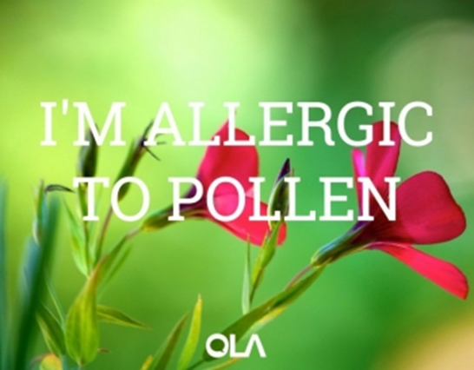
Answer the questions:
- How is allergy manifested?
- What are the most common symptoms of allergy? Have you ever had such symptoms?
- Why does an inflammation of the skin appear? Give examples.
- What is the easiest form of allergy to antibiotics?
- Is the allergy necessarily inherited?
- What is necessary to do to find the source of the problem?
- In what cases is the medical attention immediate?
8. What are you allergic to? Have you ever had an allergic reaction?
9. What are the most common allergies that you know of?
10. What new allergies might be found in the future?

Food allergy and intolerance
Task 1. Read and answer the question:
What is the difference between food allergy and food intolerance?
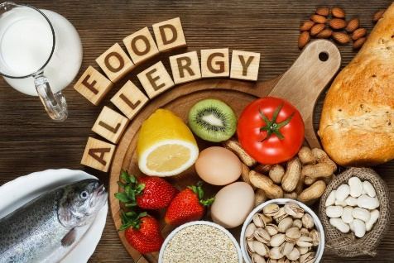
When someone has a food allergy, their immune system wrongly sees the food as hostile and the body's defense mechanism goes into action. This produces a range of symptoms that can vary from mild itching to severe breathing difficulties or even shock. These symptoms usually happen immediately after eating the food.
When someone is intolerant to a food, the immune system is usually not involved and symptoms take much longer to develop and are generally not life-threatening. However, food intolerance can adversely affect long-term health, e.g., lactose intolerance.
A. What part of the body goes into action when someone has a food allergy?
B. What is an example of a mild symptom of an allergy?
C. What is an example of a severe symptom of an allergy?
D. Name one way in which a food intolerance is different to a food allergy.

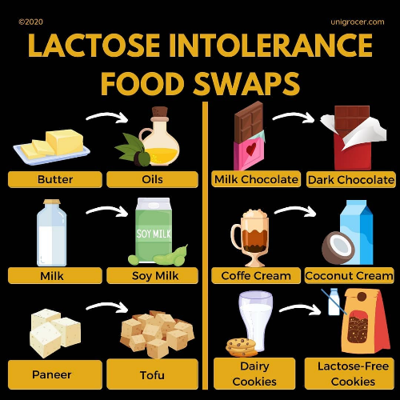
Task 2. Read about lactose intolerance:
Lactose intolerance means the body cannot easily digest lactose, a type of natural sugar found in milk and dairy products. This is not the same thing as a food allergy to milk. When lactose moves through the large intestine (colon) without being properly digested, it can cause uncomfortable symptoms such as gas, belly pain, and bloating. Some people who have lactose intolerance cannot digest any milk products. Others can eat or drink small amounts of milk products or certain types of milk products without problems.
Which of the foods can generally be eaten by people who have lactose-intolerance? Tick the foods that are ok and put a cross by those foods to avoid:
almond | chocolate | ice crem
biuscuits | dried beans | cheese
butter | egg yolk | instant soup
cakes | salad dressing | pancakes
calcium-fortified orange juice | fatty fish (like salmon) | almond milk
cream | tofu | mayonnaise
calcium-fortified soy milk | dark green leafy vegetables | broccoli

Task 3. Unscramble each word in the sentences about nuts allergies below:

1) Nuts and peanuts can useca? __________ allergic reactions, which are sometimes
severe.
2) A severe reaction to stun? __________ is called anaphylaxis and can be life-threatening.
3) Symptoms often start quickly, within an rouh? ________ of coming into contact with a nut, and sometimes within minutes.
4) Avoiding soofd? _________ that contain nuts will prevent an allergic reaction.
5) If someone has a severe recigall? ___________ reaction, an adrenaline (epinephrine) injection can be given straight away (if available) and an ambulance must be called.
6) People with nut allergies must always cechk? __________ food labels.
7) Nuts and nut soil? _________ are used as ingredients in a wide range of foods, e.g., biscuits, cakes, pastries, desserts, ice cream, breakfast cereals, cereal bars, nuts spreads, confectionery, vegetarian dishes, and salad dressing.
8) Those with nut allergies should avoid gintea? __________ foods at buffets or from delicatessens or bakeries where it is easy for food to be contaminated by touching other foods containing nuts.
9) Chinese, Thai, and Indonesian shedsi? _______________ often contain nuts and nut oil.

